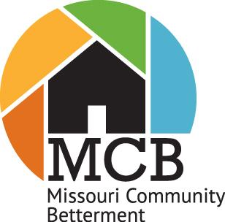
Missouri Community Betterment Educational Fund, Inc.

MCB Permission Statement

I hereby give Missouri Community Betterment Educational Fund, Inc. permission to use my name, photograph, any information submitted in conjunction with the MCB Awards Program, information about my circumstances and assistance provided to me by MCB. I understand that this will be used only in educational materials such as MCB brochures, website materials or news releases to help others understand how MCB programs can help rural communities. This information is not to be used for any commercial, money-making purpose. I will be allowed to review the material relating to me and approve of its accuracy. This information may be released by MCB for the purpose of conducting outreach activities with the general public. I understand that by signing this consent form, I am waiving any privacy interests I may have in relation to this information under the Privacy Act, 5 U.S.C. 552a, the Freedom of Information Act, 5 U.S.C. 552, and the Trade Secrets Act, 18 U.S.C. 1905.

Please complete the following information and return to:
Missouri Community Betterment, 8921 Camco Drive, Plato, MO 65552
Or via email: decamcoinc@yahoo.com
by June 30.

Name: _____________________________________

Organization: _______________________________

Address: ___________________________________

_______ ___________________________________

Phone: ___________________________________

Email: ____________________________________

Signature: _________________________________

Date: ______________________________________

