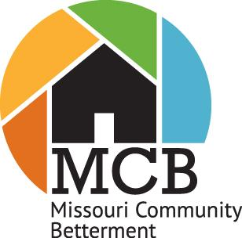

**Youth Advisory Board Application Summary**

Duties and Expectations Include:

* Youth Advisory Board will serve as liaisons and mentors to youth from non-participating communities wanting to learn more about MCB. Youth may be asked to assist other MCB Communities in need of direction and support.
* The Youth Advisory Board will be required to participate in a Zoom call each month with the MCB Executive Director, or other designated MCB Board of Directors member, to connect, plan and move initiatives forward.
* The Youth Advisory Board President will attend the MCB Board of Directors meetings and will report on youth community involvement and will provide strategic input and direction regarding current and future MCB programs.
* The Youth Advisory Board will assign a member responsible for reaching out, monthly, to represented youth groups to learn of current community engagement. That member will then give a shout out to those community youth groups on MCB’s social media platforms, with photos, if possible. Publicly celebrating community achievements of the youth is important!
* The Youth Advisory Board will work with the MCB Board of Directors and Staff to plan the Annual Fall Conference.
* Each selected member will serve a one-year term, beginning in January and ending the day after the 2024 MCB Fall Conference.

Interested applicants should:

1. Be: 14 – 18 years old.
2. Fill out the attached application form.
3. Provide (2) Letters of Recommendation from non-family members
4. Provide a current resume of leadership involvement and activities
5. Be willing to be interviewed by the MCB Board of Directors via Zoom



**2023-24 Youth Advisory Board Application**

*Please fill out and email to s.emily2601@gmail.com or* [*jwhitson@misn.com*](mailto:jwhitson@misn.com)

Name: School:

Phone: Grade Level in School:

Email: Age:

Community:

Advisor: Advisor’s Phone:

Advisor’s Email:

*Please answer the following three questions. You may attach additional pages if needed.*

1. Would you be willing to be interviewed by MCB Board of Directors members via Zoom?
2. Why do you want to be a member of Missouri Community Betterment’s Youth Advisory Board?
3. What skills do you have that make you a great addition to the Youth Advisory Board?