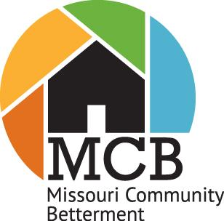

MCB Youth Group Project

Summary Outline

Please use this outline for each project.

Community/Neighborhood: ________________________________________________

Name of Project and category: ________________________________________________________

Project Coordinator: ______________________________________________________

Project Coordinator Phone: ______________________________Email:____________________________

Type of Project: _____ Long-term (1-5 years) _____ Short-term (up to 12 months)

Time Frame: Date begun _____________ Date completed ________________

Number of volunteers _____________ Age range of volunteers _________

Please use the Missouri volunteer labor rate of $31.80 when configuring volunteer hours.
Cost of Project

Materials Donated $_____________

Purchased $_____________

Labor Volunteer $_____________

Paid $_____________

Total cost $_____________

Sources of Funding
(How was money raised for this project?)

Grants _____________ $_____________

Donations ___________ $_____________

Other (explain) _______ $_____________

Narrative summary of project must include:
- Why this project?
- Who selected it?
- How does this project fit in with the organization’s plan? What assessment process led to this project? Take a look at the new M.A.P. tool and let us know which section of the tool your project would fit within, even if you haven’t used the tool yet in your community. The four sections are People; Plans of Action; Financial Resources, Infrastructure, and Assets; and Quality of Life. (If you do not have a copy of the MAP tool, email decamcoinc@yahoo.com to access a copy.)
- How does it fit in with the organization’s goals and/or those of the community?
- Who served as the lead organization?
- List other organizations, groups, and businesses that participated in the project.
- Briefly describe the way you financed the project including the name(s) of any grant, donations or other funding sources. The narrative can be a maximum of two typewritten pages, single spaced in a 12-point font.

