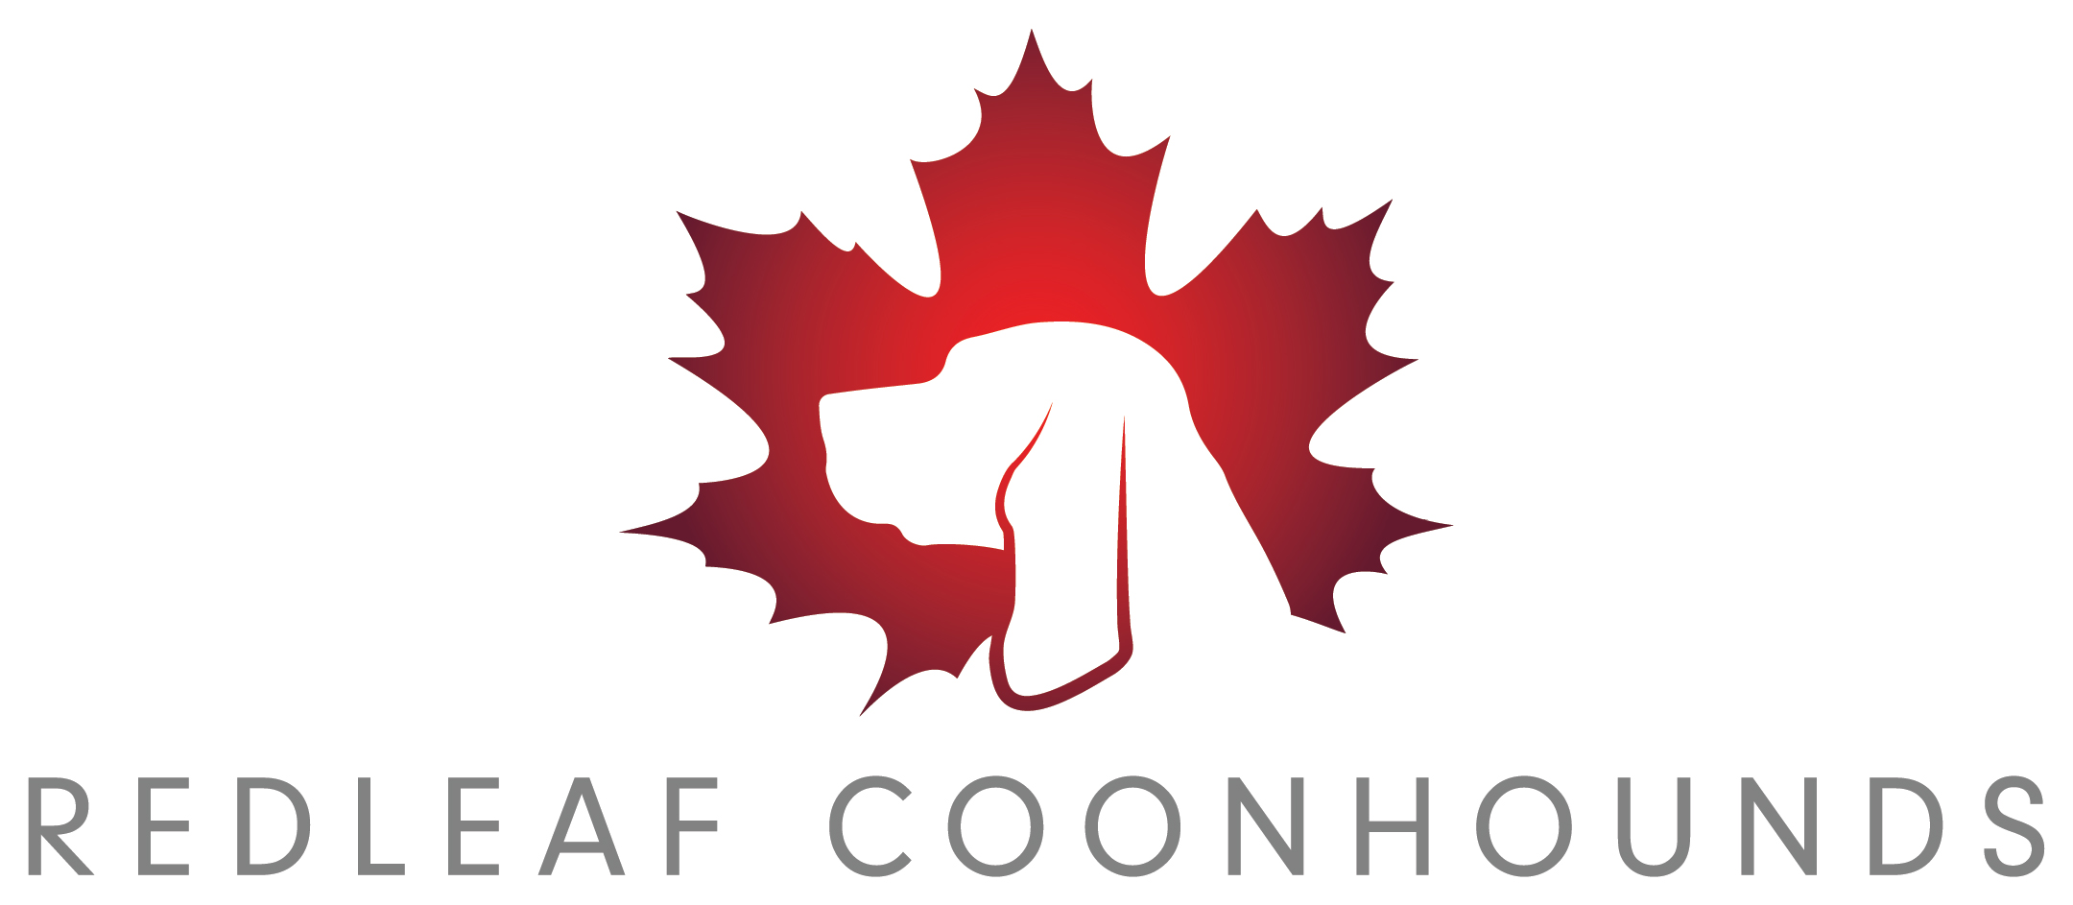

RedLeaf Coonhounds
contract for purchase agreement
for pet puppy

Christina Babey – RedLeaf Coonhounds
P.O. Box 7372
Bonnyville, Alberta T9N 2H7
(780)-207-5199
redleafcoonhounds.com
redleafcoonhounds@gmail.com

Buyer Information

Both Buyer and Seller voluntarily enter into and agree to all terms stated in this contract as witnessed by their signatures below. Whereas, Christina Babey, dba. RedLeaf Coonhounds hereinafter known as the Seller/Breeder conveys the sale of a Redbone Coonhound. Further Described as:
Registered Name: RedLeaf’s
Call Name:
Sex:
Microchip#:
Date of Birth:
AKC #:
UKC #:
Sire:
AKC # of sire: UKC # of sire:
Dam:
AKC # of dam: UKC # of dam:

Whereas ___________________, hereinafter known as the Buyers are desirous of purchasing the above described Redbone Coonhound.
Now, therefore, in consideration of the sum of $________________ dollars RedLeaf Coonhounds hereby conveys a Male/Female Redbone Coonhound.
Under the following Warranties and Conditions and No other warranties or Conditions either expressed or implied.
That the above Redbone Coonhound is a purebred dog, registered with the American Kennel Club &/or United Kennel Club. RedLeaf Coonhounds reserves the right to the initial registration of said Redbone Coonhound and will provide official registered name. AKC limited registration will be transferred at the time of sale of said Redbone Coonhound. The aforementioned Redbone Coonhound is being sold as PET ONLY and shall have spay/ovary sparing spay or neuter/vasectomy after the age of 1 (one) year.
Should the Buyer wish to keep the above Redbone Coonhound intact and if the above Redbone Coonhound meets proper breeding criteria, Seller may reverse the limited AKC registration to full registration at Buyer’s expense. The following proper breeding criteria must be met:
1. At least 24 months of age
2. OFA (or equivalent) certification of passing grade hips/elbows, cardiac and current passing eye exam
3. Full genetic health panel (Embark, Gensol diagnostics) - if the above Redbone Coonhound is a “carrier” for any genetic screening it must only be bred to a “clear”.
4. No obvious disqualifying fault according to AKC and/or UKC written breed standard.
5. Obtain a title of Championship or equivalent in a well-respected internationally-recognized kennel club (AKC, UKC, etc.)
In the event that Buyer wishes to breed this Redbone Coonhound Seller will remain as a co-owner and will be eligible for (1) one puppy back from a breeding of their choice. A puppy back is defined as a puppy chosen by the Seller between the ages of 6 (six) and 8 (eight) weeks of age. Seller must approve of the stud or bitch used in the breeding prior to the breeding taking place. Seller is responsible for transportation of said puppy. The Buyer must provide weekly updated photos of the entire litter and cannot place any puppy until the Seller has decided on the puppy back. Any puppy back will carry “RedLeaf” prefix in the registered name. All other puppies in the litter may carry the Buyer’s kennel name prefix.
The Buyer agrees that any and all transportation costs, to and/or from the Seller’s premises will be at the cost and sole responsibility of the Buyer.
The Buyer agrees to the following commitment. Buyer shall provide the above Redbone Coonhound with a fenced yard or outside kennel for daily exercise, appropriate medical care upon sickness, disease or injury, quality daily food, fresh water, shelter and affection. Buyer will continue the puppy series of vaccinations until the final vaccination at the age of over (16) sixteen weeks and will maintain appropriate inoculations for the life of the dog. Heart-worm where applicable and parasite control shall be maintained on a routine basis. Under no circumstances will the above Redbone Coonhound be kept chained or constantly outdoors.
The above Redbone Coonhound shall not be sold, transferred, or given away to any individual or to any retail or wholesale establishment for the public or to any research institution. Said Redbone Coonhound shall reside with the Buyer. If Buyer cannot keep this Redbone Coonhound they will notify Seller immediately.
Buyer agrees that at any time they are unable to continue the care of said Redbone Coonhound it shall be returned to Seller. Buyer must return said Redbone Coonhound with all AKC/UKC papers and medical records. Buyer shall assume full responsibility for the health and makeup of said Redbone Coonhound to include but not limited to; Vaccinations, parasite control, anatomical make-up, appearance, and emotional wellness. If the conditions of the aforementioned Redbone Coonhound are found to be in anyway faulted (in any of the categories of the previous sentence) RedLeaf Coonhounds is relieved of any obligation to return any portion of the purchase price. RedLeaf Coonhounds reserves the right to use (15) fifteen days to evaluate condition of said Redbone Coonhound once returned. If said Redbone Coonhound is said to be of sound mind and body, RedLeaf Coonhounds agrees to 25% of the purchase price to be refunded within 60 days of the return date.
If the aforementioned Redbone Coonhound attains a certification of a basic training class for socialization and relationship building before the age of 8 months, RedLeaf Coonhounds will provide $25.00 gift certificate to Buyer upon receipt of the certificate showing completion.
Seller guarantees this Redbone Coonhound to be in good health and sound mind at the time of this sale. A minimum of One (1) set of inoculations as well as parasite treatments have been provided to this Redbone Coonhound. The Seller will provide a health record of all vaccinations and worming treatments. Seller has administered an AKC ISO microchip with a pre-paid lifetime membership for identification of said Redbone Coonhound. Buyer agrees that Seller will remain as an alternate contact on the microchip information. Buyer has 5 days to take the aforementioned Redbone Coonhound to a licensed Veterinarian of their choice and at their expense for an initial checkup. If any health or congenital condition affecting the puppy is found during that visit buyer will be given opportunity to return the puppy at their expense, along with a signed Veterinarian certificate stating the health issue, for a full refund of the purchase price.
RedLeaf Kennels will guarantee genetic health of this Redbone Coonhound for the life of the dog. Buyer agrees to purchase the following health screenings to include but not limited to; OFA hip & elbow certification, CERF (eye testing) and OFA Heart screenings by the age of three (3) years. If the aforementioned Redbone Coonhound is said to have a genetic condition as listed above, a complete report from Orthopaedic Foundation for animals or a licensed veterinarian shall be mailed directly to Seller. RedLeaf Kennels agrees to refund 40% of the purchase price of said Redbone Coonhound within 6 months of said report. If the above mentioned screenings are not acquired and/or copy of certification is not provided to Seller before the third (3) birthday of said Redbone Coonhound, this portion of this agreement is Null and Void.
Seller agrees that if they should choose to break any of the portions of this agreements that the remainder of the agreement will be considered null and void. In the event said Redbone Coonhound is bred without written permission from Seller and without proper breeding criteria listed above being met Buyer shall forfeit said Redbone Coonhound back to Seller and pay a monetary fee of $2500.00 to Seller.
This contract is executed under the jurisdiction of the province of Alberta, which also has jurisdiction in the case of breach of contract by either party. Buyer agrees to pay all legal costs incurred by Seller necessitated by enforcement of the provisions of this contract.

This writing constitutes the agreement between RedLeaf Coonhounds “Seller/Breeder” and “Buyer” on ______ this day of _____________________ 2020.

I, ______________________________________________________________________________________________________________
(Buyer) hereby understand and agree to the terms and conditions in this contract.
This document was signed before me ________________________________________ a Notary of Public for the Province of
______________________ on the _______ day of ___________________ 2020.

Christina Babey, dba RedLeaf Coonhounds ____________________________ hereby agree to the above conditions and terms of this contract
This document was signed before me ________________________________________ a Notary of Public for the province of
________________________ on the ______ day of ___________________ 2020.

