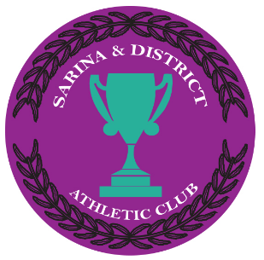Sarina & District Athletics club

# **CODE OF CONDUCT - ATHLETE**

1. Abide by club rules.
2. never argue with Marshall, official or coach.
3. Manage my own temper & not use bad language.
4. always compete to the best of my ability.
5. be a good sport, applaud & back my athletic team mates & Opponents.
6. TReat all club members & their families with respect & dignity.
7. my behaviour reflects my club no matter if i compete at home grounds or away.
8. Athletics is for me, my health, my fitness & my satisfaction, not to satisfy others.
9. Listen & follow Coaches & MArshalls instructions & respect the rules & social construct of all athletes in training & competition.

I, ______________________(PRint name) will abide by & uphold this code of conduct all season for the benefit of me & My club.

Signed:__________________________Date:_____/_____/2018.

# **CODE OF CONDUCT – parent, volunteer & coaches**

1. Abide by club rules.
2. never argue with Marshall, official or coach.
3. Manage my own temper & not use bad language.
4. Teach my Member to respect & value the club volunteers that keep the club going for members, to the best of my ability.
5. be a good sport, applaud athletic efforts of both club & away competitors.
6. TReat all club members & their families with respect & dignity.
7. Never touch athletes unless they have consented.
8. Athletics is for Everyone, for life, not to satisfy others.
9. Listen & follow Coaches & MArshalls instructions & respect the rules & social construct of all athletes in training & competition.
10. Ensure risk management & Safety management protocals are adhered to.
11. Coaches will ensure training & qualifications are current & maintained to legal requirements.
12. (Only for “Squirts” parents) I will stay & assist every week, where ever necessary to ensure my child is safe while learning new atheletic concepts.
13. Abide by official rulings & encourage children to do the same.

I, ______________________(PRint name) will abide by & uphold this code of conduct all season for the benefit of me & My club.

Signed:__________________________Date:_____/_____/2018.