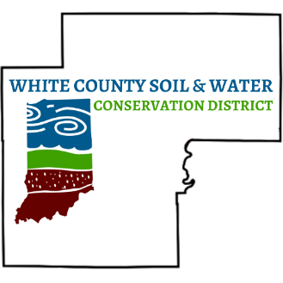 |  | ANNUAL MEETING MINUTES  March 10, 2026  Reynolds School Gym
Board Members  John Fielding  Chairman  Rich Hines  Vice Chairman  John Demerly  Supervisor  Steve Cosgray  Supervisor  Larry Kilmer  Supervisor  Bruce Reynolds  Associate Supervisor  Staff  Katie Snowberger  District Administrator |  | The White County Soil & Water Conservation District held their 2025 Annual Meeting on March 10, 2026 at Historic Reynolds Gym Reynolds, Indiana. There were 49 people in attendance.  The evening began at 6:00 PM with a welcoming address by John Fielding, recognizing all the partners and public officials in attendance. An invocation was provided by John Demerly. Soon after invocation dinner was served and John Fielding called the meeting to order.  John Fielding, Election Committee Chair, officiated the election of supervisors. John Demerly was elected to continue his duties as a supervisor on the board. Due to a mistyped ballet, Phil Huber was on the ballet and needed to be marked off. He was elected via State Soil Board. John Demerly was added to the ballet via the floor. Since the name was written on ballets, the committee handed them out and majority was in favor, Mr. Demerly was duly sworn in by Penny Titus, Congressman Baird’s Field Rep.  After the election, the minutes from the Annual Meeting on March 11, 2025 and the 2025 Financial Report were read. Chairman Fielding asked for a motion to approve which was given by John Demerly, and Rich Hines seconded. John Fielding presented to Larry Kilmer a plaque for his year of service as a Supervisor for the White County SWCD Board. He served from 2002-2026.  Following dinner, John Demerly recognized the Outdoor Education Grant recipients. Presentation from Angie Alexander from Meadowlawn Elementary School was given about their butterfly projects. Our second grant recipient was Monticello Parks Dept, for Cindy Isom. Her project was for the education garden showing kids how to care for a vegetable garden.  Our speaker for the evening was Grant Crumbaugh, with Pine Creek Camp. He gave an engaging talk about the timeline of Native American History/artifacts and culture. He was able to present recreated artifacts to show how they would have used them and how they fit into current day items we use.

Farm Service Agency partners, Allison Clark and Derek Carty from Natural Resource Conservation Service introduced themselves to the group, they both gave updates on current programs they have to offer to the group.

Tri-County FFA Soils Judging Team was present at the meeting, and the new members were presented with personalized clipboards and soil knives to congratulate them on making their way to the National Contest this year. Mitch Billue and the Monticello Parks Dept were recognized for his conservation efforts and stewardship as White County Friend of Conservation.

John Fielding gave his closing talk to the group and let them know to take a cup for the 75th year before they leave. The meeting was adjourned at 8:15 PM with a motion made by John Demerly.

