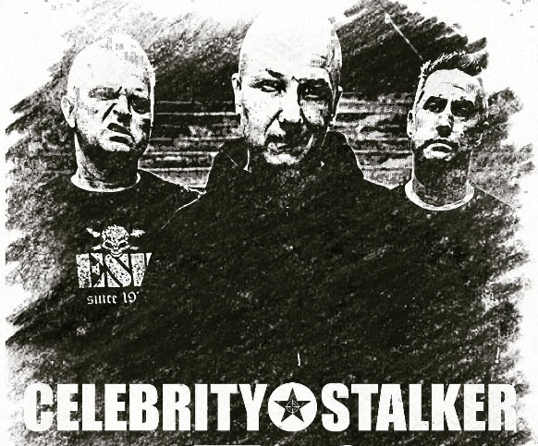
Celebrity Stalker is:
Jason Young – Bass, Lead Vocals
Larry Prosser – Lead Guitar, Lead/Backup Vocals
Chuck Moffett – Drums, Backup Vocals

Celebrity Stalker is the epitome of power-trio punk/metal crossover hellbent on moving souls and emotions with blistering vocals and guitars, and hard-hitting bass and drums. Celebrity Stalker started off 2020 with a bang by releasing their first studio album, Year of the Thief, launching with the video Thrill Seekers, followed shortly by American Dreams. Other notable songs on the album include Repressed, I Am, and Crime Styles of the Rich.
The trio hails from Southern California, and is strongly influenced by the likes of Suicidal Tendencies, Slayer, Pennywise, System of a Down and Iron Maiden. While it would seem that the name comes from an obsession with celebrities, the truth is actually quite to the contrary. Instead, the name Celebrity Stalker is an indictment of the media machine that make celebrities out of stalkers and criminals, and a society addicted to celebrity gossip and true crime stories.
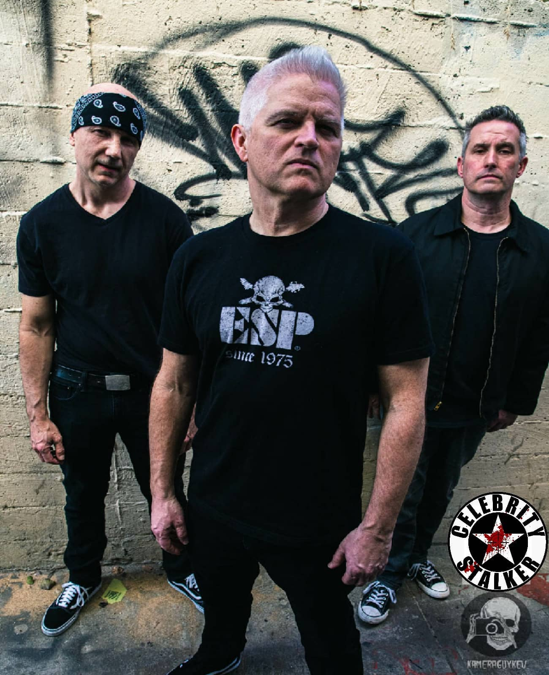
Links and Social Media:

