ND Country Fest 2020 Press Release June 22, 2020

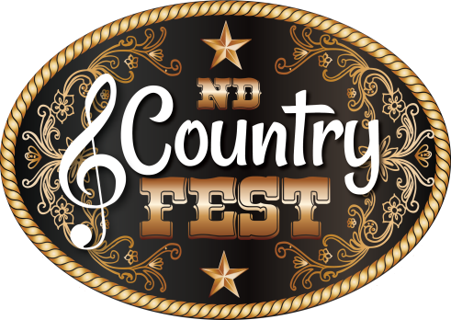

FOR IMMEDIATE RELEASE

ND Country Fest to Make History in 2020...

New Salem, ND - In historic fashion, the Dakota's largest and the Nation's fastest-growing Country Music and Camping Festival, ND Country Fest, is on schedule to bring us all safely back together again this summer, and continues to enhance the overall Festival experience. July 9-11 is going to be historic for ND Country Fest, the Dakotas, and the Nation. It will be ND Country Fest's largest show in their history; it will be the very first Festival ever to also bring you an onsite Casino (brought to you by NDSU Team Makers); and it will be among the first Country Music and Camping Festival to happen responsibly and safely in the Nation following the COVID 19 Stay at Home Orders and re-opening.

Already offering the best in Country Music, great camping making ND Country Fest a vacation destination year after year, and ALL the fun under the sun you would want to have...ND Country Fest offers so much more. In 2020 ND Country Fest is adding a Main Street Market Place for your added fun, shopping, food and beverage, a Casino, and many other displays and services. Plus, to make it even more fun with all these wonderful opportunities, ND Country Fest has extended their Concert Bowl hours to open at 10:00 am daily.

ND Country Fest is also a huge community partner giving back in so many ways. From volunteers working for their organizations, to working with other local/regional Non-Profits to help in their fund raising efforts, to offering Thursday's Festival Show FREE of charge and raising money for the local 4H and FFA groups, to co-sponsoring a huge Raffle along with Action Motor Sports of Mandan raising funds for six area Rural Fire Departments. To date in just a few short years, ND Country Fest has given back in excess of $100,000 to the region.

“We keep saying, the Patron's overall experience is of the most importance to us, and we are doing everything we can to put action to those words. We listen, then work hard to make things happen," said Luke Shafer, NDCF Founder. "We will work extremely hard to make your ND Country Fest experience the absolute safest, most exciting and very best experience possible. ND Country Fest 2020 will be an experience of a lifetime."

ND COUNTRY FEST 2020 FULL LINE-UP

DUSTIN LYNCH * CHRIS JANSON * LITTLE TEXAS
JOHN MICHAEL MONTGOMERY * LEE ROY PARNELL
DIAMOND RIO * BLIND JOE * BREAKING EIGHT
ERIC CHESSER * LAKE & LYNDALE * WILL DAKOTA
BRIANNA HELBLING AND THE OUTSIDERS * BRAXTON KEITH
DIAMONDS AND WHISKEY * KIMBERLY ATWOOD

ND Country Fest is located just west of Bismarck/Mandan in New Salem, North Dakota, at the Morton County Fairgrounds – in the shadow of Salem Sue, the world's largest Holstein. ND Country Fest 2020 is July 9-11. Tickets and Camping are on sale now at ndcountryfest.com

For the latest ND Country Fest news and announcements, tune into your favorite local Country Music Station, or check out ndcountryfest.com. Follow us on Facebook, Twitter, Snapchat, Spotify, YouTube and Instagram, and be sure to sign up for regularly published newsletters to be the first to receive the latest news and info from ND Country Fest.

ND Country Fest 2020 Tickets and Camping are on sale now at ndcountryfest.com for the season's best prices. Some items are extremely limited in quantity.

Next Price Changes are: Wednesday, June 24 at Noon (CST)
Wednesday, July 1 at Noon (CST)...Tickets go to Gate Prices

Cheat Tweets:

@dustinlynch @janson_chris @LittleTexasBand @DiamondRioBand @JM2Squared @LRPOfficial @theblindjoe @lakeand_lyndale @briannahelbling @breaking_eight @EricChesser1 @diamondswhiskey @thebraxtonkeith @kmbrlyatwood

#ndgoodtime #NDCF2020 #HOMEGROWN #NDSmart @ndcountryfest

Tickets for @ndcountryfest on sale now at ndcountryfest.com #ndgoodtime

For Approved photos: NDCF Press Material

John Gourley
Marketing and Promotions Director
ND Country Fest, LLC.
john@ndcountryfest.com
816.752.2800

