ND Country Fest 2021 Press Release July 9, 2020

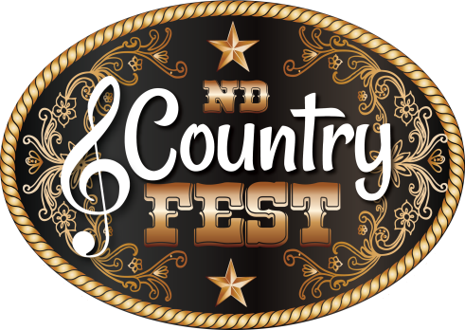

FOR IMMEDIATE RELEASE

ND Country Fest Re-Confirms Headliners for 2021

ND Country Fest Excitingly Announces Re-Confirmed for 2021

DUSTIN LYNCH, LITTLE TEXAS, DIAMOND RIO,
JOHN MICHAEL MONTGOMERY and LEE ROY PARENELL

New Salem, ND - The Dakota's largest and the Nation's fastest growing Country Music and Camping Festival, ND Country Fest announces their Headliners re-confirmed for 2021. Get ready now for the event of the summer with DUSTIN LYNCH, LITTLE TEXAS, DIAMOND RIO, JOHN MICHAEL MONTGOMERY and LEE ROY PARENELL all taking the Main Stage at ND Country Fest 2021.

In historic fashion, ND Country Fest is back on schedule to bring us all safely back together next summer, and continues to build and enhance the overall Festival experience. July 8-10, 2021 is going to be historic for ND Country Fest, the Dakotas, and the Nation. It will be ND Country Fest's largest show in their history, it will be the very first Festival ever to also bring you an onsite Casino (brought to you by NDSU Team Makers), and there will be many additional NEW attractions to enhance all Patron's experiences at the Nation's newest premier Country Music and Camping Festival.

Already offering the best in Country Music, great camping making ND Country Fest a vacation destination year after year, and ALL the fun under the sun you would want to have...ND Country Fest offers so much more. In 2021 ND Country Fest is adding a Main Street Market Place for your added fun, shopping, food and beverage, a Casino, and many other displays and services. Plus, to make it even more fun with all these wonderful opportunities, ND Country Fest has extended their Concert Bowl hours to open at 10:00 am daily.

ND Country Fest is also a huge community partner giving back in so many ways. From volunteers working for their organizations, to working with other local/regional Non-Profits to help in their fund raising efforts, to offering Thursday's Festival Show FREE of charge and raising money for the local 4H and FFA groups, to co-sponsoring a huge Raffle along with Action Motor Sports of Mandan raising funds for six area Rural Fire Departments, and more. To date in just a few short years, ND Country Fest has given back in excess of $130,000 to the region.

“The Patron's overall experience is of the most importance to us, and we are doing everything we can to put action to those words. We listen, then work hard to make things happen," said Luke Shafer, NDCF Founder. "We will work extremely hard to make your ND Country Fest 2021 experience the absolute safest, most exciting, and very best experience of a lifetime."

ND Country Fest, LLC | PO Box 456 Bismarck, ND 58502 | ndcountryfest.com
ND COUNTRY FEST 2021 RE-CONFIRMED HEADLINERS

DUSTIN LYNCH * LITTLE TEXAS * DIAMOND RIO
JOHN MICHAEL MONTGOMERY * LEE ROY PARNELL

ND Country Fest is located just west of Bismarck/Mandan in New Salem, North Dakota, at the Morton County Fairgrounds – in the shadow of Salem Sue, the world's largest Holstein. ND Country Fest 2021 is July 8-10, 2021.

For the latest ND Country Fest news and announcements, tune into your favorite local Country Music Station, or check out ndcountryfest.com. Follow us on Facebook, Twitter, Snapchat, Spotify, YouTube and Instagram, and be sure to sign up for regularly published newsletters to be the first to receive the latest news and info from ND Country Fest.

ND Country Fest 2021 Tickets and Camping will be on sale soon. Stay in touch at ndcountryfest.com to be the first to purchase your Tickets and Camping once ND Country Fest 2021 is on sale, and for the season's best prices. Some items will be extremely limited in quantity.

Cheat Tweets:

@dustinlynch @LittleTexasBand @DiamondRioBand @JM2Squared @LRPOfficial

#ndgoodtime #NDCF2021 #HOMEGROWN #NDSmart @ndcountryfest

John Gourley
Marketing and Promotions Director
ND Country Fest, LLC.
john@ndcountryfest.com
816.752.2800

