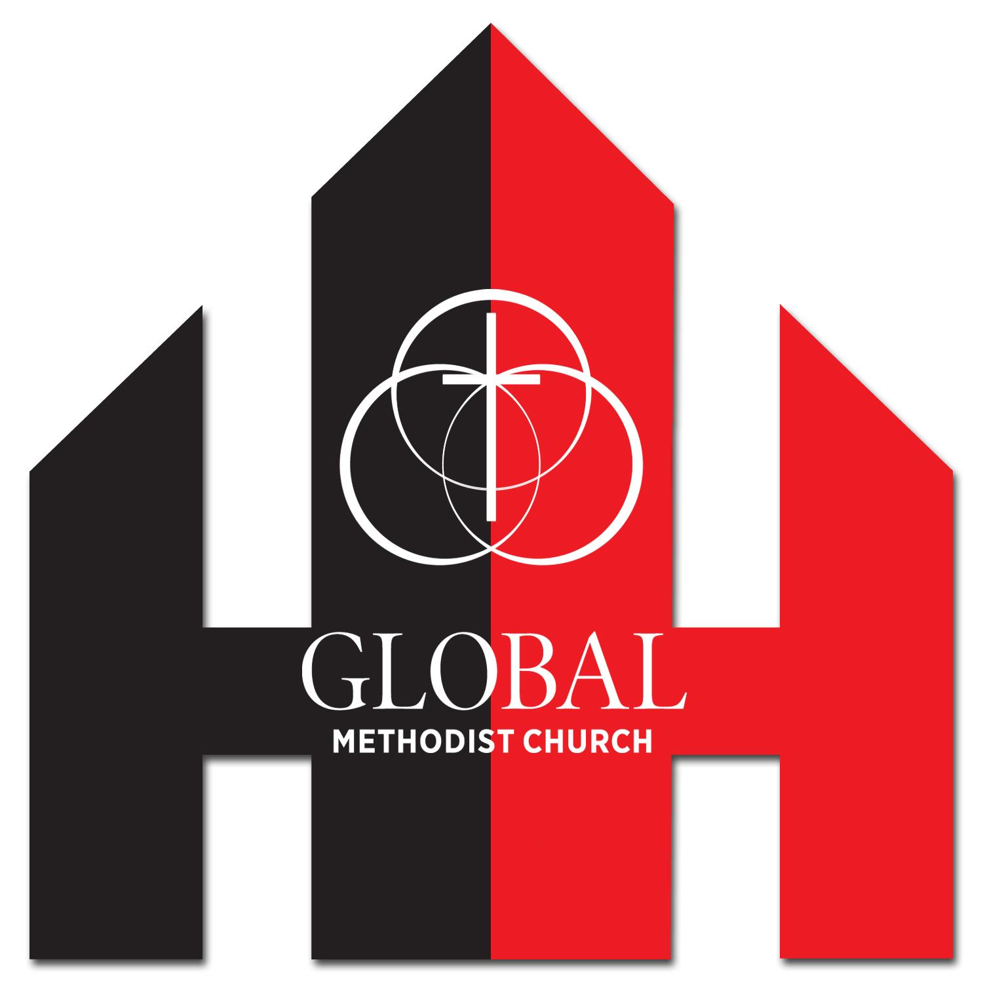

9/2/2025

Dear Parents and Guardians,

Students have an opportunity to serve alongside a few hundred other youth in Texas during the Winter Mission Weekend, February 13-15, 2026. This weekend is coordinated through the Revive Movement that ran it last year as well as our summer camp. We will leave Friday afternoon to make it to Dallas, Texas by 6pm and return Sunday afternoon by 3:30/4:00 pm.

The total cost for the Winter Mission Weekend is $175/participant. The church is committed to ⅓ of the cost ($59/participant) and the remaining 2/3 ($116) can be split between fundraising and parent contribution. If parents are unable to cover the last 1/3 of the cost they can fill out a scholarship application online on our website [hhmc.church/students](http://hhmc.church/students). We do not want the cost to be a deterrent for anyone.

We will have two fundraising opportunities this Fall. This September will be our second annual “You’ve Been Flocked” fundraiser. More information about this fundraiser can be found on the website. The second fundraiser will be a Chili Lunch and Silent Auction after church on November 2nd. More details to come as we get closer.

Attached you will find a registration card to reserve your student’s spot. We currently have 15 spots reserved for our church. Please register by Dec 31st as the cost does increase by $25/participant starting January 1st. Once I receive the registration card I will email a link for you to register through the revive website. I have also included a sample schedule and packing list. Please feel free to contact me with any questions or concerns.

I believe this weekend will be a meaningful time for our students and I hope you will encourage them to attend. It will be a weekend full of worship, community, growth, and service to the Lord.

In Christ,

[Megan Longley](mailto:students@hhmc.church)

Student Ministry Director

Harker Heights Methodist Church

students@hhmc.church

602-290-0031