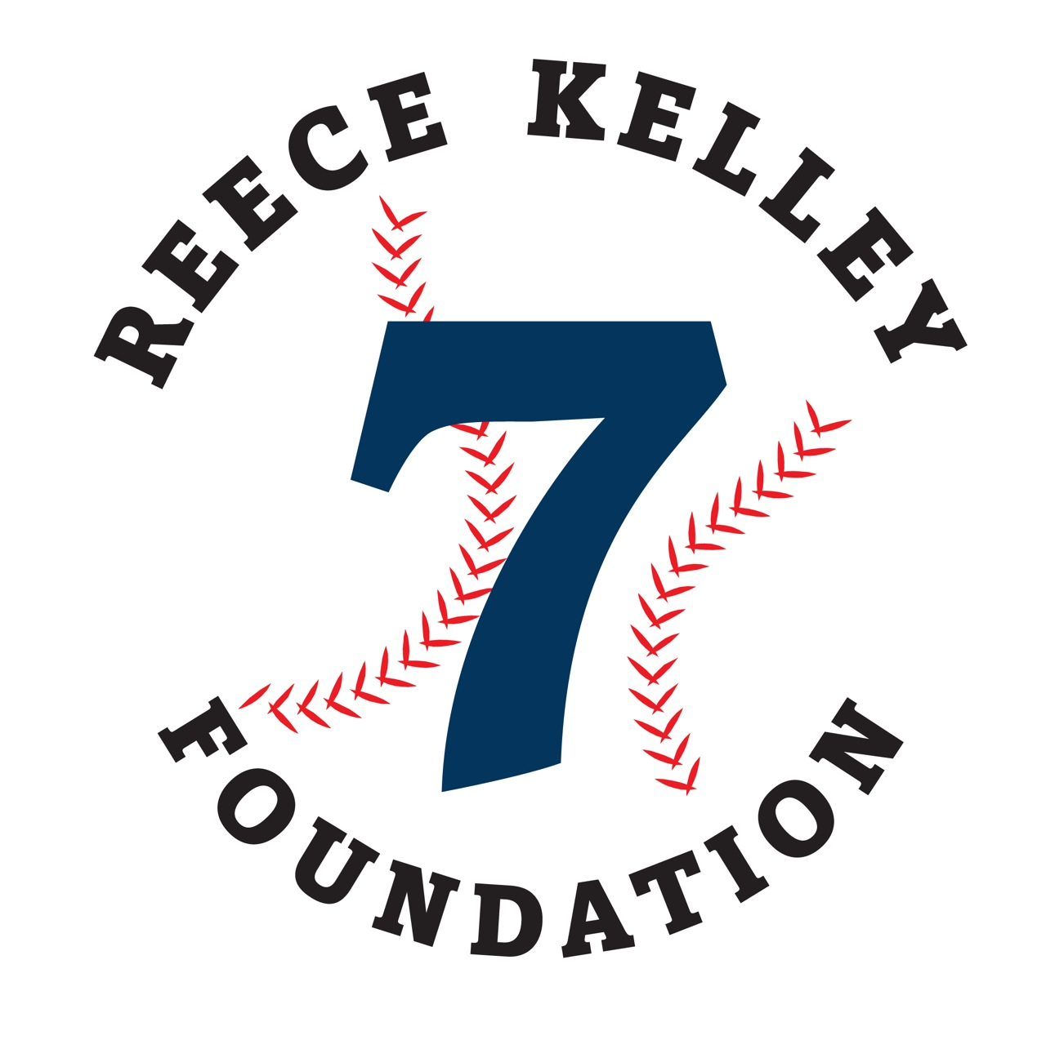

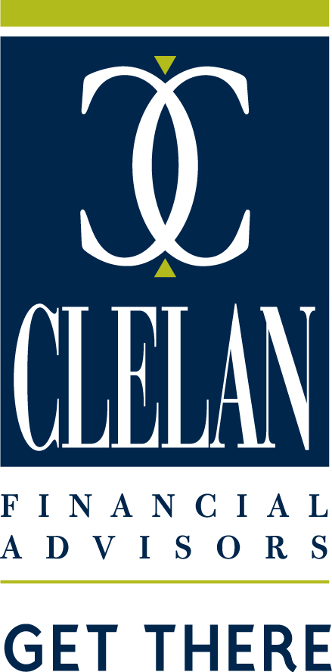
Contact Person: _____________________
Company: __________________________
Address: ___________________________
City: _______________________________
State: _______Zip Code: ____________
Phone: _____________________________
Email: _____________________________
Names of Golfers:
1. _________________________________
2. _________________________________
3. _________________________________
4. _________________________________

☐ $500 for FOUR GOLFERS
☐ $125 SINGLE (HOLE SPONSOR)
☐ Other Sponsorship
☐ MONETARY DONATION
TOTAL AMT ENCLOSED: __________

To the recipients of the 2025 Reece Kelley Foundation Scholarship Awards:

Noah Heath &
Virginia Huntzinger
Congratulations!

Please send form and check to:

Reece Kelley Foundation

6 Oaktree Road,

Hummelstown, PA 17036

Email: info@reecekelleyfoundation.org
Grand Slam Sponsors:

WWW.CESCLEAN.COM
MAKE A DIFFERENCE
13th Annual
Memorial Golf Tournament

Monday October 13, 2025
Registration • 10:30AM
Shot Gun Start • 11:30AM

Join us at...

1242 Harrisburg Pike

Carlisle, PA 17013

Carlisle
Country Club

ReeceKelleyFoundation.org
Registration Form

Grand Slam Sponsor: $2500 Home Run Sponsor: $2000

COST: $500 per FOURSOME
Registration • 10:30 AM
Shotgun Start • 11:30 AM
GOLF FEE INCLUDES:
Driving Range prior to event
Light Lunch during Registration
Green Fees and Cart
Gift Bag
Buffet Style Dinner immediately following golf
CONTESTS INCLUDE:
Longest Drive (male and female)
Closest to the Pin
Four (4) Hole-in-One Prizes
DINNER AND EVENTS:
Cash Bar at Dinner
Amazing Raffle Items

Reece Kelley was a happy, fun-loving boy who passed away after a tragic accident in the summer of 2008, four days before he was to start fourth grade. Reece had a big heart, a bright smile, and a sense of integrity. In his nine short years he made a difference to all who knew him. In his honor and memory, a Foundation bearing his name has been created. The primary goal of this Foundation is to raise money to provide college scholarships to students who are Making a Difference in their communities. We hope you will get involved in making this event a success!
TOURNAMENT INFORMATION
Includes a (2) player “Greens and Cart Pass” for future use at the Club, name displayed on signage at dinner, Hole Sign.
Includes four golfers, logo displayed in all golf carts.

Includes four golfers, logo displayed on gift provided to all golfers.

Includes four golfers, 1 drink ticket per golfer, reserved table at dinner, logo displayed on signage at dinner, Hole Signs on the putting green and driving range.

SPONSORSHIP OPPORTUNITIES
Triple Sponsor: $1200 Double Sponsor: $500
Includes four golfers, logo displayed on signage at dinner, Hole Sign.
Gift Sponsor: $1500 Golf Cart Sponsor: $1500

All sponsorship levels include advertisement on the website and in the golf brochure. For more information, call Mel at 717-979-8646.

Includes four golfers, a (4) player “Greens and Cart Pass” for future use at the Club, VIP check in, 2 drink tickets per golfer, reserved table at dinner, logo displayed on main tournament banner, Hole Sign on green and driving range.

