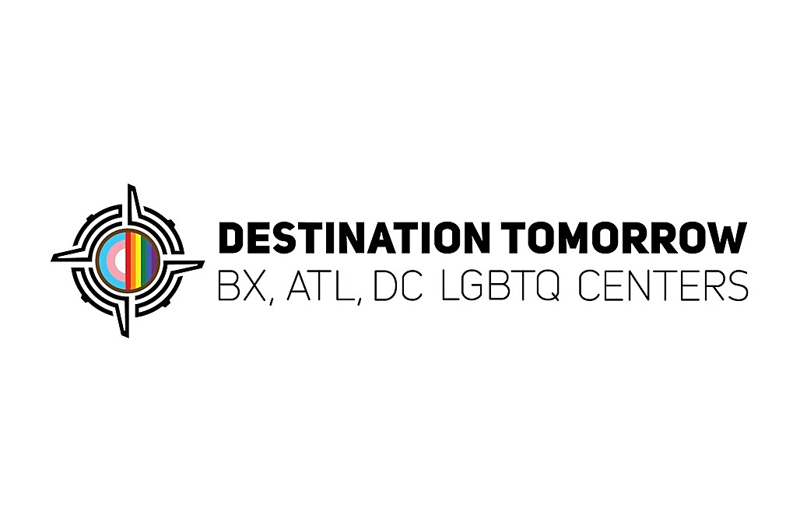

Job Title: Grants and Contracts Manager
Location: Bronx, NY
Reports to: Chief Strategy Officer, Development and Government Affairs (CSO)
Salary: 60,000
Position Summary
The Grants & Contracts Manager oversees the full lifecycle of Destination Tomorrow’s grants and contracts portfolio, encompassing both “Giving”—funding awarded by the organization, and “Receiving”—funding received by the organization.
This role builds and maintains the systems, processes, and governance required to track, execute, and report on all grants in full compliance with funder and organizational requirements. Working across programs, Development and leadership, this role ensures that funded activities are implemented effectively and delivered on time, identifying risks and capturing data to demonstrate impact and inform agency strategy.
Core objectives:
• Enable program leaders and grantees to successfully implement funded work
• Ensure compliance, accountability, and audit readiness

Core Responsibilities
Enterprise Grants & Contracts Systems
- Design and implement a centralized grants and contracts management system (e.g., Asana or equivalent) to track active and pending funding and establish standardized processes, templates, and workflows for grant tracking, reporting, and closeout.
- Maintain a comprehensive database of all grants and contracts, including key terms, deliverables, reporting deadlines, funding amounts, and compliance requirements.
- Ensure cross-agency adoption of the new system; manage user access and provide training.
- Serve as the central coordination point for all grant and contract activity across programs.

Incoming Grants & Contracts (“Receiving”)
- Track and manage all awarded grants and contracts to Destination Tomorrow, ensuring full visibility into timelines, deliverables, reporting, and compliance requirements.
- Monitor and enforce program leader’s adherence to grant deliverables and contract terms.
- Consolidate qualitative and quantitative data from program leaders for funder reporting and to inform the Development strategy.
- Support proposal development, draft, review, and manage agreements, including MOUs, subawards, and consultant contracts, in coordination with leadership and external partners.
- Oversee grant closeout processes, ensuring all requirements are fulfilled and documented.

Outgoing Grants / Grantee Program (“Giving”)
- Design and operationalize Destination Tomorrow’s grants program, including a fair and transparent application, review, and selection process aligned with agency impact goals.
- Manage communication with applicants and grantees, including award notifications, agreements, and ongoing engagement.
- Track disbursements and enforce grantee compliance with reporting requirements and funding terms.
- Capture and synthesize outcomes and impact data to inform future funding decisions and represent Destination Tomorrow by sharing these insights in statewide forums.
Governance, Compliance, Enforcement & Reporting
- Monitor portfolio-wide compliance, identifying and escalating risks, delays, and gaps in execution or operations, maintaining audit-ready documentation.
- Enforce adherence to grant and contract requirements across internal teams and external grantees.
- Consolidate real-time qualitative and quantitative data across all grants to assess implementation progress and impact, providing regular leadership visibility.

Qualifications
- 5–7+ years of experience in grants management, contracts administration, or program operations within a nonprofit, government, or community-based organization.
- Work with specialized populations such as the LGBTQIA+ community.
- Experience managing complex grant portfolios, including compliance, reporting, and contract oversight.
- Proven ability to manage multiple priorities simultaneously maintaining strong attention to detail and meeting deadlines.
- Experience drafting and managing programmatic contracts, MOUs, subawards, and compliance documentation.
- Strong systems-thinking skills, with experience building or managing tracking systems, workflows, or databases.
- Demonstrated ability to coordinate across teams and enforce accountability, identify and mitigate risks in a cross-functional environment.
- Strong writing, communication, and organizational skills, and attention to detail, particularly for reporting and documentation.
- Proficiency with project management and/or CRM tools (e.g., Asana, Salesforce, or similar).
- Commitment to the mission, vision, and values of Destination Tomorrow, including equity, inclusion, and community empowerment.
Key Competencies
• Systems Design & Process Implementation
• Compliance & Accountability Enforcement
• Cross-Functional Coordination & Influence
• Data Management & Reporting
• Risk Identification & Escalation
• Attention to Detail & Follow-Through
• Clear, Direct Communication

