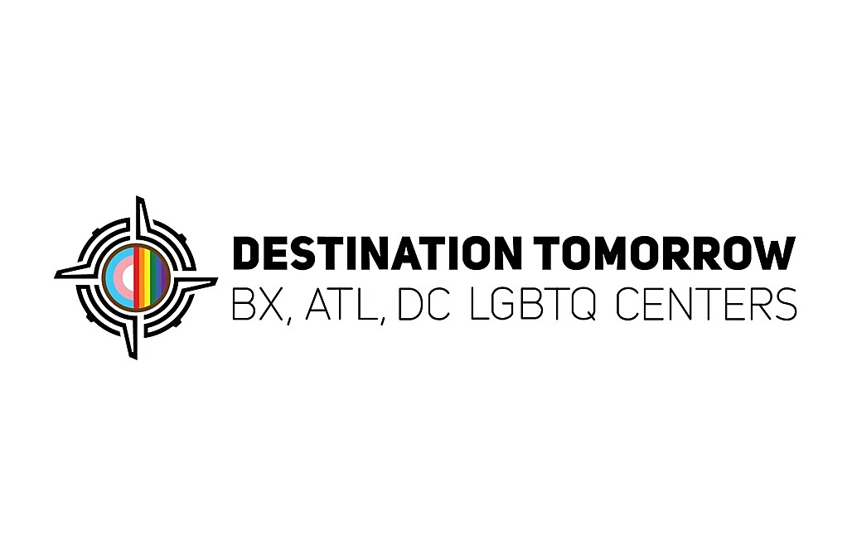

Residential Aides

Locations: LIC/Queens, Chinatown, Washington Heights

Must have a Food Handler’s Permit.
LGBTQ+ and diversity friendly a must!

Key Responsibilities
- Assist with on-site services delivery providing support duties, such as client outreach,
- and communications.
- Provide client-interfacing during evening and night shifts when main staff are away.
- Assist with food services implementation.
- Assist with preparation of area for recreational activities and other training or activities.
- Help gather client data collection for services involved.
- Participate in training relating to program improvement.
- When possible and capable, offer peer assistance.
- Participate in individual and group support.
- Participate in agency and program Q/A process.
- Monitor the area and provide resources for clients.
- Maintain a welcoming, safe, stable environment for clients.
- Make hourly rounds within and outside the facility to ensure safety and security.
- Incident management: Report and document incidents, crisis interventions, communicate with on-call management team.
- Record keeping including documentation of daily attendance, shift report, visitors, writing progress notes.
- Perform other related duties as assigned.

Minimum Qualifications:
HSE with at least 2 years of relevant experience. Proficiency with Microsoft Office Suite
High School Diploma or General Education Degree (GED), associate degree preferred. CPR and First Aid certifications a plus. Experience working with People with health, homelessness, poverty, and cultural/language issues

