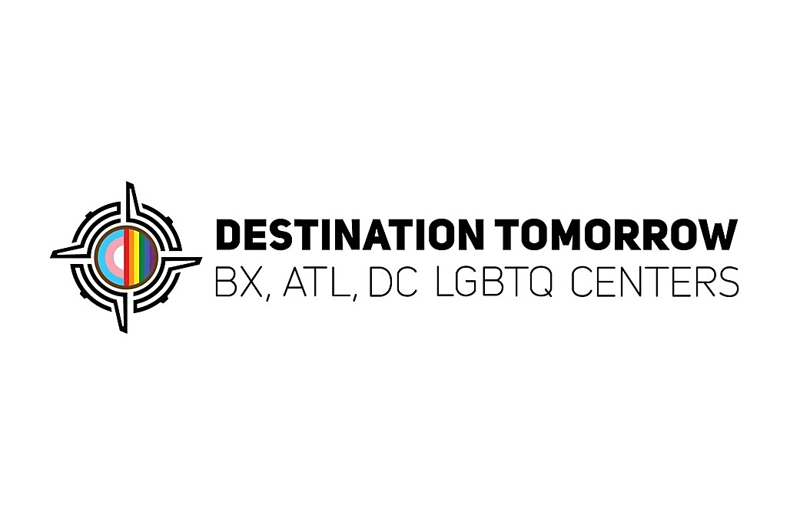

HR Generalist

Reports To | Head of Human Resources
Location | Bronx, NY
Status | Full-Time
Salary | $66,300 - $75,000
Level | Junior / Early-Career HR Professional

Position Summary
The HR Generalist is the operational engine of the DT HR function — the person who ensures all administrative work supporting DT's people is completed on time and that nothing falls through the cracks. Payroll, recruiting and hiring coordination, onboarding paperwork, HRIS maintenance, benefits tracking and administration — this role owns the details.

Reporting to the Head of Human Resources, the HR Generalist is a junior role well-suited for someone early in their HR career who is highly organized, proactive, and excited to grow in a mission-driven, fast-moving, growing nonprofit. You won't be expected to handle complex employee relations matters independently — but you will provide critical support to a team that does, and you'll learn a great deal in the process.

Core Responsibilities
1. HR Administration & Recordkeeping
- Maintain accurate, confidential employee records and HR documentation across the full employee lifecycle.
- Manage and update the HRIS system; ensure personnel files are complete, current, and compliant with confidentiality standards.
- Process and track employment changes — new hires, terminations, title changes, pay adjustments, leave statuses.
- Respond to routine employee inquiries (benefits, policies, HR processes) and escalate substantive questions to the Head of HR.
- Generate routine HR reports and workforce analytics to support organizational decision-making.
- Conduct periodic personnel file and HRIS audits to ensure compliance and data integrity.
- Administer and track employee leaves, including FMLA, Paid Family Leave, ADA accommodations, Workers' Compensation, and other applicable leave programs.
- Coordinate Workers' Compensation claims and return-to-work processes.
- Maintain accurate leave documentation and ensure compliance with federal, state, and local regulations.

2. Payroll Management
- Process bi-weekly (or semi-monthly) payroll in coordination with finance; ensure accuracy of hours, deductions, and employee data.
- Track and enter leave, overtime, and time-off records; flag discrepancies for resolution before payroll runs.
- Serve as the first point of contact for payroll-related employee questions; escalate complex issues appropriately.

3. Recruitment and Hiring Coordination
- Support DT's recruitment efforts by posting open positions, managing applicant tracking, and coordinating interview logistics with hiring managers.
- Communicate with candidates throughout the hiring process — scheduling, status updates, and offer logistics.
- Conduct reference checks and background checks for all candidates in the hiring pipeline.
- Maintain recruiting records and support the Head of HR in tracking time-to-hire and pipeline metrics.
- Contribute to ongoing improvements to DT's recruitment strategy, hiring process, and candidate experience, in support of the Head of HR's direction.

4. Onboarding & Offboarding
- Own the administrative onboarding experience for new hires: collect documentation, set up HRIS profiles, coordinate equipment requests, and ensure all required paperwork is completed.
- Prepare and distribute offer letters, new hire packets, and required compliance documents.
- Coordinate the administrative offboarding process — final paperwork, system access deactivation, benefits termination — in partnership with the relevant managers.

5. Benefits Administration & Compliance Tracking
- Own benefits enrollment, changes, and employee questions; liaise with DT's benefits broker or administrator as needed.
- Track mandatory training completions, credential renewals, and compliance certifications — flagging gaps to the Head of HR and Compliance Director.
- Assist in ensuring DT's HR practices are compliant with federal, state, and local employment law; flag potential issues to HR leadership.

6. HR Team Support
- Provide general administrative support to the Head of HR through scheduling, notetaking, document preparation, and project coordination.
- Help prepare materials for staff communications, trainings, and HR initiatives.
- Maintain organized shared HR files, templates, and process documentation.
- Assist with employee engagement and recognition initiatives.

Qualifications
Required
- 2–4 years of HR, administrative, or people operations experience — nonprofit, social services, shelter, healthcare, or community-based settings preferred.
- Experience with payroll processing and HRIS systems including OnPay.
- Familiarity with background check and reference check processes.
- High level of organizational discipline: you track details, hit deadlines, and flag problems early.
- Excellent discretion and ability to handle confidential information professionally.
- Strong written communication skills; clear and professional in all correspondence.
- Proficiency with Microsoft Office; comfort learning new systems quickly.
- Genuine passion for the mission — you care about the communities DT serves.

Preferred
- Bachelor's degree in HR, Business Administration, or related field.
- PHR or SHRM-CP credential, or active pursuit of one.
- Experience with nonprofit compliance requirements or grant-funded workforce environments.

