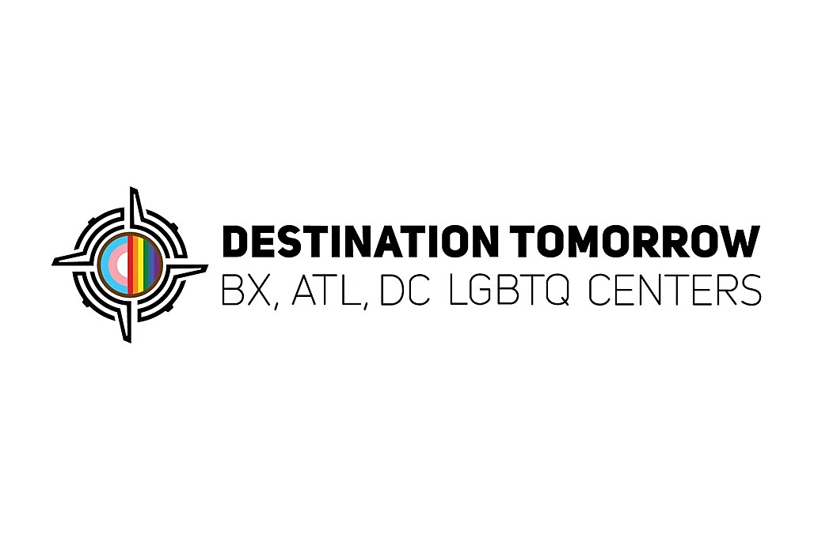

Security Guard / Client Care Monitor (Shelter Program)
Salary: $40,000
Location: New York City, NY
Employment Type: Full-Time

About Destination Tomorrow

Destination Tomorrow (DT) is a national grassroots LGBTQ+ organization founded in the Bronx, built on the principle that no individual should have to leave their neighborhood for necessary services. DT's mission is to move clients off the path of emergency care to one where they can grow, learn, and flourish by emphasizing economic, social, and mental empowerment through comprehensive educational, financial, and health programs, as well as housing solutions. As an expanding multi-site organization, Destination Tomorrow proudly serves the community across The Bronx, New York City; Atlanta, GA; and Washington, D.C.

Position Summary
Destination Tomorrow is hiring Security Guard / Client Care Monitors to support the safety, structure, and daily operations of our LGBTQIA+ residential housing program serving transgender, gender non-conforming, and non-binary adults.
This is a hands-on security + resident support role in a congregate shelter setting. Staff are actively engaged throughout the shift—monitoring the facility, conducting rounds, responding to incidents, and ensuring safety at all times.

What You’ll Do (Daily Responsibilities)
- Control access to the building (sign-ins, exits/entries, visitor screening)
- Conduct frequent foot patrols of all facility areas throughout your shift
- Monitor resident activity and maintain a safe, orderly environment
- Respond to incidents, conflicts, emergencies, and safety concerns in real time
- Document all incidents, shift activity, and observations clearly and accurately
- Enforce facility policies consistently and professionally
- Support fire drills, safety checks, and emergency preparedness procedures
- Communicate concerns promptly with supervisors and program leadership
- Interact with residents in a respectful, trauma-informed, professional manner

What This Job Is Like
This is not a passive security post. You will be moving throughout the facility, engaging with residents, and actively responding to situations as they arise.

The environment is fast-paced and may involve working with individuals experiencing homelessness, trauma, mental health challenges, or crisis situations. Strong boundaries, professionalism, and calm decision-making are essential.

Requirements
- NYS Security Guard Registration Card required (you will be asked to show this)
- F02 Certification required (you will be asked to show this)
- CPR/First Aid Certification preferred
- High School Diploma or equivalent preferred
- Strong communication and report-writing skills
- Ability to stand, walk, climb stairs, and remain active for long periods
- Experience working in shelters, residential programs, security, or social services preferred
- Ability to work respectfully with LGBTQIA+ communities

