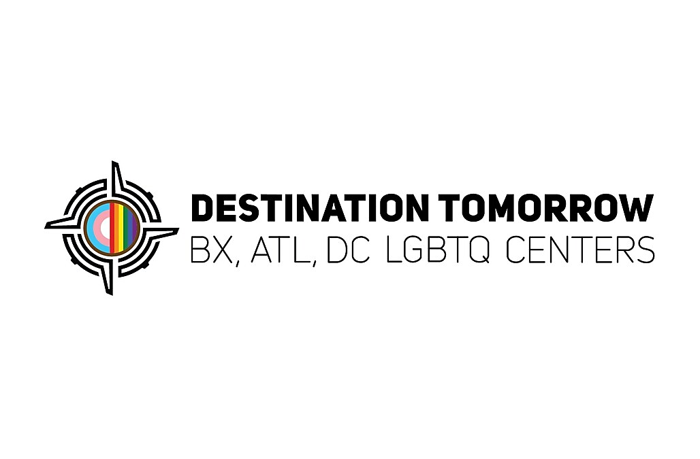

Bookkeeper

Destination Tomorrow is looking for a bookkeeper. Must be LGBTQ+ friendly! Non-profit and housing voucher experience is a plus! QuickBooks is mandatory.

Job Duties:
- Manage data entry for both Account Payable and Receivables
- Manage and organize both physical paperwork and email.
- Payroll duties as assigned.
- Assist with budget preparation.
- Communicate with vendors and clients as needed.
- Maintain, implement, and adhere to internal controls while ensuring that accounting procedures comply with GAAP
- Assist with yearly audit.

Requirements:
- Minimum 3+ years of related experience in bookkeeping
- Must have experience using QuickBooks
- Strong working knowledge of Excel, Word,
- Background in accounting principles and regulations
- Strong attention to detail and ability to multitask.
- Excellent written and verbal communication skills.
- Ability to work independently and meet deadlines.

