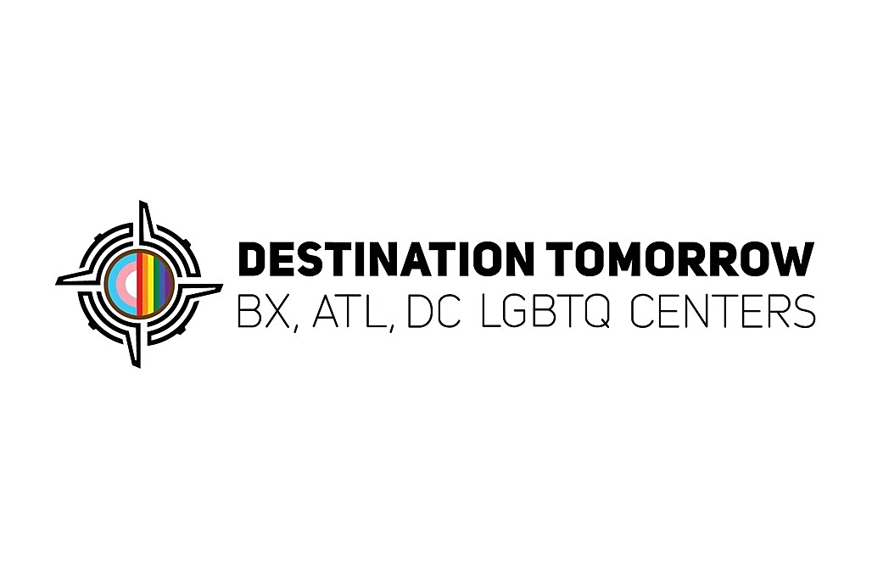

Residential Aide/Driver
Salary: $40,000
Location: New York City, NY
Employment Type: Full-Time

About Destination Tomorrow

Destination Tomorrow (DT) is a national grassroots LGBTQ+ organization founded in the Bronx, built on the principle that no individual should have to leave their neighborhood for necessary services. DT's mission is to move clients off the path of emergency care to one where they can grow, learn, and flourish by emphasizing economic, social, and mental empowerment through comprehensive educational, financial, and health programs, as well as housing solutions. As an expanding multi-site organization, Destination Tomorrow proudly serves the community across The Bronx, New York City; Atlanta, GA; and Washington, D.C.

What the Role Is Like
Destination Tomorrow is hiring a Driver / Program Support Staff member to support transportation and daily operations within our LGBTQIA+ transitional housing program. This is a dual-role position: driving a 12-passenger van for client transportation and supporting shelter operations when not driving.

What You’ll Do (Daily Responsibilities)
Transportation Duties
- Safely transport residents to medical appointments, housing appointments, and program activities
- Operate a 12-seat passenger van (company-provided)
- Transport program supplies and materials as needed
- Complete vehicle inspections, mileage logs, and safety checks daily
- Maintain cleanliness and safety of program vehicles
Program Support Duties (When Not Driving)
- Assist with Residential Aide station coverage
- Support kitchen operations (prep, cleanup, basic assistance)
- Assist with administrative and operational tasks as assigned
- Support general shelter flow and resident needs as directed by supervisors

What This Job Is Like
You will not be driving all day every day. This role requires flexibility—downtime between trips is spent supporting shelter operations. The environment is active, team-based, and service-driven. Staff are expected to shift between driving responsibilities and hands-on program support depending on daily needs.

Requirements
- Valid NYS driver’s license required
- Comfortable driving a 12-seat van
- Clean and responsible driving record
- Experience working with individuals impacted by homelessness, poverty, mental health, or healthcare barriers preferred
- Ability to work respectfully with LGBTQIA+ communities
- Team-oriented with strong communication skills

