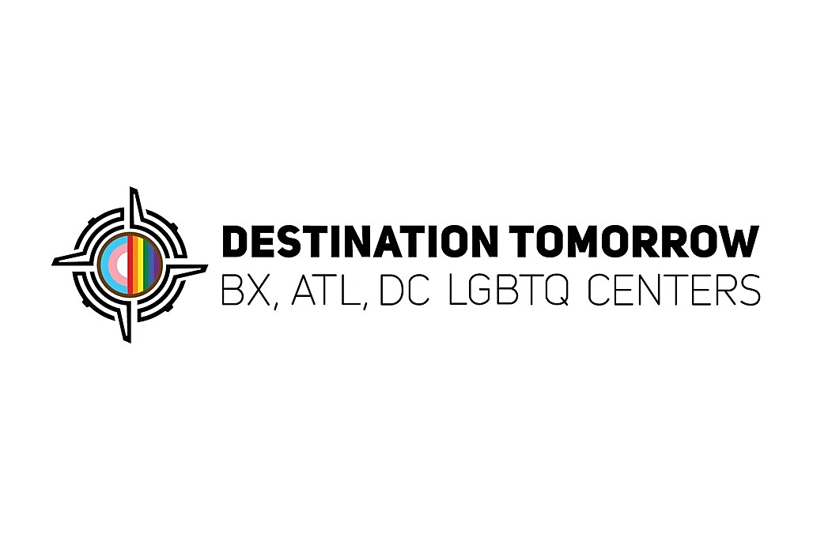

Case Manager (Shelter / Residential Program)
Salary: $50,000
Location: New York City, NY
Employment Type: Full-Time OR Per Diem
Schedule & Availability
- Primary schedule: 8:00 AM – 4:00 PM
- One late day per week required
- Must be available to work one weekend day

About Destination Tomorrow

Destination Tomorrow (DT) is a national grassroots LGBTQ+ organization founded in the Bronx, built on the principle that no individual should have to leave their neighborhood for necessary services. DT's mission is to move clients off the path of emergency care to one where they can grow, learn, and flourish by emphasizing economic, social, and mental empowerment through comprehensive educational, financial, and health programs, as well as housing solutions. As an expanding multi-site organization, Destination Tomorrow proudly serves the community across The Bronx, New York City; Atlanta, GA; and Washington, D.C.

Position Summary

Destination Tomorrow is hiring a Case Manager (Shelter / Residential Program) to support residents in our LGBTQIA+ transitional housing program serving transgender, gender non-conforming, and non-binary adults.

This role is ideal for candidates with experience in DHS shelters, supportive housing, residential programs, or social services case management who are comfortable managing a caseload in a fast-paced, compliance-driven environment. This is a hands-on, onsite case management role involving direct client engagement, service planning, documentation, and coordination of housing and supportive services.

What You’ll Do

You will manage a caseload of residents and support their progress toward housing stability and self-sufficiency.

Daily responsibilities include:
- Conduct intake assessments for new residents entering the housing program
- Create individualized service plans and Independent Living Plans (ILPs)
- Meet regularly with residents to review goals, progress, and barriers
- Complete ongoing assessments (semi-annual and quarterly reviews)
- Maintain accurate, timely case notes and documentation in required systems (including CARES)
- Assist clients with benefits applications, housing applications, and public assistance programs
- Provide housing navigation support including CityFHEPS, CURRENT, HOMES, and related resources
- Make referrals to community-based service providers (mental health, medical, employment, etc.)
- Escort clients to appointments (medical, housing, benefits, and social services as needed)
- Respond to resident crises, urgent needs, and stabilization issues in coordination with program staff
- Collaborate with shelter team members to ensure resident needs and compliance requirements are met

What This Job Is Like

This is a high-volume, frontline case management role in a congregate shelter setting.

You will be working directly with residents who may be experiencing:
- Housing instability and homelessness
- Mental health and medical challenges
- System navigation barriers (benefits, housing, legal systems)
- Crisis situations requiring quick response and coordination

Successful Case Managers in this role are:
- Highly organized and able to manage multiple cases at once
- Comfortable with fast-paced documentation and compliance deadlines
- Strong communicators who can maintain professional boundaries
- Proactive problem-solvers who follow through consistently
- Comfortable working onsite in a structured residential environment

Required Experience & Skills
- 1–2 years of shelter-based, residential, or DHS-contracted case management experience required
- High documentation and compliance expectations
- Multiple competing priorities throughout the day
- Frequent interruptions due to resident needs and crises
- Tight deadlines for service plans and reporting
- Required responsiveness to urgent program needs
- Experience completing assessments and Independent Living Plans (ILPs)
- Experience working with housing systems and placements
- Familiarity with CARES documentation system preferred
- Knowledge of CityFHEPS, CURRENT, HOMES, or similar housing programs preferred
- Strong organizational skills and ability to manage deadlines and caseloads
- Experience working with individuals impacted by homelessness, poverty, or health disparities
- Associate degree preferred (Human Services, Social Work, Psychology, or related field)

