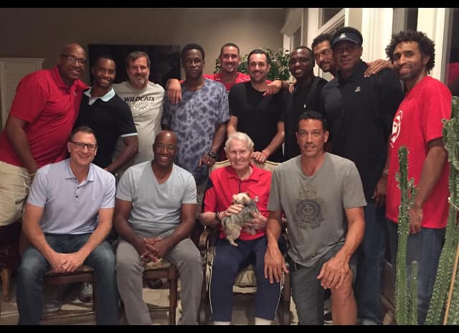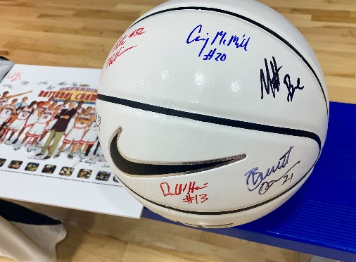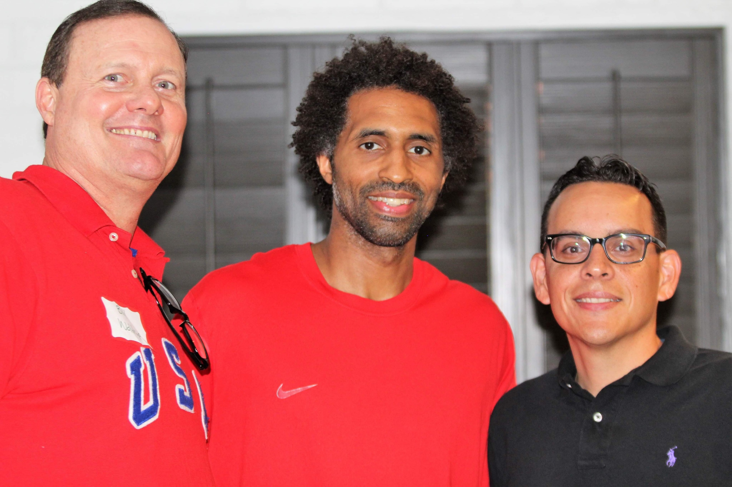
August 26 – 29, 2021
The Lute Olson Memorial Fantasy Basketball Camp returns for year four! Campers will once again stay at the luxurious Westward Look Resort. It’s been a popular place the last three years for coaches and campers to get together. Some special Lute memorial items are being planned. Our camp is not just about the basketball, which is very competitive, but the new friendships made. Former UA players like Pete Williams are still talking smack with their new friends on our Facebook page! We promise memories that will last a lifetime!
All basketball practices and games will take place at the Sporting Chance Center. Instructors committed to date include Pete Williams, Matt Muehlebach, Ben Davis, Craig McMillan, Joe Turner, Bennett Davison, Reggie Geary, and A.J. Bramlett. Other former Wildcats are expected to be announced shortly.
A spot on the 2021 Lute Olson Fantasy Basketball Camp is priced at $2,250 per camper ($1,750 if hotel accommodations aren’t needed); non-refundable deposit of $500 is due by August 1st. Along with a roster spot, fantasy campers will receive:
- Three nights of resort accommodations
- All meals provided including two private dinner parties with all campers & coaches
- Daily basketball instruction and team competition
- Personalized Lute Olson Fantasy Basketball Camp reversible practice top
- Instructors signed basketball, numerous UA related swag, and more
- Go to the Lute Olson Fantasy Basketball Camp Facebook page to see all of the fun from last year. Here are a lot more photos: https://bit.ly/3B5rNpE.

For more information contact Mike Feder at luteolsonfantasycamp@gmail.com or Steve Rivera at steve.rivera95@gmail.com. Mike can also be reached at (520) 954-8803.

