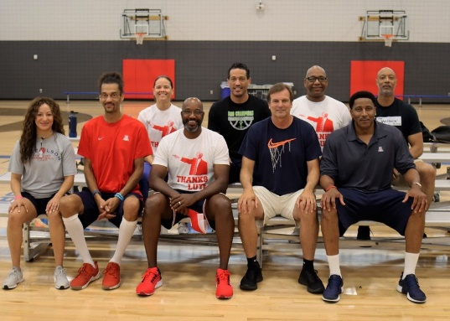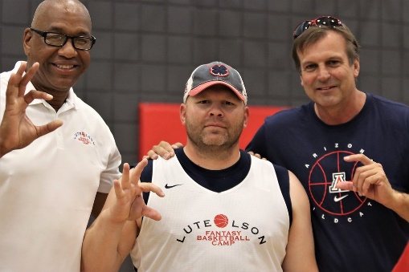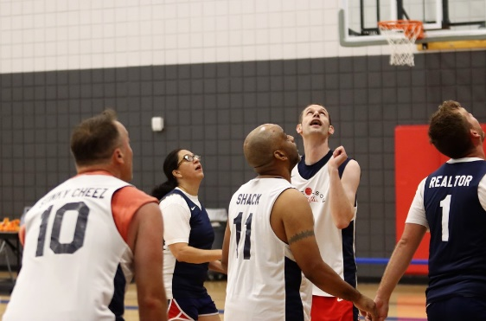
August 18 – 21, 2022
The Lute Olson Fantasy Basketball Camp returns for year five! Out of town campers will this year stay at the luxurious Westin La Paloma. Tommy Lloyd used his connections to get us in there. We will continue to come up with great swag. Our camp is not just about the basketball, which is very competitive, but the new friendships made. Former UA players like Pete Williams are still talking smack with their camp friends on our Facebook page! His team lost in the championship game so he’s still shooting for his three “Pete”. We promise memories that will last a lifetime!
All basketball practices and games will take place at the Sporting Chance Center. Our “coaching” lineup includes Pete Williams, Ben Davis, Bennett Davison, Reggie Geary, Matt Muehlbach, Felecity Willis, A.J. Bramlett, Donnell Harris and Eddie Smith. Other former Wildcats are expected to be announced shortly.
A spot on the 2022 Lute Olson Fantasy Basketball Camp is priced at $2,250 per camper ($1,750 if hotel accommodations aren’t needed); non-refundable deposit of $500 is due by July 25. Along with a roster spot, fantasy campers will receive:
- Three nights of resort accommodations at Westin La Paloma
- All meals provided including two private dinner parties with all campers & coaches
- Daily basketball instruction and team competition
- Personalized Lute Olson Fantasy Basketball Camp reversible practice top
- Instructors signed basketball, numerous Wildcats related swag, and more
Go to the Lute Olson Fantasy Basketball Camp Facebook page to see all of the fun. Here is the link for the 2021 photos from Andy Morales: https://bit.ly/3Ivy8hW.
For more information contact Mike Feder at luteolsonfantasycamp@gmail.com or by phone at (520) 954-8803.

