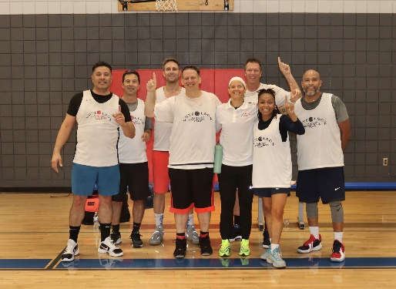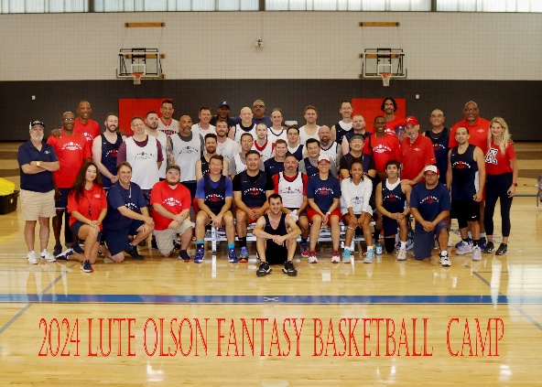**

**August 21 – 24, 2025**

The Lute Olson Fantasy Basketball Camp returns for year eight! Out-of-town campers will stay at the luxurious Westward Look Resort this year, our home for the first few years. We will continue to come up with great swag. Our camp is not just about basketball, which is very competitive, but the new friendships made. Sean Elliott and Kenny Lofton were a big hit in 2024. They are trying to work it out in their schedules to be with us once again.

All basketball practices and games will take place at the Sporting Chance Center. Our “coaching” lineup will include a lot of the “regular” camp coaches like Pete Williams, Joe Turner, Matt Muehlebach and Bennett Davison as well as hopefully a few new names.

A spot on the 2025 Lute Olson Fantasy Basketball Camp is priced at $2,250 per camper ($1,750 if hotel accommodation isn’t needed); non-refundable deposit of $500 is due by July 19 but full payment is preferred. Along with a roster spot, fantasy campers will receive:

* Three nights of resort accommodation and breakfast at Westward Look (out of town campers & coaches)
* All meals provided including two private dinner parties with all campers & coaches
* Daily basketball instruction and team competition
* Tentative invite from Tommy Lloyd to Wildcats practice at Richard Jefferson Gym
* Personalized Lute Olson Fantasy Basketball Camp reversible practice top
* Instructors signed memorabilia, numerous Wildcats & Camp related swag, and more

Go to the Lute Olson Fantasy Basketball Camp Facebook page to see all of the fun. Here is the link for the 2024 photos from Andy Morales: <https://shorturl.at/wNUNC>.

For more information contact Mike Feder at [luteolsonfantasycamp@gmail.com](mailto:luteolsonfantasycamp@gmail.com) or by phone at (520) 954-8803.