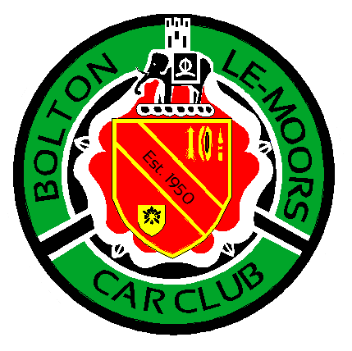**[http://www.blmcc.co.u](http://www.blmcc.co.uK)**[**k**](http://www.prestonmotorsport.club/)

BLMCC WINTER NAVIGATIONAL SCATTER REGULATIONS

Bolton le Moors Car Club (BLMCC) will be promoting a navigational scatter on the 27th March 2025. The event will be held on Maps 102 and 109. Use of your own maps is recommended although map extracts will be available to those who do not have their own maps. The Start and Finish will be at the Jolly Crofters, Horwich (Post Code BL6 6RE or Grid Reference 6580 1130 Map 109).

There will be no tricky navigation as our Navigational Scatters are an opportunity for Novices and Experts alike to get out and about and have some fun. Two or more people are allowed in the car but all passengers must be signed on and wear seat belts at all times while the car is in motion.

All cars must hold a current MOT, insurance and be taxed.

**1. ANNOUNCEMENT**

Bolton le Moors Car Club will organise a Clubman’s Navigational Scatter on the 27th March 2025.

**2. JURISDICTION**

The meeting will be held under the General Regulations of the Motorsport UK (incorporating the provisions of the International Sporting Code of the FIA), and these supplementary regulations and any further written instructions that the organisers may issue.

**3. AUTHORISATION**

A Motorsport UK Rally-Navigational Scatter-Clubman’s Permit has been applied for and will be on

display at Signing On.

**4. ELIGIBILITY**

The event is open only to members of Bolton le Moors Car Club and competitors will need a RS Clubman licence which is free from Motorsport UK. Bolton le Moors Car Club Membership can be obtained on the night for any non members.

**5.** P**ROGRAMME**

Programme for the event

**a. Scrutineering/Signing-On opens………………………………………………………………………….19.30hrs b. Car 1 starts ………..…………………………………………………..………………………………………..…20.00hrsc. Car 1 due back at the Jolly Crofters ……………………………………………………………….……21.45hrs**

Car 1 will receive their plots at 20.00hrs and have 1.75 hours to plot, decide which points they will be visiting, visit the points and be back at the finish venue. The following cars will leave at 1 minute intervals.

Total mileage for the event is not specified, but competitors should carry enough fuel to cover approximately 60 miles. There will be opportunities to purchase fuel during the event.

**6. SCRUTINEERING**

All vehicles must comply with Motorsport UK National Competition Rules Chapter 13, Appendix 15Para’s 1 to 6 inclusive.

**7. ENTRIES**

The Entry for the event will open on the publication of these SRs and closes the night before the event at 20.00hrs. The Entry is free to all Bolton le Moors Car Club Members.

The maximum entry for the event is 15, entries will be on a first come first served basis.

**8. OFFICIALS**

Clerk of the Course – Ian Swallow – 07989 600764/chiefmarshalblmcc@gmail.comEntries Secretary……Victoria Swallow – 07972 355542/chiefmarshalblmcc@gmail.com

Judges of Fact will be appointed to observe competitors’ driving. All named officials are Judges of Fact. Additional Judges of Fact may be appointed and their names published at the start of the event**. We want you to enjoy the event but please remember this is a scatter, not a road rally!**

**9. ROUTE INSTRUCTIONS**

Once you have signed on you will receive a time in which you can collect your clues/plots.Competitors will receive their full route information, references and clues at the given time. The location of the points to be visited will be defined by 8 figure map references (plotted using a basic roamer).At some of the points visited competitors may be required to leave their vehicle. Each location will be worth a varying number of points. There is no defined route – crews are required to visit no more than 75% of the locations given, in any particular order and amassing as many points as possible. Points will vary depending on the location and difficulty. Crews will be informed in their route handout the value of each location visited.

**10. SCORING AND PENALTIES**

**a.** For providing proof of visiting a clue point (by providing a photo), along with the correct answer, points will be awarded as designated on question sheet.

**b.** For NOT providing the correct answer but proof of visiting clue point, i.e., answer not 100% correct but clearly shows without doubt that location was visited, half points will be awarded though.**c.** For reporting to finish later than the 1.75 hour window from when you collected your plots. Ten points will be deducted for every minute late.

**d.** For action contrary to the spirit of the event – **Exclusion**

**e.** For driving likely to bring motorsport into disrepute, excessive speed, contravening traffic regulations or excessive wheel spin as reported by a Judge of Fact – **Exclusion**

**11. RESULTS**

Ties will be resolved by the crews with lowest total mileage for the points covered.

Final results will be published at the end of the event as soon as possible. Any protests will be thrown out.

**12. AWARDS**

Awards will be given to 1st, 2nd & 3rd Driver and Navigator and form part of the Club Championship as per Club Championship Regulations.

**13. COMPETITOR REQUIREMENTS**

Competing crews will require a copy of OS Maps 102 & 109 (latest edition although map printouts will be provided for those that require them), a mobile phone with camera, a basic roamer, pen, pencil, torch and good footwear.

**14. FINAL INSTRUCTIONS**

There will be no Final Instructions sent out for this event. All info regarding event will be on the club’s

Facebook page.

**Any Questions contact chiefmarshalblmcc@gmail.com**