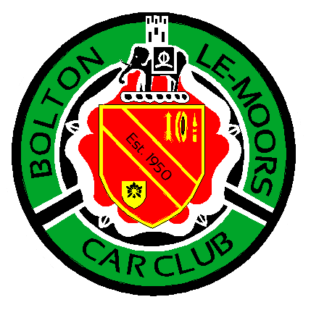
http://www.blmcc.co.uk
BLMCC SPRING NAVIGATIONAL SCATTER REGULATIONS
Bolton le Moors Car Club (BLMCC) will be promoting a navigational scatter on the 26th March 2026. The event will be held on Maps 102, 103 and 109. Use of your own maps is recommended although map extracts will be available to those who do not have their own maps. The Start will be at the Nabs Head, Samlesbury (Post Code PR5 0UQ or Grid Reference 622 293 Map 102and Finish will be at the Jolly Crofters, Horwich (Post Code BL6 6RE or Grid Reference 658 113 Map 109).
There will be no tricky navigation as our Navigational Scatters are an opportunity for Novices and Experts alike to get out and about and have some fun. Two or more people are allowed in the car but all passengers must be signed on and wear seat belts at all times while the car is in motion.
All cars must hold a current MOT, insurance and be taxed.
1. ANNOUNCEMENT
Bolton le Moors Car Club will organise a Clubman’s Navigational Scatter on the 26th March 2026.
2. JURISDICTION
The meeting will be held under the General Regulations of the Motorsport UK (incorporating the provisions
of the International Sporting Code of the FIA), and these supplementary regulations and any further written
instructions that the organisers may issue.
3. AUTHORISATION
A Motorsport UK Rally-Navigational Scatter-Clubman’s Permit has been applied for and will be on
display at Signing On.
4. ELIGIBILITY
The event is open only to members of Bolton le Moors Car Club and competitors will need a RS Clubman licence which is free from Motorsport UK. Bolton le Moors Car Club Membership can be obtained on the night for any non members.
5. PROGRAMME
Programme for the event
a. Scrutineering/Signing-On opens………………………………………………………………………….19.15hrs
b. Car 1 starts ………..…………………………………………………..………………………………………..…19.45hrs
c. Car 1 due back at the Jolly Crofters ……………………………………………………………….……21.45hrs
Car 1 will receive their plots at 19.45hrs and have 2.00 hours to plot, decide which points they will be visiting,
visit the points and be back at the finish venue. The following cars will leave at 1 minute intervals.
Total mileage for the event is not specified, but competitors should carry enough fuel to cover approximately
65 miles. There will be opportunities to purchase fuel during the event.
6. SCRUTINEERING
All vehicles must comply with Motorsport UK National Competition Rules Chapter 13, Appendix 15
Para’s 1 to 6 inclusive.

7. ENTRIES
The Entry for the event will open on the publication of these SRs and closes the night before the event at
20.00hrs. The Entry is free to all Bolton le Moors Car Club Members.
The maximum entry for the event is 15, entries will be on a first come first served basis.
8. OFFICIALS
Clerk of the Course – Ian Swallow – 07989 600764/chiefmarshalblmcc@gmail.com
Entries Secretary……Victoria Swallow – 07972 355542/chiefmarshalblmcc@gmail.com
Judges of Fact will be appointed to observe competitors’ driving. All named officials are Judges of Fact.
Additional Judges of Fact may be appointed and their names published at the start of the event. We want you
to enjoy the event but please remember this is a scatter, not a road rally!
9. ROUTE INSTRUCTIONS
Once you have signed on you will receive a time in which you can collect your clues/plots.
Competitors will receive their full route information, references and clues at the given time. The location of the points to be visited will be defined by 6 figure map references (plotted using a basic roamer).
At some of the points visited competitors may be required to leave their vehicle. Each location will be worth a varying number of points. There is no defined route – crews are required to visit no more than 75% of the locations given, in any particular order and amassing as many points as possible. Points will vary depending on the location and difficulty. Crews will be informed in their route handout the value of each location visited.

10. SCORING AND PENALTIES
a. For providing proof of visiting a clue point (by providing a photo), along with the correct answer, points will be awarded as designated on question sheet.
b. For NOT providing the correct answer but proof of visiting clue point, i.e., answer not 100% correct but
clearly shows without doubt that location was visited, half points will be awarded though.
c. For reporting to finish later than the 2.00 hour window from when you collected your plots. Ten points
will be deducted for every minute late.
d. For action contrary to the spirit of the event – Exclusion
e. For driving likely to bring motorsport into disrepute, excessive speed, contravening traffic regulations
or excessive wheel spin as reported by a Judge of Fact – Exclusion
11. RESULTS
Ties will be resolved by the crews with lowest total mileage for the points covered.
Final results will be published at the end of the event as soon as possible. Any protests will be thrown out.
12. AWARDS
Awards will be given to 1st, 2nd & 3rd Driver and Navigator and form part of the Club Championship as per Club Championship Regulations.
13. COMPETITOR REQUIREMENTS
Competing crews will require a copy of OS Maps 102, 103 & 109 (latest edition although map printouts will be provided for those that require them), a mobile phone with camera, a basic roamer, pen, pencil, torch and good footwear.
14. FINAL INSTRUCTIONS
There will be no Final Instructions sent out for this event. All info regarding event will be on the club’s
Facebook page.
Any Questions contact chiefmarshalblmcc@gmail.com

