Auchinairn Forest Kindergarten
Handbook
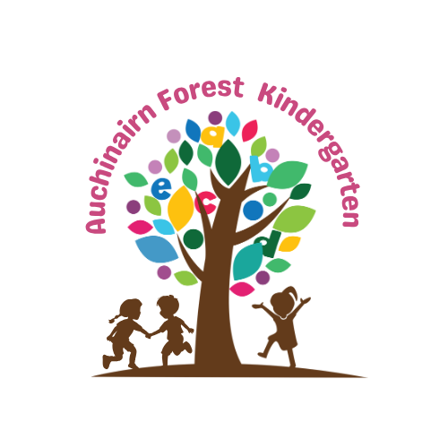

Contents
Page 3 | Vision, Aims and Values
Page 5 | Kindergarten information  Registering and Admissions  Enrolment
Page 6 | Admissions Policy  Kindergarten Staff
Page 7 | Kindergarten Families  Starting Nursery  Arrival and Collection
Page 8 | Daily Plan
Page 9 | Attendance  Un-Notified Absence Policy
Page 10 | The Curriculum
Page 11 | Children’s Rights
Page 12 | Equal Opportunities and Inclusion  Support for Learning and Targeted Intervention
Page 13-15 | The Importance of Play
Page 16 | Your Child’s Learning Journal  Outings  Nursery Uniforms
Page 17 | Next Steps  Parents and Carers Communication  Complaints Procedure
Page 18-19 | GIRFEC
Page 20 | Protection of Vulnerable Groups – Child Safeguarding  Healthy Eating  Setting the Table  Exercise  Child Smile Programme  Text Service
Page 21 | Security  Emergency Closure Arrangements  Family Circumstances  Data Protection/GDPR  Health and Wellbeing
Page 22 | Health and Wellbeing cont.  Fire Drills  Smoking Control  Dogs  Insurance
Page 23 | Prams and Buggies  Policies  Parking  Risk Assessments  Travel
Page 24 | CCTV

Visions, aims and values
The vision of Auchinairn Forest Kindergarten (AFK) and Forest School (FS) is to ensure children and staff within the service develop to the highest standard possible. We aim to provide a warm, caring, safe and stimulating environment for children aged between three to five years between the hours of 7.30am and 6pm.

We value good character and promote a culture of collegiality, where integrity, respect, trust and communication are central to the culture. A culture where open and honest communication is valued, where co-operation is essential, and fairness is integral to a collegiate practice; These are at the core of the service’s ethos. We aim to help nurture happy, confident and resilient children.

We strongly believe in the benefits of outdoor play and are committed to providing outdoor and particularly woodland activities. Our approach to the outdoor practice is based on the six Forest School principles:

- Forest School is a long-term process of frequent and regular sessions in a woodland or natural environment, rather than a one-off visit
- Forest School takes place in a woodland or natural wooded environment to support the development of a relationship between the learner and the natural world
- Forest School aims to promote the holistic development of all those involved, fostering resilient, confident, independent and creative learners
- Forest School offers learners the opportunity to take supported risks appropriate to the environment and to themselves
- Forest School is run by qualified Forest School practitioners who continuously maintain and develop their professional practice
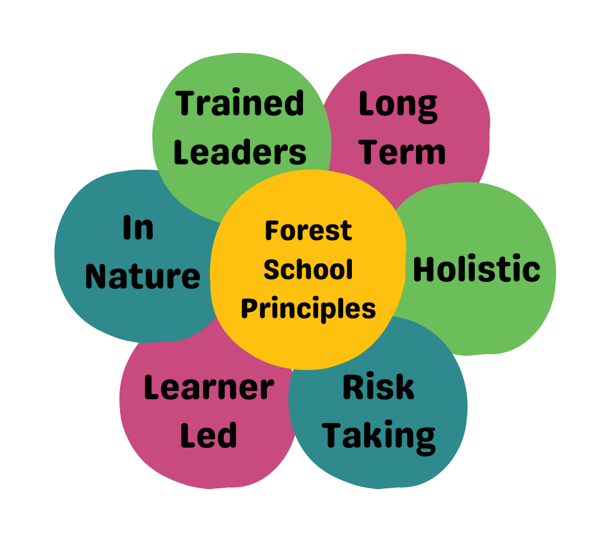
- Forest School uses a range of learner-centred processes to create a community for development and learning

We believe that children and young people should be respected for who they are and also for their capacity to instigate, test and maintain curiosity in the world around them. We believe in the child’s right to play, their right to access the outdoors, their right to access risk and their right to experience the vibrant reality of the natural world. Play is integral to the FS ethos and principles: - we aim to ensure children have access to an area which supports these principles and tailor to the needs of the individual child and their right to play.

Through the outdoor and woodland experiences, we provide, children and young people will be given the opportunity to develop curiosity, self-confidence, self-esteem, creativity, empathy, communication skills, social skills, their knowledge of the natural environment, their ability to assess risk, share responsibility in the decision-making process and share all duties fairly and equally. FS enables everyone to connect with nature, value the flora and fauna and take care of the environment.

Whether we are indoors or outdoors, we aim to provide a range of stimulating, fun activities and outings for all children. We aim to plan these activities and outings in collaboration with service users, within the local community. We aim to provide children with appropriately challenging and achievable tasks and activities which promote confidence, self-esteem, resilience, social skills, emotional intelligence, language and communication skills, problem solving skills, conflict resolution skills and independence.

We aim to ensure children are cared for by competent and confident staff, who, will respect and treat each child with dignity, respect for privacy, to help them make informed choices, to ensure their safety in all aspects of life, to encourage them to reach their full potential and ensure equality and diversity.

Sessions continue throughout all seasons and involve risk taking in a supported environment. There must be a level 3 trained FS leader on site allowing fire and tool activities, shelter building and tree climbing session to be allowed, and to ensure we respect the land.

Children within the service may participate in activities which will involve an element of risk, however, before participating, the child/young person’s age and stage of development will be assessed as will their understanding of the risks involved. The risks associated with such activities will be assessed and all such activities supervised.

Information
NAME | Auchinairn Forest Kindergarten
ADDRESS | Indoor – Unit 2, 173 Auchinairn Road, Glasgow, G641NG  Outdoor – Woodland off Lumloch Road, G645LD
TELEPHONE | 07584514181 or 07720086816
E-MAIL | auchinairnafterschoolcare@outlook.com
WEBSITE | www.auchinairnafterschoolcare.co.uk
SOCIAL MEDIA | Facebook – Auchinairn Afterschool Care & Forest School
CAPACITY | 24 Children from 7.30am to 3pm and 8 children from 3pm to 6pm.
CARE INSPECTORATE | CS2003003655 – Karen Bradley
HOURS OF OPERATION | 7.30am to 6pm
DAILY SESSION TIMES | 9am to 3pm Monday to Friday, option to add early start and later pick up. 7.30am to 9am and 3pm to 6pm. Limit of 8 children from 3pm.
HOLIDAY DATES | Centre is closed on the following dates:  Friday 26th & Monday 29th September 2025  Monday 22nd December 2024 – Friday 2nd January 2026  Friday 3rd April & Monday 6th April 2026  Monday 4th May 2026  Friday 22nd & Monday 25th May 2026  Monday 20th July 2026
FUNDING/FEES | Full time (50 weeks) – 2 days 9am to 6pm + 1 day 9am to 2.30pm OR 3 days 9am to 3pm + 1 day 9am to 2.30pm. Term time – 5 days per week 9am to 3pm or 3 days per week 8am to 6pm.

Registering and Admissions
Parents applying for a nursery place must register by emailing Auchinairnafterschoolcare@outlook.com and requesting a registration pack.
To complete the registration process, you will need to provide:
- Child’s birth certificate
- Proof of residence
- Utility bill (dated within the last 3 months)

Enrolment
Once you have completed the registration documents, you will be invited to attend a parent induction with a member of the AFK team. Before your child starts with the setting, they will also attend at least one child taster session.

Admissions Policy
Places will be allocated initially by date of application. There may be a small number of subsidised places available to families in line with regional priority groups.
Priority will be given to siblings of children already attending the service.
East Dunbartonshire Council children will be eligible for funding on the 1st day of new term after the child’s 3rd birthday. Cross-boundary funding is available for children who live in the Glasgow City Council area. To apply for a funded place, please ensure, as well as completing registration documents for AFK, you must also apply for the funding via Early years - how to apply - East Dunbartonshire Council.
Kindergarten Staff
Name | Position | Qualifications | Days/Hours Worked
Management
Nikki Morton | Manager
Julie Jamieson | Deputy Manager
Early Years Workers
Kris Wallace-Boyle | Senior Early Years Worker | SVQ3 social services of children and young people.  Fire and tool trained. | Monday(Planning), Tuesday, Wednesday, Thursday, Friday
Danielle Morton | Early Years Worker | SVQ3 social services of children and young people.  Fire and tool trained. | Monday, Tuesday, Wednesday
Mia Gribbon | Early Years Worker | Working towards SVQ3 social services of children and young people. Fire and tool trained. | Monday to Friday
Ella Queen | Early Years Worker | Fire and Tool trained | Monday to Friday
Bank Staff
Charlene Strang | Bank Staff | FOLA Level 8. SVQ3 Social services of children and young people. | Monday to Friday
Julie Jamieson | Bank staff | FOLA Level 8. SVQ3 Social services of children and young people. | Monday to Friday
Lesley Morton | Bank staff | Forest School Leader Level 3. SVQ3 CCLD. | Monday to Friday
All staff members have been vetted through Disclosure Scotland. All staff members are appropriately qualified and are members of the Scottish Social Services Council (SSSC).





Kindergarten Families
Parents are encouraged to become involved in every stage of their child’s development. We recognise the importance of the partnership with families and strive to build and maintain a sound and effective relationship with each parent/carer. Your involvement will contribute greatly to all aspects of your child’s wellbeing and education. We are keen to involve parent/carer in our service and their contribution in improving the service. We have many activities that our families can become involved in, for example open days and get to know the staff sessions, and stay and play. We welcome family members to help at our open days and encourage grandparents to get involved too.

Starting Nursery
Each child will be assigned a key worker. Before beginning nursery a Care Plan is given to parents to complete and handed in for their key worker. This allows a child’s key worker to establish a relationship with both the child and the parent/carers.
Once you enrol your child you will be invited for a visit to complete a parent induction, you will receive your care plan after the induction, either a paper copy or via email. Prior to your child starting, or on your child’s first day you must return the care plan, to allow your child’s key worker to go over the details with you and answer any questions that you may have.
Please notify us immediately if your contact numbers change – particularly mobile numbers. It is essential we keep our records up to date in case we have to contact you in an emergency.

Arrival and Collection
Children should be taken to the playroom in the morning. They will have free play until we get ready for forest school, which will be around 9am. From 9-10am we will be getting ready for the outdoors and travelling, setting up out outdoor session. From 10am there will be child led play, until snack time which will take place at 10.30am. Between snack and lunch the children will have a mix of child led play, planned activities(CfE) and story time. Lunch will take place between 12.15 and 1pm. After lunch there will be a mix of quiet time and planned learning, until reflection time at 2.30pm.
See overleaf for an average daily plan.

Daily Plan
7.30am-8.15am – Breakfast
8.15am-9.15am – Free Play.
9.15am-9.30am – Circle Time
9.30am-10.30am – Prepare to go outdoors (set up, kids getting ready, packing bus, getting to woods, woodland set up) *,**
10.30am-10.45am – Morning snack time
10.45am-11am – Free Play
11am-11.30am – Planned Activity Time
11.30am-11.45am – Free Play
11.45am-12.15pm – Story Time
12.15pm-1pm – Lunch Time
1pm-1.30pm – Planned Activity Time
1.30pm-2.30pm – Free Play
2.30pm-3pm – Reflection / Home

*INDOORS DAY (weather too severe to leave building) – between 9.30am and 10.30am, instead of getting ready for outdoors, have 30 minutes of Free Play and 30 minutes of Planned Activity.
**NON-WOODLAND DAY (weather too severe for woodland, but can go elsewhere, park etc) – 9.30am-10.30am - get ready to go out(get kids ready and prepare snack), outdoor time. Have morning snack outdoors and return before 12.15pm for Lunch.

Children should be brought and collected from kindergarten by a responsible adult. It is very important that staff are notified of any change in arrangements, for example if a friend or other family member is to drop/collect your child.
If staff do NOT know the person collecting, they will be asked for your password, which is your responsibility to pass on to them. Your child will not be passed over to someone without the correct password and your notice via message.
At pick up time, please try to arrive at least 10 minutes before the allotted time so that you have time to collect items and chat to key workers if necessary.

Attendance
Regular attendance in kindergarten is very important to ensure you child does not miss out on learning opportunities and experiences.

Un-notified Absence Policy
The kindergarten requires you to phone before 9am, if your child is unable to attend that day for any reason.
If the Kindergarten has not been contacted by this time, the Manager/Depute will arrange to contact parents and/or emergency contacts by telephone to establish a reason for absence.
In the event of being unable to contact parents or emergency contacts, the Manager/Depute may have to consider making arrangements to make a home visit. This procedure is in place to safeguard your child.

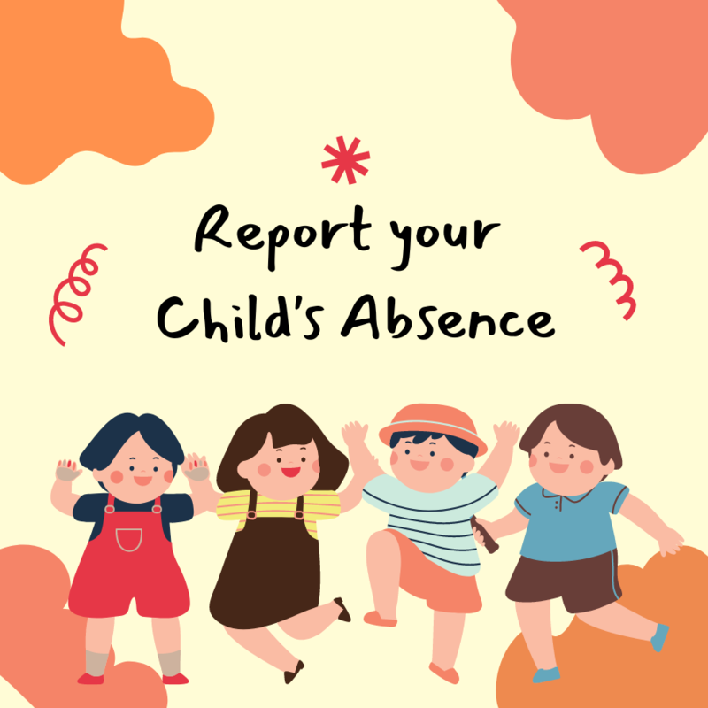

The Curriculum

Through play at nursery activities, we aim to:
- Encourage and help children build positive relationships
- Give children the opportunity to be independent and successful
- Provide each child with the necessary skills to enable effective learning
- Encourage children to have self-confidence
At Auchinairn Forest Kindergarten we follow the Curriculum for Excellence. The CfE is organised into 8 curriculum areas:
- Expressive Arts
- Health and Wellbeing
- Languages
- Mathematics and Numeracy
- Religious and Moral Education
- Sciences
- Social Studies
- Technologies
Staff plan a balances curriculum covering these areas. Planning is available for parents/carers to read and discuss with staff at any time. Every child is treated as an individual at AFK. Children will be involved in activities that support their individual needs and development.
WHAT WE DO
- Provide a range of interesting and enjoyable activities suited to the needs of each child
- We talk and interact with the children
- We give the children praise and encouragement
- We help the children to form relationships with other children and adults
- We encourage the children to try new experiences
- We encourage the children to question and look for answers
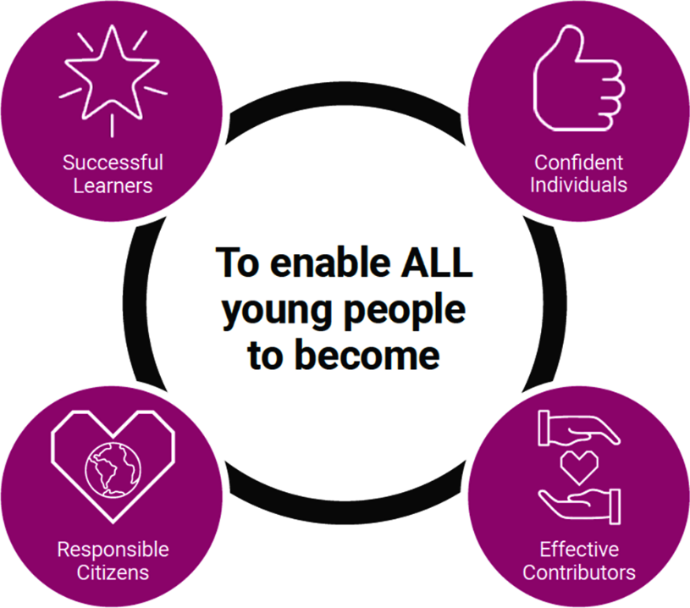
- We encourage children to risk assess and manage their own play

Children’s Rights
We want to recognise, respect and promote children’s rights. These include right to be treated fairly, to be heard and to be as healthy as possible.
Our vision is a Scotland where children’s human rights are embedded in all aspects of society. A Scotland where policy, law and decision making take account of children’s rights and where all children have a voice and are empowered to be human rights defenders.
Parents and families, communities, local and national governments, and organisations which work with children and families, all play a critical role in helping children understand and experience their rights.
The United Nations Convention on the Rights of the Child (Incorporation) (Scotland) Bill: leaflet - gov.scot (www.gov.scot) is the global ‘gold standard’ for children’s rights and sets out the fundamental rights of all children. We already use UNCRC as a framework to ensure that we consider children’s rights whenever we take decisions, and to help provide every child with a good start in life and a safe, healthy and happy childhood. It forms the basis of the national approach for supporting children, called Getting it right for every child (GIRFEC) - gov.scot (www.gov.scot).
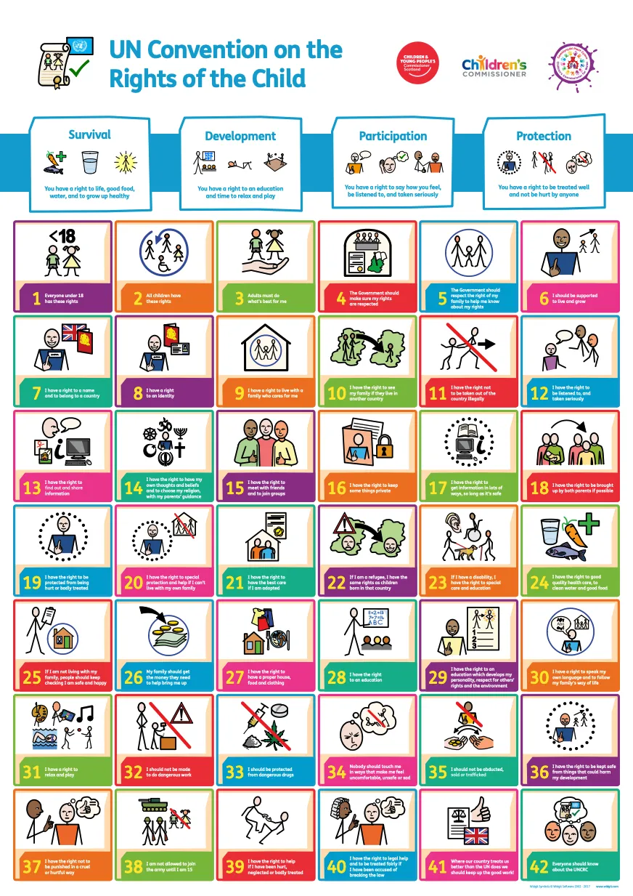

Equal opportunities and Inclusion
At AFK we promote equality and strive to help every child benefit from education.
All staff ensure equal opportunities are given regardless of age, disability, marriage, civil partnership, gender reassignment, pregnancy and maternity, religion and belief, sex and sexual orientation.
All incidents of racism are treated seriously and reported.
Full equality policy can be found in registration pack.


Support for Learning and targeted Intervention
At Auchinairn Forest Kindergarten, every child is treated as an individual – developing and learning at their own pace. Staff continually observe children to ensure that they provide stimulating, challenging and interesting activities and be available to provide assistance when required. The online learning journal (Tapestry - Log In (tapestryjournal.com)) give parents the opportunity to monitor their child’s progress throughout their early years. Parents will be invited to attend parents evening in November and May. During your child’s time at the nursery, staff will have gathered significant evidence charting their development. The kindergarten has a duty to ensure that all our children have equal access to the curriculum, supported as appropriate to their individual needs. This covers not only the content of activities and strategies, but also minor adaptions to the physical environment if required.
We strive to identify children with additional support needs as soon as possible. Individual needs are recognised, and appropriate support is put in place – whether this is for a child with, for example, social problems, speech difficulties or a very able child.
Parental involvement and support are also vital in the development of a child’s education. Key workers will highlight and discuss any difficulties a child may be experiencing with the staff team at out child development meetings. Children are then placed on a staged intervention programme. Parents will be advised of any issues as early as possible and will be kept up to date with all aspects of the staged intervention within the kindergarten. Occasionally, we may need to enlist the help of outside agencies, for example, Speech and Language Therapist, Educational Psychologist, and Health Visitors. Parental consent will be sought to consult with these agencies and parents will be involved in each step of the way.
Importance of play
“Play is the highest expression of human development in childhood, for it alone is the free expression of what is in a child’s soul.”
Friedrich Froebel, 1782-1852
Play is a very emotive word which means different things to different people. The meaning of play has been debated by philosophers and academics for centuries, and was recognised as far back as Plato who is quoted as saying ‘avoid compulsion and let your children play’ In the last century David Lloyd George stated that ‘play is a child’s first claim on the community’ Play gained wider recognition under the United Nations Convention on the Rights of the Child in which Article 31 enshrines the child’s right to play.
Young children, who learn to share, take turns, work, and play with others show a higher degree of success later in life. As children became older and had more opportunities for peer interaction, the non-social types (solitary and parallel) declined in favour of the social types (associative and cooperative) Lorton & Walley, 1979
Health Benefits of Outdoor Play
• Increases physical activity. Children who attend schools with diverse natural settings are more physically active, more aware of nutrition, more civil to one another & more creative.
• Improves nutrition. Children who grow their own food are more likely to eat fruits and vegetables and show higher levels of knowledge about nutrition.
• Improve healthy eating habits throughout their lives (Morris & Zidenberg-Cherr,2002).
• Improves eyesight. More time spent outdoors is related to reduced rates of near sight.
Physical Benefits of Outdoor Play
• Children need daily exercise that will get their hearts and lungs working hard. NHS guidelines recommend the under 5s need 3hrs exercise/day with a mix of bone strengthening, muscle building and cardiovascular.
• Running, climbing, digging, and swinging from branches, these needs are more than met every day.
• Exercise improves children's emotional health, allowing for relaxation, calmness, and a heightened sense of well being (Armstrong 1996)
• Children who play regularly in natural environments show more advanced motor fitness, including coordination, balance, and agility. They are ill less often.
Natural Connections - Benefits of Outdoor Play
• An affinity to and love of nature, along with a positive environmental ethic, grow out of regular contact with and play in the natural world during early childhood.
• Children's loss of regular contact with the natural world can result in a bio-phobic future generation not interested in preserving nature and its diversity. “Imagine a world in which all children grow up with a deep understanding of the life around them” (Louv 2005).

Social Benefits of Outdoor Play
• Improves social relations. Children will be better able to get along with others, healthier and happier with regular opportunities for free and unstructured play outside.
• Supports creativity and problem solving. Studies found children engage in more creative forms of play in green areas and played more cooperatively (Bell and Dyment, 2006).
• Play in nature is especially important for developing capacities for creativity, problem-solving, and intellectual development.
• When children play in natural environments, their play is more diverse with imaginative and creative play that fosters language and collaborative skills.
• Play in a diverse natural environment reduces or eliminates bullying.
• Natural environments stimulate social interaction between children.
• Children permitted to play freely with peers develop skills for seeing things through another person's point of view – co-operating, helping, sharing, and solving problems
Cognitive Benefits of Play
Play is crucial to the healthy development of children’s minds. Science confirms our intuitions about the benefits of play. It appears to have important positive effects on the brain and on a child’s ability to learn.
• Play opportunities improve memory and stimulate the growth of the cerebral cortex
• Play and exploration trigger the secretion of BDNF, a substance essential for the growth of brain cells.
• Kids pay more attention to academic tasks when they are given frequent, brief opportunities for free play
• Play develops children’s language skills & promotes creative problem solving.
Will children really learn?
• While playing outdoors a child is likely to encounter opportunities for decision making that stimulate problem solving and creative thinking because outdoor spaces are often more varied and less structured than indoor spaces.
• There are usually fewer constraints outdoors on children’s gross motor movement and less restriction on visual and gross motor exploration which induces curiosity and the use of imagination.
• The problem solving that occurs in play use higher-level skills that integrates attention and other cognitive functions such as planning, organizing, sequencing, and decision making.
• Play is an active form of learning that unites the mind, body, and spirit. Until at least 9 years learning occurs best when the whole self is involved.
• Learning outside the classroom supports the development of healthy and active lifestyles and promoting a sense of well-being
• It gives children contact with the natural world & experiences that are unique to outdoors e.e. direct contact with the weather & seasons.
• It teaches children to understand and respect nature, the environment and the interdependence of humans, animals, plants, and lifecycles.
Outdoor Learning Play Opportunities:
• Outdoors offers space which is particularly important to children who learn best through active movement. Very young children learn predominately through sensory & physical experiences which supports brain development & creation of neural networks.
• For many children, playing outdoors at their early years setting may be the only opportunity they have to play safely and freely while they learn to assess risk and develop the skills to manage new situations.
• Learning that flows seamlessly between indoors and outdoors makes the most efficient use of resources and builds on interests and enthusiasms.

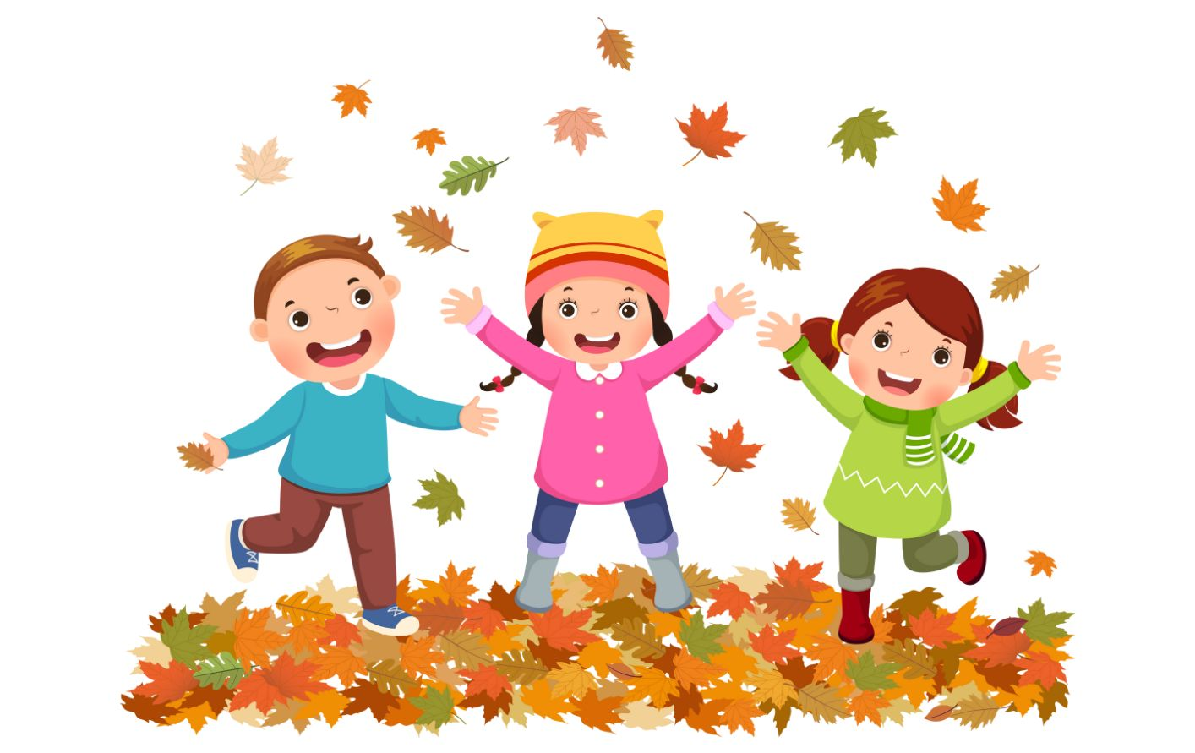

Your Child’s Learning Journal
Why we use online journals:
- To develop home links with parents/carers
- Encourage parents to become involved with their child’s kindergarten journey
- Encourage home learning and tack your child’s development at kindergarten
- To allow parents access to their child’s progress on a regular basis
- To all parents to look at children's photographs
- To allow children to share their achievements to family and friends across the world

With Online Learning Journals parents are able to log into their child’s profile at any time and comment and interact with their learning. They can also upload their own home observations or achievements from home.


Outings
Outings and trips are an important part of our curriculum. Each year at Auchinairn Forest Kindergarten, we arrange for the children to visit places of interest. The children travel to/from these visits by minibus. In addition, we may go for walks to local shops, park, and libraries. Appropriate consent will be secured from parents/carers beforehand. Parent/carers are encouraged to come along as helpers.

Nursery Uniform
The nursery offers a uniform of red t shirts and hoodies with the kindergarten logo, these items are available to buy from us. Uniform is not compulsory, but we discourage children form coming into kindergarten in ‘good’ clothes. Our children will be outdoors as much as possible.
As part of your initial registration fee, we provide children with outdoor suits, boots, jacket and waterproof bag. These will be given out at the time of our child starting with the service, should you need any further equipment or clothing there will be a charge for each item.
Charges are as follows:
Outdoor Suit £20
Waterproof Bag £20
Outdoor Jacket £10
Outdoor Boots £15
Children should arrive at nursery wearing a pair of trainers or shoes and not their outdoor boots. Please ensure that your child does not have on any jewellery items, as the kindergarten cannot be responsible for the loss of any item of jewellery. For outings, please ensure your child has had suncream applied before attending the setting.
Please ensure all items of clothing are clearly marked with your child’s name.

Next steps
The transition to Primary School can be a big step for many young children (and their parents) so we aim to make it easier in the following way.
We hope to build strong relationships with our local schools in the hopes of creating links with our local primary schools, with the hopes of teachers coming to our service to meet the children going into primary 1.

Parent and Carers Communication
At AFK we recognise the great importance of working with parents and carers to establish good relationships. We hope to work together with parents and carers to achieve this. There are a number of ways in which we will communicate with you:
- Online tapestry journal
- Newsletters
- Parent board in centre
- Texts
- Emails
- Facebook
- Nursery website
- Face to face
We have two parents’ evenings in November and May. Additionally, we may ask for parent/carer volunteers to help with various events or outings.

Complaints Procedure
We are always keen to maintain our quality of service, If, however, you have a complaint the nursery will deal with this as quickly as possible. Please refer to our complaints policy for information on our complaints procedure, this can be found in our registration pack.
Our Care Inspectorate number is CS2003003655, we are inspected on regular intervals, our latest Care Inspectorate report can be found on our website. www.auchinairnafterschoolcare.co.uk

GIRFEC (Getting it Right for Every Child)
GIRFEC is the national approach in Scotland to improving outcomes and supporting the wellbeing of our children and young people by offering the right help at the right time for the right people.
SHANARRI
The acronym SHANARRI is formed from the eight indicators of wellbeing:
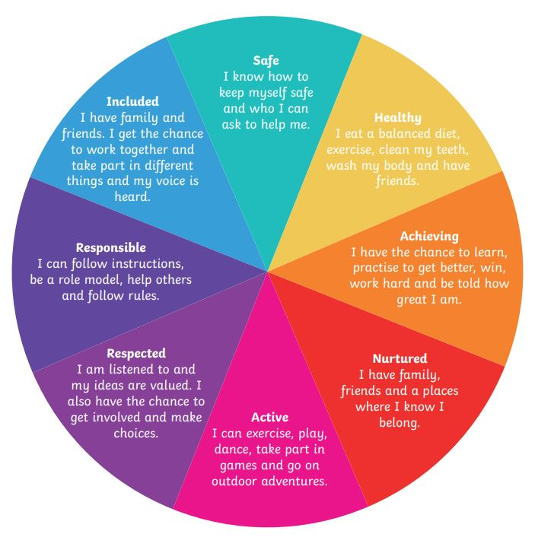
- Safe
- Healthy
- Achieving
- Nurtured
- Active
- Respected
- Responsible
- Included

We aim to plan and deliver inclusive Forest School activities:
Safe
- Risk and site assessments which ensure the site is suitable for all
- Small ratios with familiar adults
- Clear boundaries whilst allowing freedom to explore
- Modelling tool use and using friends to help those less able in tool use
Healthy
- Healthy food options
- Active outdoor activities
- Wearing appropriate clothing
Active
- Outdoor environment encourages physical activity and outdoor free play
- Large area for children to explore and enjoy
- Are encouraged to fully participate, regardless of medical needs or disabilities
- Planned activities which promote active lifestyles (tree climbing, woodland walks, etc.)
Nurtured
- A positive ethos is created and shared by all
- Opinions are valued
- Children are supported when necessary
- Differences are celebrated
- The environment stimulates senses
Achieving
- Plan for achievable tasks
- Use behavioural approach – positively praise each step
- Celebrate success
- Share experiences with others
- Differentiate the curriculum learning according to needs
Respected
- Listen to children’s views
- Allow children to risk assess
- Support developing friendships
- Consider groupings or partnerships to meet individual needs
Responsible
- Allowing children to light fires and use tools
- Children can teach each other new skills
- Children encouraged to risk assess their activities
Included
- Adapted activities depending on needs
- Appropriate locations to be chosen
- Extra adult ratio where needed
- Various food options available which respect religious beliefs
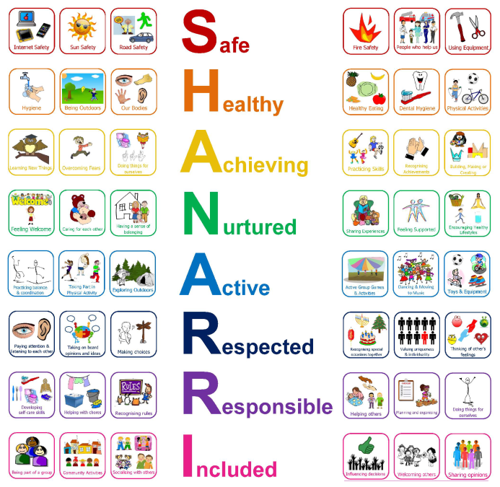
- Individual care plans in place where needed

Protection of Vulnerable Groups – Child Safeguarding
Child Safeguarding Policy is included in registration pack.

Healthy Eating
At AFK we encourage and promote a healthy eating programme. This always includes a variety of fresh fruit and/or vegetables. The children are offered the option of milk or water to drink. Children are encouraged to drink from an open cup. The daily menus are made up in a two-week rotation and are send to the parent/carer in advance. All lunches are free to all 1140 children, you may provide a packed lunch, but we ask that it be a healthy lunch.
Parents should inform staff of any food intolerances, allergies or dietary requirements at the registration process.

Setting the Table
The Setting the Table document highlights the importance of nutrition in the early years and the role that childcare providers have in shaping both current and future eating patterns in young children, AFK developed the menu for our children using this information.

Exercise
The children are lots of opportunities to take part in physical activities during our forest school sessions, in both planned activities and outdoor free play.

Child Smile (teeth brushing) Programme
The child smile programme focuses on the promotion of healthy eating and oral health within early years’ establishments as it is widely acknowledged that establishing healthy eating habits at an early age is important to ensure a balanced and varied diet which can then continue into adulthood. We have enrolled in this programme and will provide toothbrushing as part of the children’s daily routine.

Text service
The nursery uses text messaging to advise of upcoming events, unexpected closures, and changes in the service due to adverse weather conditions. It is important, therefore, that parents keep us informed of any changes to contact telephone numbers.

Security
The kindergarten doors are locked at all times. Entry to building is gained by ringing the doorbell. We ask parents/carers not to open the door for others to enter, but to advise a member of staff who will allow access.
Emergency Closure Arrangements
In extreme weather conditions please think of your child. Check before you set off as to whether the kindergarten has been affected by adverse weather conditions. You can telephone the kindergarten from 7.30am onwards if you have any concerns. Where possible we will update the Facebook and send a text to advise of closures.
There may be occasions when the kindergarten may have to close due to emergency circumstances out with our control. Parents will be notified through text message about any such closures.

Family Circumstances

At AFK we understand that family circumstances may change. It is helpful if the nursery is advised of any changes as soon as possible. You can be assured that any information given to staff will be treated sensitively and in confidence. It is helpful if you keep the staff informed of anything happening at home that might affect the way your child is feeling, or their behaviour, e.g. the birth of a sibling, death of a relative, moving home etc. It will help us support your child in a sympathetic and appropriate way.

Data Protection/GDPR
GDPR policy is included in registration pack.

Health and Wellbeing
If your child is required to take any medication prescribed by a GP during Kindergarten hours, please discuss this with a member of staff. Parents will be asked to complete a medication consent and intake form allowing the administration of medicine.
Asthma If your child suffers from asthma, please inform their keyworker. Parents should also advise of activities or circumstances that may bring on an attack.
Accidents/Incidents If any accidents or incidents occur during the sessions, staff will record them and inform the parent/carer. Parents/carers will be asked to sign the form and will be given a copy for their records.
Head Injuries If a child sustains a head injury, we will contact parents to advise them of the circumstances and condition of the child. Parents will then make a decision of whether to come to collect them immediately or wait until the end of the session.
Your Child is Unwell Please advise the Kindergarten before 9am if your child will not attend due to ill health. Please note nursery policy for children suffering from sickness and/or diarrhoea means that they should not return to kindergarten until 48 hours after their symptoms have subsided. This policy is in line with guidelines issues by NHS Scotland. If you are unsure, please contact the kindergarten for advice.
Should your child become unwell while at kindergarten, we will contact parents in the first instance. If parents cannot be reached, we will then contact the emergency contacts you have provided. In the event we are unable to contact anyone, the Manager will make a decision with regard to the child’s welfare.

We do NOT keep Calpol or Ibuprofen in the Kindergarten, the onus is on the parents to bring in prescribed medication. If your child has a fever and needs medication, they may be better at home until they feel better.

Fire Drills
A fire test is carried out every week. This helps ensure that alarm equipment and fire doors are checked regularly. A fire drill is carried out every month, this is to ensure staff and children are familiar with the evacuation procedures. The alarm systems and equipment are under contract to receive an annual inspection.

When the alarm sounds, children and staff will leave from the nearest emergency exit. They will walk to the designated fire muster point at the side of the building where they will be counted, and a register will be done. Once the staff are satisfied everyone is accounted for, they will return to the building.
There is fire procedure information at the entrance to every room.

Smoking Control
AFK have always operated a strict no smoking policy. Smoking is not permitted in the building.

Dogs
NO DOGS are allowed in the building unless by prior arrangement with management. We have children who may be frightened of dogs or have an allergy to them.

Insurance
Please dissuade your child from bringing toys or special things. They can easily become lost among out toys. We would hate precious items to be broken or go missing, AFK has no insurance to cover the loss of personal items.

Prams and buggies
Unfortunately, we do not have space to store buggies or prams in the building. Please take them home with you. In a situation where someone else is picking your child up, please speak to staff. We will NOT be held responsible if any buggy or pram is stolen or damaged.
Policies
We have a range of policies written to inform parents, staff and outside agencies of details of our practice. These are held in a policies folder in the corridor, and available via email upon request. The policies are sent to parents/carers during the registration process. We will ask parents for their input when reviewing polices.

Parking
Please park in the carpark at the side of the building. For pick up during high volume times staff will advise where to park.
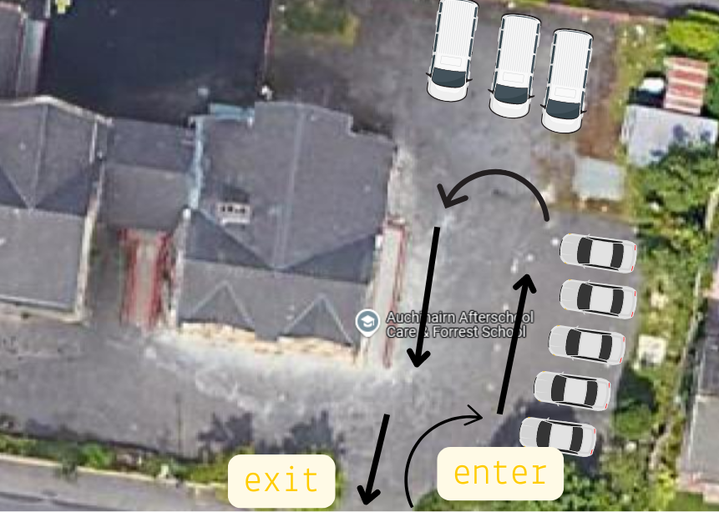

For collection and drop off at woods, information will be given to any new parents/carers on how to park at the woodland.

Risk Assessments
Risk assessments can be viewed upon request. To request please email auchinairnafterschoolcare@outlook.com

Travel
We will travel between the indoor base and woods using our fleet of minibuses. We will provide the appropriate child seat belt required by law. Or in cases where the seat belts are standard we will provide a child car seat.

CCTV Use in Our Setting
To help keep children, staff, and visitors safe, Auchinairn Forest Kindergarten uses closed-circuit television (CCTV) in key communal and external areas such as entrances, corridors, and outdoor play spaces. CCTV helps us maintain security, protect property, and support the investigation of any incidents or concerns. Cameras record images only — no audio or sound is recorded anywhere on site. Footage is stored securely, viewed only by authorised staff, and automatically deleted after a short retention period (normally 30 days) unless required for a specific investigation. We follow the UK General Data Protection Regulation (UK GDPR), the Data Protection Act 2018, and the Care Inspectorate’s guidance on privacy and safeguarding. If you would like more information, please speak with the Manager or our Data Protection Lead.

