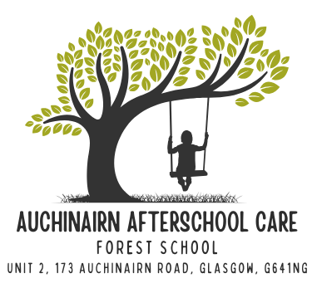

HOLIDAY DATES 2025/26
(from August 2025)

FULL DAY CARE GLASGOW
Friday 10th October 2025
Monday 13th to Friday 17th October 2025
Monday 16th – Wednesday 18th February 2026
Tuesday 7th – Friday 10th April 2025 & Monday 13th – Friday 17th April 2026.
Thursday 7th May 2026
Schools finish 1pm Thursday 25th June 2026

FULL DAY CARE EDC
Friday 10th October 2025
Monday 13th to Friday 17th October 2025
Monday 16th – Wednesday 18th February 2026
Tuesday 7th – Friday 10th April 2025 & Monday 13th – Friday 17th April 2026.
Thursday 7th May 2026
Schools finish 1pm Thursday 25th June 2026

CLOSED
Friday 26th & Monday 29th September 2025
Monday 22nd December 2024 – Friday 2nd January 2026
Friday 3rd April & Monday 6th April 2026
Monday 4th May 2026
Friday 22nd & Monday 25th May 2026
Monday 20th July 2026

We follow the council websites for holiday dates, if they are updated at any point, our dates may change. We will inform parents as soon as we have the information.

