WILD ROOTS FOREST CHILDCARE
2026-2027



Contents
Page 4-5 | Vision, Aims and Values
Page 6 | Aftercare information  Location
Page 7 | Insurance  Registering and Admissions  Enrolment  Admissions Policy
Page 8 | Staff
Page 9 | Staffing  Ratios  Role of Supporting Adult
Page 10 | AASC Forest School Families  Inductions and Taster Sessions
Page 11 | Inductions Cont.
Page 12 | Arrival and Collection Cont  Attendance  Late Collection  Un-Notified absence policy
Page 13-16 | Forest School Sessions  Risk Management  First Aid  Health and Safety  Daily Sessions  Cancellation
Page 17-19 | Play
Page 20 | Children’s Rights
Page 21 | Equal opportunities and Inclusion  Your child’s learning journal
Page 22 | Outings  Parent and carer communications  Complaints procedure
Page 23-24 | GIRFEC
Page 25-26 | Anti-Bullying
Page 27-28 | Behaviour
Page 29 | Behaviour cont.  Child Protection  Food at forest school  Exercise  Hygiene
Page 30 | Hygiene cont.  Text service  Security  Emergency Closure Arrangements  Data Protection
Page 31 | Health and Wellbeing  Fire Drills  Smoking Control
Page 32 | Dogs  Personal Property  Policies  Parking  Risk Assessments
Page 33 | Travel  Fees and Payments  CCTV



Visions, aims and values
The vision of Auchinairn Afterschool Care (AASC) and Forest School (FS) is to ensure children and staff within the service develop to the highest standard possible. We aim to provide a warm, caring, safe and stimulating environment for primary school aged children hours of 3pm and 6pm.

We value good character and promote a culture of collegiality, where integrity, respect, trust and communication are central to the culture. A culture where open and honest communication is valued, where co-operation is essential, and fairness is integral to a collegiate practice; These are at the core of the service’s ethos. We aim to help nurture happy, confident and resilient children.

We strongly believe in the benefits of outdoor play and are committed to providing outdoor and particularly woodland activities. Our approach to the outdoor practice is based on the six Forest School principles:

- Forest School is a long-term process of frequent and regular sessions in a woodland or natural environment, rather than a one-off visit
- Forest School takes place in a woodland or natural wooded environment to support the development of a relationship between the learner and the natural world
- Forest School aims to promote the holistic development of all those involved, fostering resilient, confident, independent and creative learners
- Forest School offers learners the opportunity to take supported risks appropriate to the environment and to themselves
- Forest School is run by qualified Forest School practitioners who continuously maintain and develop their professional practice
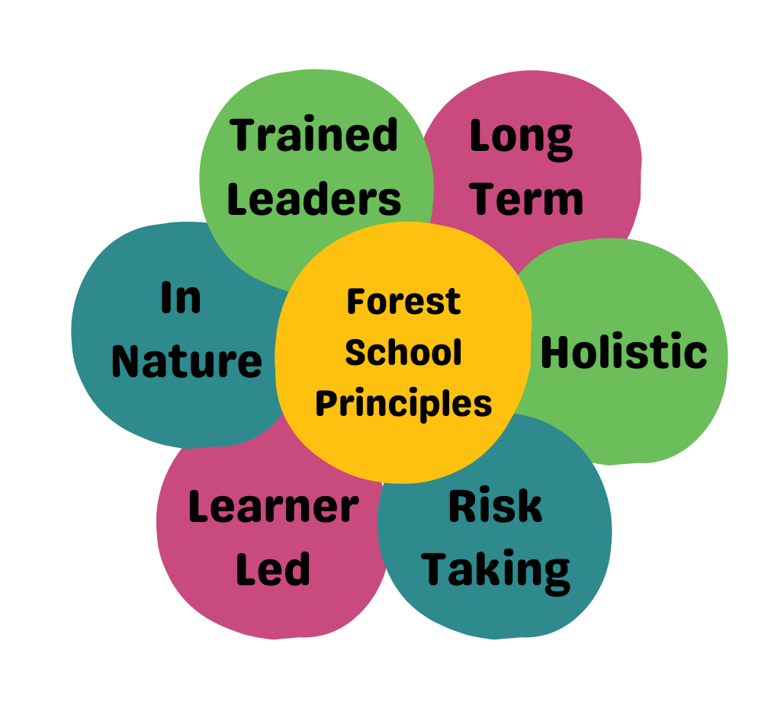
- Forest School uses a range of learner-centred processes to create a community for development and learning

We believe that children and young people should be respected for who they are and also for their capacity to instigate, test and maintain curiosity in the world around them. We believe in the child’s right to play, their right to access the outdoors, their right to access risk and their right to experience the vibrant reality of the natural world. Play is integral to the FS ethos and principles: - we aim to ensure children have access to an area which supports these principles and tailor to the needs of the individual child and their right to play.

Through the outdoor and woodland experiences, we provide, children and young people will be given the opportunity to develop curiosity, self-confidence, self-esteem, creativity, empathy, communication skills, social skills, their knowledge of the natural environment, their ability to assess risk, share responsibility in the decision-making process and share all duties fairly and equally. FS enables everyone to connect with nature, value the flora and fauna and take care of the environment.

Whether we are indoors or outdoors, we aim to provide a range of stimulating, fun activities and outings for all children. We aim to plan these activities and outings in collaboration with service users, within the local community. We aim to provide children with appropriately challenging and achievable tasks and activities which promote confidence, self-esteem, resilience, social skills, emotional intelligence, language and communication skills, problem solving skills, conflict resolution skills and independence.

We aim to ensure children are cared for by competent and confident staff, who, will respect and treat each child with dignity, respect for privacy, to help them make informed choices, to ensure their safety in all aspects of life, to encourage them to reach their full potential and ensure equality and diversity.

Sessions continue throughout all seasons and involve risk taking in a supported environment. There must be a level 3 trained FS leader or fire and tool trained staff member on site for fire and tool activities, shelter building and tree climbing to be allowed, and to ensure we respect the land.

Children within the service may participate in activities which will involve an element of risk, however, before participating, the child/young person’s age and stage of development will be assessed as will their understanding of the risks involved. The risks associated with such activities will be assessed and all such activities supervised.

Information
NAME | Auchinairn Afterschool Care and Forest School (AASC)
ADDRESS | Indoor – Unit 2, 173 Auchinairn Road, Glasgow, G641NG  Outdoor – Woodland off Lumloch Road, G645LD
TELEPHONE | 07584514181 or 07720086816
E-MAIL | auchinairnafterschoolcare@outlook.com
WEBSITE | www.auchinairnafterschoolcare.co.uk
SOCIAL MEDIA | Facebook – Auchinairn Afterschool Care & Forest School
CAPACITY | 96 Children from 3pm to 6pm.
CARE INSPECTORATE | CS2003003655 – Karen Bradley
HOURS OF OPERATION | 7.30am to 6pm
DAILY SESSION TIMES | 7.30am to 9am breakfast club. 3pm to 6pm Monday to Friday. 7.30am to 6pm school holidays full day care.
HOLIDAY DATES | Centre is closed on the following dates:  Friday 25th & Monday 28th September 2026  9th October 2026  Monday 21st December 2026 – Monday 4th January 2027  Friday 26th & Monday 29th March 2027  Monday 3rd May 2027  Friday 28th & Monday 31st May 2027  Monday 19th July 2027
FUNDING/FEES | Breakfast club is £7 per day, afterschool care is £19.50 per day and full day care is £48 per day.

Location
The location of our outdoor woodland site is off Lumloch Road, G665LD. This postcode covers a vast area of land, so we encourage you to search for the site via Google Maps. An aerial view of the site has been added below.
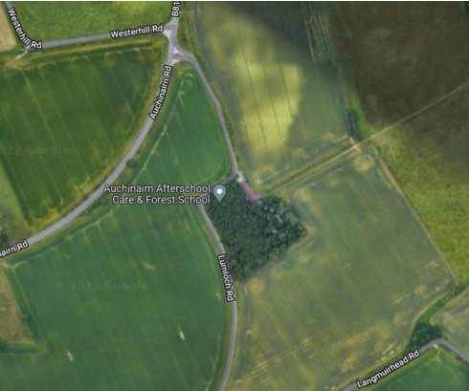

The woodland site AASC use is owned by Caledonian Estates and managed by Galbraith. AASC have been granted permission by Caledonian Estates to use the woodland for Forest School sessions. We have full access to the woodland site, overall maintenance of the site is our responsibility. However out of respect for the landowners AASC will ask for permission before taking down any trees, or making large changes to the site(like adding the car park).

Insurance
The Forest School is covered by Public Liability and Employer’s Liability Insurance. Insurance is brokered by Birnbeck Insurance Services. Birnbeck provides competitive bespoke insurance policies utilising the majority of UK insurers tailored to commercial, business and personal needs.
Registering and Admissions
Parents applying for an aftercare place must register by emailing Auchinairnafterschoolcare@outlook.com and requesting a registration pack.

Enrolment
Once you have completed the registration documents, you will be invited to attend a parent induction with a member of the AASC team. Before your child starts with the setting, they will also attend at least one child taster session.

Admissions Policy
Places will be allocated initially by date of application. There may be a small number of subsidised places available to families in line with regional priority groups.
Priority will be given to siblings of children already attending the service.
Full admissions policy can be found in the Parent Policies attachment.

Aftercare Staff
Name | Position | Qualifications | Days/Hours Worked
Management
Nikki Morton | Manager | PDA Childhood Practice | Monday to Friday
Julie Jamieson | Deputy Manager | FOLA Level 8. SVQ3 Social services of children and young people. PDA Childhood Practice - Underway | Monday to Friday
Senior Staff
Charlene Strang | Senior Childcare Practitioner | Forest School Leader Level 3.  SVQ3 CCLD. | Monday to Friday.
Nadine Jamieson | Senior Childcare Practitoner | Fire and tool trained. SVQ4 CCLD. | Monday to Thursday
Laurie Ferguson | Childcare Practitioner | SVQ3 Social services of children and young people. Fire and Tool Trained | Monday to Friday
Shannon Devine | Childcare Practitioner | Fire and tool trained.  working towards SvQ3 social services of children and young people | Monday to Friday
Mia Gribbon | Childcare Practitioner | Fire and Tool trained, working towards SCQ3 social services of children and young people | Monday to Friday
Ella Queen | Childcare Practitioner | Fire and tool trained, working towards SVQ3 social services of children and young people | Monday to Friday
Craig Bryson | Childcare Practitioner | Fire and Tool trained. | Monday to Friday
Kacie McCue | Childcare Practitioner | Fire and Tool Trained
All staff members have been vetted through Disclosure Scotland. All staff members are appropriately qualified and are members of the Scottish Social Services Council (SSSC).





Staffing and Ratios
Forest School sessions are run by a Level 3 Forest School Practitioners or Forest and Outdoor Learning(FOLA) level 8 with the support of other adults.
Qualified level 3 or Forest and Outdoor Learning(FOLA ) Level 8 Practitioners – Nikki Morton Level 3 (2017) and Lesley Morton Level 3 (2019),Charlene Ferguson FOLA level 8 (2023), Julie Jamieson FOLA level 8(2024). Most other members of the team are trained in fire and tool use.
All Forest School Leaders hold an Outdoor First Aid certificate while other staff members hold indoor First Aid certificates.
All members of staff have a current PVG, any helper/volunteer/new employee who do not have a PVG will never be left alone with children.
Leader Responsibilities
• Review and update relevant policies and the handbook when necessary
• Manage and update risk assessments when required
• Carry out Risk and Site Assessments, and share with all participating adults and children
• Inform parents of Forest School sessions, advising them of appropriate clothing and seek permission
• Carry an appropriate first aid kit in line with the First Aid policy to address medical and allergy needs.
• Engage with parents of children participating with Child Protection concerns or with Additional Support Needs so as to meet their needs appropriately.

Ratios
The following ratios as standard practice:
General Activities P1 – P7 1:8
Tool use and fire building P1 – P3 1:1/1:2 (when skilled)
P4 – P7 1:4 (This can be changed at FS Leaders discretion)
Adult supporters may consist of both PVG checked staff from within the practice and parent helpers to ensure the ratios are adhered to.

The role of the supporting adult
The role of the supporting adult in forest school is to assist the forest school leader in ensuring safety, security and the health & wellbeing of the learners. Assist in completing risk assessments(both site and dynamic) and regular inspections of the environment, activities and any equipment. They build trusting relationships and engage in shared learning through play-based and largely child-initiated and led activities. The supporting adult should always seek guidance from the Forest School Leader before organising activities.
AASC Forest School Families
Parents are encouraged to become involved in every stage of their child’s development. We recognise the importance of the partnership with families and strive to build and maintain a sound and effective relationship with each parent/carer. Your involvement will contribute greatly to all aspects of your child’s wellbeing. We are keen to involve parent/carer in our service and their contribution in improving the service. We have many activities that our families can become involved in, for example open days and get to know the staff sessions, and stay and play. We welcome family members to help at our open days and encourage grandparents to get involved too.

Afterschool Care Induction
At Auchinairn Afterschool Care, we want every child to feel safe, welcomed and ready to settle confidently into our service. To support this, all families follow a clear induction process before their child begins.
Parent/Carer Induction – Required
All parents and carers must complete an induction before their child can start attending. This ensures families are fully informed and we have all the necessary information to support each child’s wellbeing, safety and individual needs.
We understand that parents and carers have busy schedules, and to support this we have introduced a flexible digital induction that can be completed at a time that suits you.
Digital Induction
Our primary induction is delivered through our online digital induction, which provides key information about:
- Daily routines and collection procedures
- Snack arrangements, allergies and dietary needs
- Behaviour, wellbeing and our values-based approach
- Forest School/outdoor learning
- Policies, permissions and expectations
This must be completed before the child’s start date.
Optional Face-to-Face Induction
If preferred, families may request a face-to-face induction. This provides an opportunity to visit the setting, meet the team and discuss any individual needs or questions in person.
Taster Session – Required
Every child must attend a taster session before starting. This allows them to:
- Meet staff and other children
- Explore the environment
- Experience the routine informally
- Build confidence at their own pace
This helps ensure a smooth, positive transition for each child.
Key Worker Allocation
When a child starts with the service, they are allocated a key worker. The key worker:
- Builds a supportive, trusting relationship with the child
- Observes their strengths, interests and areas where they may need support
- Helps them settle into routines and make connections with others
- Works closely with families to share updates and support wellbeing
- Maintains and updates the child’s learning journal, celebrating achievements and tracking development
This approach ensures each child receives consistent support and feels known, valued and understood within the service.
Welcoming Your Child
Once enrolled, we take time to get to know each child—their interests, needs and what helps them feel secure. Staff offer a warm welcome, introduce routines gradually and support children to settle at their own pace.

Arrival and Collection
Breakfast Club
Children should be dropped at our indoor base for breakfast club from 7.30am, please note the latest your child can be dropped is 8.30am, as we leave for school at this time. The latest drop of for your child to have breakfast is 8.15am, this is to ensure your child has enough time to eat and enjoy their breakfast, if you are dropping your child after 8.15am please ensure they have had breakfast before.
Staff will escort your child to school using our fleet of minibuses.

Afterschool Care
Staff will collect your child from school at 3pm, we will then transport them to the location of our session via our fleet of minibuses. The service closes at 6pm.
Sessions take place in our outdoor woodland, should the location of the session need to change due to adverse weather, staff will inform parents via text message, please note only one parent will be messaged at this time, so whoever receives the message please pass the information on to whomever is collecting.
Children can be collected from the service at any time, however, the staff and children will leave the woodland and return to the indoor base at 5.30pm.
If you are collecting before 5.30pm please collect from the outdoor woodland, anytime after this children can be collected from the indoor base.

Full Day Care
Our service opens at 7.30am, children can be dropped off at the indoor base anytime after this. We ask that children are dropped off by 9am, to ensure we have can get ready for the outdoors as early as possible. If you are dropping off later than 9am, please text and inform staff. Children can be collected from the outdoor woodland or the indoor base. Generally during full day care we aim to return to the indoor base by 4.30pm, if there are any changes we will inform parents/carers via text message. Our service closes at 6pm.

Attendance
Regular attendance in aftercare is very important to ensure you child does not miss out on learning opportunities and experiences.
Children should be brought and collected from aftercare by a responsible adult. It is very important that staff are notified of any change in arrangements, for example if a friend or other family member is to drop/collect your child.
If staff do NOT know the person collecting, they will be asked for your password, which is your responsibility to pass on to them. Your child will not be passed over to someone without the correct password and your notice via message.
If you require to chat with the staff for any reason please ensure you are arriving for collection at least 10 minutes before the end of a session.
Late Collection
Our service closes at 6pm, if you are late there may be additional charges applied.
Un-notified Absence Policy
The aftercare requires you to phone or text before 12pm, if your child is unable to attend that day for any reason. School pick up time can be a stressful time for staff, especially if your child is not present on their scheduled day and you have not notified us previously.
Please note if you have not notified us of your child’s absence and we cannot get a hold of you at pick up time, we will follow our unnotified absence policy, which can be found in your registration pack.
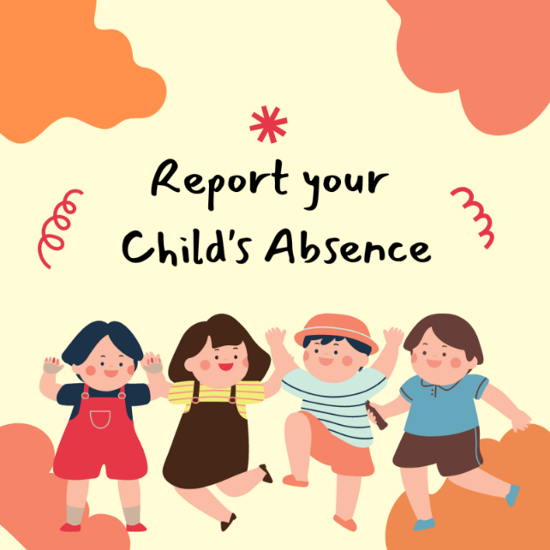

Forest School Sessions
Risk Management
Due to the child-led ethos in forest school and being out in a natural unpredictable environment, AASC forest school understands that taking risks will form a part of each session. We aim to risk assess dynamically throughout each session, and before any new activity take place a full risk assessment be drawn up by a forest school leader. Ultimately we will aim to teach learners how to assess risks on their own, allowing the learner to be fully independent during their forest school experience. In order to ensure we are providing the safest learning experience for our learners, the forest school leader's will consistently apply the five-step approach to risk assessments for all activities.
Five step approach
- Look for hazards
- Decide who may be harmed and how

- Evaluate the risks and decide whether the current precautions are adequate or whether more controls should be put in place
- Record the findings
- Review the assessment and revise if necessary

Risk assessments are how we ensure our forest school sessions remain safe, in addition we follow the guidelines below.
- Carry out seasonal risk assessments on each site Forest School activities take place.
- Daily site risk checklist will be completed by each forest school leader before any learners arrive on site, findings are recorded on daily risk assessment form.
- Complete an activity risk assessment for any new activity to be undertaken (before activity begins).
- Ensure all staff and helpers/volunteers have read over and are familiar with site, and activity risk assessments prior to session.
- Be responsible for teaching children adequate skills in order to keep themselves safe, particularly in relation to the use of tools and fire.
- Involve staff, volunteers and children in the risk assessment process as part of learning, and the forest school experience.
- Inform staff, volunteers and children of any potential hazards and any adjustments in place to minimise the risk.
- Ensure all legal guidelines regarding off-site activities, such as adequate insurance and parental permissions are met.
- Ensure that all staff, volunteers and children are aware of the emergency procedures for the forest school site.

First Aid
The responsibility of health and safety at Forest School is that of the qualified Forest School Leader. However, any adult who is trained within first aid and holds a current certificate may support the administration of First Aid. The leader will ensure that kits carry essential items and that procedures are followed according to the guidelines below. All members of the AASC have had first aid training as part of their induction training.
If an accident should occur, the senior staff member/forest school leader will complete and accident report which is shared with parents.

Before carrying out a Forest School session it is vital that any prior medical issues are known. Parents must complete a registration form, which has a section relating to medical needs. If a child should require regular medication parents must complete a medical administration form for the sessions which should be kept confidentially within the medicine/emergency bag. Adults/staff should be made aware of medical needs, such as the use of an epi pen or inhalers, where appropriate. AASC have a staff meeting where any medical needs are discussed before a session begins, to ensure all staff are made aware. Individual medicines should be kept in a box with the medical consent form, clearly labelled with the child’s name, date of birth and expiry date.

Health and Safety
AASC and Forest School health and safety policy is included in your registration pack.

Forest School Sessions
For forest school sessions, we section off the woodland into three groups, the school your child attends will determine which group they are in, they groups are red, yellow and blue. We section off the woodland using bunting as a boundary.
Once the children are transported to the woodland from school, the staff will support them to get ready for the outdoors, putting on their outdoor suits, boots and putting their personal items into a waterproof bag.
Once children are ready, they will wash their hands and sit for a small snack. During snack we will offer children a drink of water as well.
After snack children are then free to play within their group area, children are also allowed to explore out with their boundary, but must let the staff know before.
The staff for each group will come prepared with activities for the session, these activities include both forest school, craft, exploration, problem solving and physical activities. Listed below are some activities the children can take part in during a session.
- Fire building, campfire cooking, mini fires

- Tool work, flint and steel practice, using potato peeler, knives, axe, mallets, bow saw, hand saws, draw knives, palm drills, shovels etc. Any tool work must be done by a forest school qualified member of staff, or a staff member with the fire and tool qualification. The ratios of adult to child when doing these activities will depend on the children present and are at the discretion of the forest school member.

- Den building, using roped and tarps
- Tree climbing
- Foraging
- Whittling

- Obstacle courses, using slackline, blue net, ropes and tyres, zip-line
- Scavenger hunts
- Nature friendly crafts, we do not use glue or glitter in the woodland
- Physical games, great for keeping the children warm in the colder months
- Music games
- Water play
- Woodland walks
During every session staff will put up a swing, hammock, have mud kitchen, tarps and ropes available for the children to explore and play.
At the end of each session, children will tidy up their area before we leave the woodland. ‘Leave no trace’ is an important part of our forest school session ethos, and staff will support children to ensure we are leaving the woodland in the condition it was when they arrived. This includes tidying away any equipment or filling in any holes that the children may have made during the session.
The children will then get ready to leave the woodland, removing the outdoor suits, boots and getting their personal items from the waterproof bags.
Reflective practice is an important part of our sessions, completing a reflection with the children allows staff to understand which activities and events the children enjoyed, learn what the children would like to do in the future and highlights any problems that need to be addressed during future sessions. Collaboration between the staff and children during this time fosters trusting relationships and supports children to exercise their right to have their views and opinions heard. This reflection time also allows staff to reflect on their session and own practice, which is critical for improving their daily practice.

Cancellation of outdoor session
The Forest School Leader is responsible for the cancellation of Forest School sessions.
Forest School should be cancelled in the following circumstances:
- Changes and damages to the site deeming the site unsafe during the risk assessment that cannot be resolved in time.
- Severe weather conditions, for example thunder storms or high winds(above 5 on the Beaufort Scale).
- Insufficient adult to child ratio.
- Absence of Forest School Leader.
In the event of a cancellation parents will be informed through the service’s text messaging system. Parent helpers/volunteers will be personally phoned.
In the event of unexpected extreme weather, children will be transported back to indoor base and parents/carers will be notified by senior staff by text. Parents/carers will collect their children from the indoor base.
Should the outdoor session need to be cancelled, the session will be moved to the indoor base. The forest school leader will inform parents via our text messaging service if a session requires to be moved indoors. Should this occur AASC forest school will still try, where possible, to include aspects of the forest school learning to the indoor session.


The Importance of Play in Forest School
Play is a fundamental part of childhood and is recognised in Scotland as a core right, a developmental necessity, and a central feature of high-quality early learning and childcare (ELC) and primary-age pedagogy. As stated in the United Nations Convention on the Rights of the Child (UNCRC), Article 31, every child has the right to rest, leisure, and play. Scotland is committed to embedding the UNCRC in legislation, and AASC Forest School upholds these rights across our Kindergarten and Afterschool Care provision.
“Play is the highest expression of human development in childhood.”
— Friedrich Froebel
Play Within Scottish Policy and National Frameworks
Play is at the heart of several key Scottish educational and care documents, including:
- Realising the Ambition: Being Me (2020) – Scotland’s national practice guidance for early years. It emphasises learning through play, exploration, movement, and outdoor experiences.
- Curriculum for Excellence (CfE) – Play-based and experiential learning underpin early level experiences and outcomes, supporting smooth transition from early years into primary education.
- My World Outdoors (Care Inspectorate) – Highlights the importance of outdoor play in improving children’s wellbeing, confidence, resilience, and learning.
- My Childminding Experience / Out to Play Guidance – Advocates for frequent access to nature, loose parts, and high-quality outdoor environments.
- Play Strategy for Scotland (2013) and Getting It Right for Every Child (GIRFEC) – Recognise play as essential for achieving wellbeing indicators (SHANARRI): Safe, Healthy, Achieving, Nurtured, Active, Respected, Responsible, Included.
AASC Forest School embraces these principles by creating an environment where children—whether in our Forest Kindergarten or After School Care—can thrive through meaningful, sustained, and self-directed play outdoors.
Why Play Matters
Holistic Development
Play supports all areas of GIRFEC wellbeing and aligns with the developmental pathways outlined in Realising the Ambition. Through play, children develop:
- emotional wellbeing
- social skills
- physical competence
- creativity
- resilience
- curiosity and problem-solving
- early literacy and numeracy in meaningful contexts
Children who are supported to play freely in natural environments show long-term benefits in confidence, independence, and learning.
Health Benefits of Outdoor Play
Outdoor play is recognised by NHS Scotland and Care Inspectorate guidance as vital for children’s physical and mental health.
Benefits include:
- Increased physical activity and cardiovascular health
- Improved emotional regulation, calmness, and wellbeing
- Stronger immune system and fewer illnesses
- Better eyesight due to exposure to natural light
- Opportunities for healthy risk-taking, judgement, and resilience
- Development of gross and fine motor skills, balance, agility, and coordination
These benefits apply to early years and school-aged children, making high-quality outdoor provision essential in both our Kindergarten and Afterschool Care settings.
Environmental Connection and Sustainability
Aligned with Scotland’s commitment to Learning for Sustainability, outdoor play encourages children to:
- build a lifelong connection to nature
- understand seasonal changes, habitats, and ecosystems
- develop respect for the environment and living things
- learn how their actions impact the natural world
Forest School promotes environmental stewardship through regular, immersive contact with nature.
Social Benefits
Research and Scottish practice guidance highlight that outdoor play strengthens social development:
- encourages cooperation, negotiation, and teamwork
- fosters empathy, communication, and shared problem-solving
- reduces conflict and bullying
- enhances peer relationships
- supports mixed-age interactions (important in Afterschool Care)
Natural environments stimulate social interaction, giving children space to collaborate, take turns, lead, and follow in equal measure.
Cognitive and Learning Benefits
Play aligns with the Curriculum for Excellence Early Level by enabling experiential, hands-on learning. Outdoors, children:
- make decisions and solve problems
- test theories and explore cause and effect
- use imagination and creativity
- embed early literacy and numeracy through real experiences
- strengthen executive functioning: planning, sequencing, organising, and evaluating
“Learning that flows between indoors and outdoors makes the most efficient use of children’s interests and natural curiosity.” (Realising the Ambition)
Outdoors, children encounter open-ended opportunities for learning across the curriculum in a way that feels natural, joyful, and meaningful.
Will Children Really Learn Through Play?
Yes—play is recognised by Scottish Government, Education Scotland, and Care Inspectorate as an essential form of learning.
In Forest School, children learn through:
- exploration
- curiosity
- risk assessment
- creative thinking
- problem-solving
- teamwork
- resilience
Outdoor spaces offer fewer constraints, more novelty, and greater sensory richness than indoor settings, making them ideal for supporting real-world learning.
For Kindergarten children, play forms the foundation of early learning.
For primary-aged children in Afterschool Care, play offers crucial time for recovery, expression, physical activity, and emotional regulation after the structure of the school day.
Play is not an “extra”—it is central to healthy development and lifelong learning.
Outdoor Learning and Play Opportunities
AASC Forest School provides:
- access to diverse natural spaces
- opportunities for movement, exploration, and challenge
- open-ended loose parts play
- sensory and physical learning essential for brain development
- safe opportunities for risk-taking
- experiences that support wellbeing, resilience, and independence
For many children, Forest School may be the only safe, accessible outdoor environment they can regularly access. This makes our provision vital to ensuring all children experience their right to play, their right to nature, and their right to meaningful outdoor learning.


Children’s Rights
We want to recognise, respect and promote children’s rights. These include right to be treated fairly, to be heard and to be as healthy as possible.
Our vision is a Scotland where children’s human rights are embedded in all aspects of society. A Scotland where policy, law and decision making take account of children’s rights and where all children have a voice and are empowered to be human rights defenders.
Parents and families, communities, local and national governments, and organisations which work with children and families, all play a critical role in helping children understand and experience their rights.
The United Nations Convention on the Rights of the Child (Incorporation) (Scotland) Bill: leaflet - gov.scot (www.gov.scot) is the global ‘gold standard’ for children’s rights and sets out the fundamental rights of all children. We already use UNCRC as a framework to ensure that we consider children’s rights whenever we take decisions, and to help provide every child with a good start in life and a safe, healthy and happy childhood. It forms the basis of the national approach for supporting children, called Getting it right for every child (GIRFEC) - gov.scot (www.gov.scot).


Equal opportunities and Inclusion
At AASC and Forest School we promote equality and strive to help every child benefit from education.
All staff ensure equal opportunities are given regardless of age, disability, marriage, civil partnership, gender reassignment, pregnancy and maternity, religion and belief, sex and sexual orientation.
All incidents of racism are treated seriously and reported.
Full equality policy can be found in registration pack.


Your Child’s Learning Journal
Why we use online journals:
- To develop home links with parents/carers
- Encourage parents to become involved with their child’s forest school journey
- Encourage home learning and tack your child’s development at forest school
- To allow parents access to their child’s progress on a regular basis
- To all parents to look at children's photographs
- To allow children to share their achievements to family and friends across the world

With Online Learning Journals parents are able to log into their child’s profile at any time and comment and interact with their learning. They can also upload their own home observations or achievements from home.


Outings
When adverse weather prevents us from taking our session to our usual woodland setting, we will utilise local places of interest for the children to visit and explore, ensuring that they are still getting outdoors, and maintaining their connection with nature.

Parent and Carers Communication
At AASC and Forest School we recognise the great importance of working with parents and carers to establish good relationships. We hope to work together with parents and carers to achieve this. There are several ways in which we will communicate with you:

- Online tapestry journal
- Newsletters

- Parent board in centre
- Texts
- Emails
- Facebook
- Website
- Face to face
We will also have open days throughout the year, which allows parents to come to our woodland and see what a forest school session looks like, as well as get involved with the activities.
Complaints Procedure
We are always keen to maintain our quality of service, If, however, you have a complaint the nursery will deal with this as quickly as possible. Please refer to our complaints policy for information on our complaints procedure, this can be found in our registration pack.
Our Care Inspectorate number is CS2003003655, we are inspected on regular intervals, our latest Care Inspectorate report can be found on our website. www.auchinairnafterschoolcare.co.uk

GIRFEC (Getting it Right for Every Child)
GIRFEC is the national approach in Scotland to improving outcomes and supporting the wellbeing of our children and young people by offering the right help at the right time for the right people.
SHANARRI
The acronym SHANARRI is formed from the eight indicators of wellbeing:
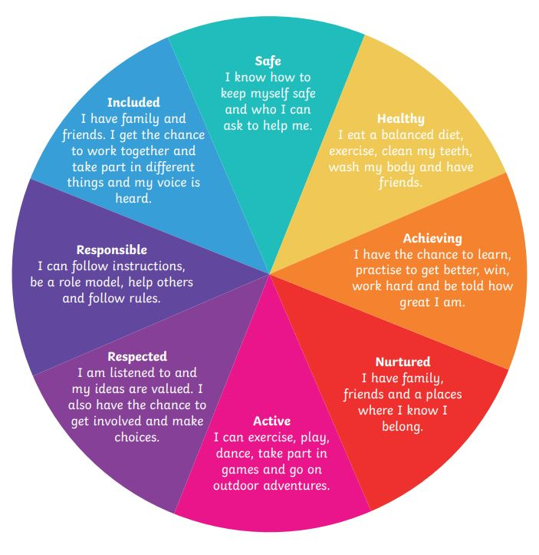
- Safe
- Healthy
- Achieving
- Nurtured
- Active
- Respected
- Responsible
- Included

We aim to plan and deliver inclusive Forest School activities:
Safe
- Risk and site assessments which ensure the site is suitable for all
- Small ratios with familiar adults
- Clear boundaries whilst allowing freedom to explore
- Modelling tool use and using friends to help those less able in tool use
Healthy
- Healthy food options
- Active outdoor activities
- Wearing appropriate clothing
Active
- Outdoor environment encourages physical activity and outdoor free play
- Large area for children to explore and enjoy
- Are encouraged to fully participate, regardless of medical needs or disabilities
- Planned activities which promote active lifestyles (tree climbing, woodland walks, etc.)
Nurtured
- A positive ethos is created and shared by all
- Opinions are valued
- Children are supported when necessary
- Differences are celebrated
- The environment stimulates senses

Achieving
- Plan for achievable tasks
- Use behavioural approach – positively praise each step
- Celebrate success
- Share experiences with others
- Differentiate the curriculum learning according to needs
Respected
- Listen to children’s views
- Allow children to risk assess
- Support developing friendships
- Consider groupings or partnerships to meet individual needs
Responsible
- Allowing children to light fires and use tools
- Children can teach each other new skills
- Children encouraged to risk assess their activities
Included
- Adapted activities depending on needs
- Appropriate locations to be chosen
- Extra adult ratio where needed
- Various food options available which respect religious beliefs
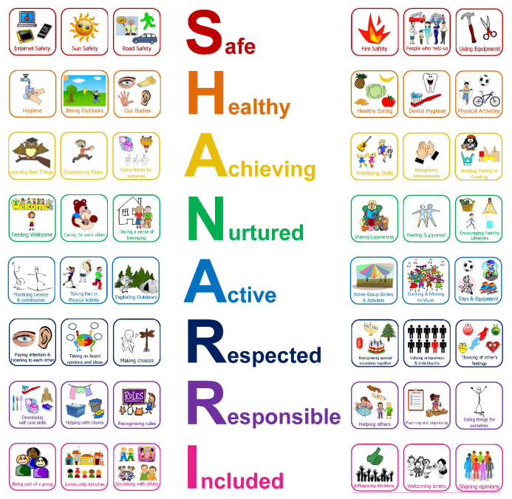
- Individual care plans in place where needed

Anti-Bullying
Auchinairn Afterschool Care and Forest School will provide a supportive, caring and safe environment in which all children are free from the fear of being bullied. Bullying of any form is not tolerated in our service, whether carried out by a child or an adult. Staff, children and parents or carers will be made aware of the service’s position on bullying. Bullying behaviour is unacceptable in any form. Any child who is a victim of bullying will be dealt with in a sympathetic manner. If bullying is suspected or reported, the incident will be dealt with immediately by the member of staff informed, and then discussed with the supervisor. A clear account of the incident will be recorded in an Incident form. All staff will be informed so that close monitoring of the victim and bully can begin.
Parents of both parties will be informed.
Auchinairn Afterschool Care and Forest School defines bullying as the repeated harassment of others through emotional, physical, psychological or verbal abuse.
• Physical: Pushing, scratching, spitting, kicking, hitting, biting, taking or damaging belongings, tripping up, punching or using any sort of violence against another person.
• Psychological: Behaviour likely to create a sense of fear or anxiety in another person.
• Emotional: Being deliberately unkind, shunning or excluding another person from a group or tormenting them. For example, making another person feel ‘left out’ of a game or activity, passing notes about others or making fun of another person.
•Verbal: Name-calling, put-downs, ridiculing or using words to attack, threaten or insult. For example, spreading rumours or making fun of another person’s appearance.
Preventing bullying behaviour
Staff at Auchinairn Afterschool Care and Forest School will foster an anti-bullying culture in the following ways:
• Encouraging caring and nurturing behaviour
• Discussing friendships and encouraging paired, group and team play
• Encouraging children to report bullying without fear
• Discussing the issues surrounding bullying with the children, including why bullying behaviour will not be tolerated
• Exploring the consequences of bullying behaviour with the children.
Responding to bullying behaviour
Auchinairn Afterschool Care and Forest School acknowledges that despite all efforts to prevent it, bullying behaviour is likely to occur on occasion. Should such incidents occur, the service will respond in accordance with the following principles:
• We will address all incidents of bullying thoroughly and sensitively.
• Victims of bullying will be offered the immediate opportunity to discuss the matter with a member of staff who will reassure the child and offer support.
• They will be reassured that what they say will be taken seriously and handled sympathetically.
• Staff will support the individual who has been bullied, keeping them under close supervision, and checking their welfare regularly.
· If another child witnesses bullying and reports this, staff will reassure them that they have done the right thing. Staff will then investigate the matter.
• If a member of staff witnesses an act of bullying, involving children or adults at the service, they will inform the supervisor.
• Children who have bullied will be helped by discussing what has happened, establishing why the child became involved. Staff will help the child to understand why this form of behaviour is unacceptable and will encourage him/her to change their behaviour
• If bullying behaviour persists, more serious actions may have to be taken, as laid out in the promoting positive behaviour policy.
• All incidents of bullying will be reported to the manager and will be recorded on an Incident form. The manager and other relevant staff will review the service’s procedures in respect of bullying, to ensure that practices are relevant and effective.



Behaviour at Forest School
At Forest School, we believe that children thrive when they feel safe, respected, valued, and included. Positive behaviour develops through strong relationships, clear expectations, and a nurturing environment rather than through punishment or rewards. We follow a Values Based Development approach, modelling respect, kindness, trust, empathy and responsibility in all we do. These values are discussed daily and children are encouraged to practise them both at Forest School and beyond.
Our approach is guided by national frameworks including GIRFEC, UNCRC, Better Relationships, Better Learning, Better Behaviour, the Care Inspectorate, and the Playwork Principles. We view behaviour as communication, and our aim is to understand what children are telling us through their actions while helping them develop emotional regulation, social skills, and confidence.
Our Behaviour Approach
Forest School nurtures a positive learning environment by focusing on what children do well. Staff model calm, respectful interactions, and use positive language to promote cooperation and emotional wellbeing. We help children learn the skills needed to manage emotions, resolve conflict, and build strong relationships.
We do not use extrinsic rewards or punishment. Instead, we rely on restorative conversations, empathy, problem-solving, and supporting children to take ownership of their actions. Behaviour is addressed on an individual basis, reflecting our child-centred philosophy and recognising the unique needs, abilities and experiences of each child.
Collaborative Expectations: Our “Ways of Being”
Rather than having a list of rules, we work with children to develop shared agreements based on Good Character. These include ideas such as:
- We look after each other
- We take care of our forest and equipment
- We listen to others
- We use kind words and actions
These principles are revisited regularly—often on the walk to the woods—and reinforced through conversation, modelling and practice.
How We Encourage Positive Behaviour
We support children to succeed by:
- Connecting first – understanding how a child is feeling before responding.
- Focusing on learning, not blame – exploring what happened and what could be done differently.
- Using restorative practice – discussing impact, repairing harm, and restoring relationships.
- Keeping a calm, nurturing atmosphere – adults model gentle voices and respectful language.
- Promoting autonomy – giving children space to solve problems independently when safe.
- Celebrating positive contributions – noticing kindness, cooperation, empathy, effort and teamwork.
When Challenges Arise
We understand that challenging behaviour is something a child does, not something they are. With support, children can learn new strategies.
Our stepped approach is:
- Gentle reminder about our shared agreements.
- Supportive conversation to understand feelings and help regulate emotions.
- Restorative follow-up to repair relationships and reflect on what happened.
- Partnership with families if concerns continue, working together to support the child.
Children are always given time, space, and support to resolve conflict and reflect on choices.
More Serious or Unsafe Behaviour
If behaviour:
- Goes against our values and ethos
- Is unsafe, harmful, or aggressive (verbally, emotionally, or physically)
- Prevents others from learning or participating
- Stops staff from safely leading the session
We will:
- Discuss concerns with parents/carers to agree strategies for positive support.
- Act immediately if a child’s behaviour poses a significant safety risk. Families may be contacted for immediate collection.
- Continue working in partnership to put in place additional support strategies.
- Only consider exclusion when all other reasonable strategies have been exhausted.
Staff complete an incident report for any serious or ongoing concerns.
Forest School does not provide refunds where a child must be collected due to unsafe behaviour.
Bullying, Inclusion and Respect
We do not tolerate bullying, including repeated behaviour that harms, frightens or excludes another child. Our response follows the RespectMe national guidance.
We are committed to inclusion, equal opportunities, and upholding children’s rights (UNCRC Article 12 – the right to be heard). All children are welcomed and supported to participate fully.
Working in Partnership with Families
We believe children achieve the best outcomes when home and Forest School work together. Families can expect:
- Open communication about approaches, expectations and concerns
- Early conversation if behaviours of concern arise
- Shared planning of strategies to support their child
- Respect for their insights into their child’s needs
We aim to help every child feel capable, confident, and connected.

Listening to Children’s Voices
Children are involved in shaping our approach through discussions, reflection, role-play, and group planning. Their ideas help guide our shared expectations and support strategies.



Protection of Vulnerable Groups – Child Safeguarding
Child Safeguarding Policy is included in registration pack.

Food at forest school
At snack time children will be offered a choice of snack, this is usually a low sugar item, such as crackers, cheese biscuits, breadsticks, rice cakes, etc. While cooking on the fire, we offer a variety of items, these include, hotdogs, pancakes, waffles, s’mores, pizza, crepes, brioche, pain au chocolate, etc.
All dietary restrictions are adhered to, we have alternatives of the above items, for children with any dietary requirements.
Parents should inform staff of any food intolerances, allergies or dietary requirements at the registration process.

Exercise
The children are lots of opportunities to take part in physical activities during our forest school sessions, in both planned activities and outdoor free play.
Hygiene
Toileting
Within the parent consent form parents will be made aware of the toileting procedure and children will be carefully informed of this also.
During our sessions we provide an onsite portable toilet, which is located inside a toilet tent with an eco-friendly toilet. The waste is taken away from the woodland site and disposed of safely at the indoor base.
New children to the service are shown the toilet and how to use it during their first visit to the site, to help them build confidence and familiarity with the toilet.
If a child should require assistance while using the toilet, the staff member will do so in a manner which the dignity of the child is not compromised and all child protection guidelines are met, this may include bringing in another staff member for assistance.
Handwashing
A handwashing station (tippy tap) is located near to the toilet area to ensure children have access to handwashing after they use the toilet.
Children are encouraged to use the tippy tap before eating and after using the toilet, regular handwashing is also encouraged throughout sessions.
Handwashing guidelines(taken from by NHS Scotland) are also in view of the handwashing station. AASC use eco-friendly soap which will not have an adverse effect on the environment.
Hands are dried with paper towel. All waste is taken off the site, it is the responsibility of all staff members to remove all handwashing and toileting equipment from the site.

Text service
The aftercare uses text messaging to advise of upcoming events, unexpected closures, and changes in the service due to adverse weather conditions. It is important, therefore, that parents keep us informed of any changes to contact telephone numbers.

Security
The aftercare doors are locked at all times. Entry to building is gained by ringing the doorbell. We ask parents/carers not to open the door for others to enter, but to advise a member of staff who will allow access.
Emergency Closure Arrangements
In extreme weather conditions please think of your child. Where possible we will update the Facebook and send a text to advise of closures.
There may be occasions when the aftercare may have to close due to emergency circumstances out with our control. Parents will be notified through text message about any such closures.
The in-depth policy regarding emergency closures can be found in your policies pack.

Family Circumstances
At AASC and forest school we understand that family circumstances may change. It is helpful if the aftercare is advised of any changes as soon as possible. You can be assured that any information given to staff will be treated sensitively and in confidence. It is helpful if you keep the staff informed of anything happening at home that might affect the way your child is feeling, or their behaviour, e.g. the birth of a sibling, death of a relative, moving home etc. It will help us support your child in a sympathetic and appropriate way.

Data Protection/GDPR
GDPR policy is included in registration pack.

Health and Wellbeing
If your child is required to take any medication prescribed by a GP during aftercare hours, please discuss this with a member of staff. Parents will be asked to complete a medication consent and intake form allowing the administration of medicine.
Asthma If your child suffers from asthma, please inform their keyworker. Parents should also advise of activities or circumstances that may bring on an attack.
Accidents/Incidents If any accidents or incidents occur during the sessions, staff will record them and inform the parent/carer. Parents/carers will be asked to sign the form and will be given a copy for their records.
Head Injuries If a child sustains a head injury, we will contact parents to advise them of the circumstances and condition of the child. Parents will then make a decision of whether to come to collect them immediately or wait until the end of the session.
Your Child is Unwell Please advise the aftercare before 12 noon if your child will not attend due to ill health. Please note the aftercare policy for children suffering from sickness and/or diarrhoea means that they should not return to aftercare until 48 hours after their symptoms have subsided. This policy is in line with guidelines issues by NHS Scotland. If you are unsure, please contact the aftercare for advice.
Should your child become unwell while at aftercare, we will contact parents in the first instance. If parents cannot be reached, we will then contact the emergency contacts you have provided. In the event we are unable to contact anyone, the Manager will make a decision with regard to the child’s welfare.

We do NOT keep Calpol or Ibuprofen in the aftercare, the onus is on the parents to bring in prescribed medication. If your child has a fever and needs medication, they may be better at home until they feel better.

Fire Drills
A fire test is carried out every week. This helps ensure that alarm equipment and fire doors are checked regularly. A fire drill is carried out every month, this is to ensure staff and children are familiar with the evacuation procedures. The alarm systems and equipment are under contract to receive an annual inspection.
When the alarm sounds, children and staff will leave from the nearest emergency exit. They will walk to the designated fire muster point at the side of the building where they will be counted, and a register will be done. Once the staff are satisfied everyone is accounted for, they will return to the building.
There is fire procedure information at the entrance to every room.



Smoking Control
AASC and Forest School have always operated a strict no smoking policy. Smoking is not permitted in the building.
Dogs
No dogs are allowed in the building unless by prior arrangement with management. We have children who may be frightened of dogs or have an allergy to them.

Personal Items at forest school
Please dissuade your child from bringing toys or special things. They can easily become lost among our toys. We would hate precious items to be broken or go missing, AASC and Forest School has no insurance to cover the loss of personal items.

Policies
We have a range of policies written to inform parents, staff and outside agencies of details of our practice. These are held in a policies folder in the corridor, and available via email upon request. The policies are sent to parents/carers during the registration process. We will ask parents for their input when reviewing polices.

Parking
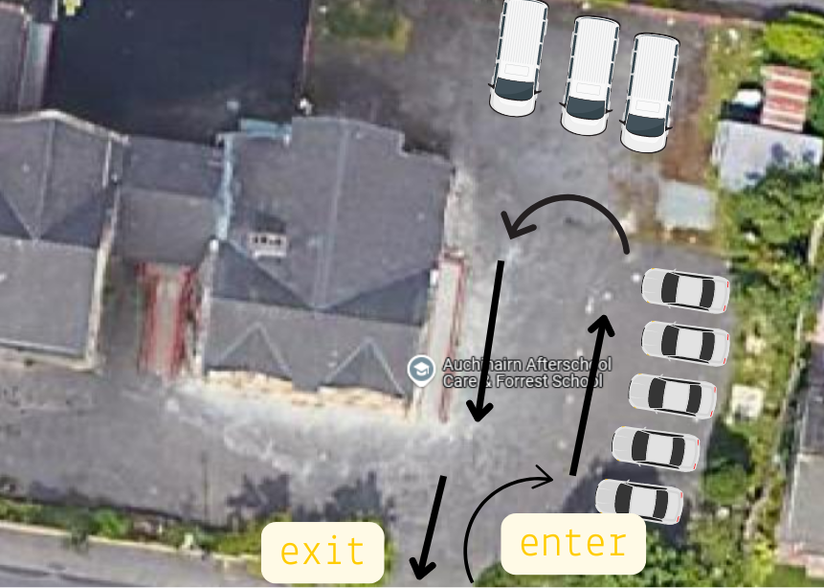
Please park in the carpark at the side of the building. For pick up during high volume times staff will advise where to park. There is a system in place to keep the disruption for parents to a minimum when collecting children, please enter the car park and follow instructions from staff. There is a diagram below for extra information.

For collection and drop off at woods, information will be given to any new parents/carers on how to park at the woodland during your induction, but we follow a similar system as we do indoors.

Risk Assessments
Risk assessments can be viewed upon request. To request please email auchinairnafterschoolcare@outlook.com

Travel
We will travel between school and indoor base or woods using our fleet of minibuses. We will provide the appropriate child seat belt required by law. Or in cases where the seat belts are standard we will provide a child car seat.

Fees and Payments
Fees are due on the 1st of each month, from August to June, or from August to July if you add on holiday dates. Fees are paid up front, so fees paid on the 1st of August will cover sessions taken throughout August.
Fees are calculated for the year, we take the total number of days attending, add any extras like our annual registration fee, then evenly divide the total over the payment months of the year. This means that your monthly fee will not change throughout the year, you will have the same amount to pay on the 1st of each payment month.

CCTV Use in Our Setting
To help keep children, staff, and visitors safe, Auchinairn Afterschool Care uses closed-circuit television (CCTV) in key communal and external areas such as entrances, corridors, and outdoor play spaces. CCTV helps us maintain security, protect property, and support the investigation of any incidents or concerns. Cameras record images only — no audio or sound is recorded anywhere on site. Footage is stored securely, viewed only by authorised staff, and automatically deleted after a short retention period (normally 30 days) unless required for a specific investigation. We follow the UK General Data Protection Regulation (UK GDPR), the Data Protection Act 2018, and the Care Inspectorate’s guidance on privacy and safeguarding. If you would like more information, please speak with the Manager or our Data Protection Lead.

