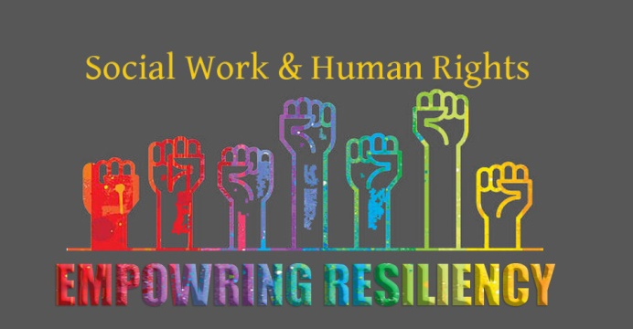
DEADLINE EXTENDED UNTIL AUGUST 26!

Part 1: 2020 Conference Theme
NASW-NM is seeking submissions for our 2020 Social Work Conference: “Social Work & Human Rights: Empowering Resiliency” The theme this year resulted from many conversations with our community of social workers, stakeholders, and social justice patterns. Time after time, the idea that People Matter and Human Rights is the defining issue of our time was resounding. This is a complex time in our history as a world, nation, and state and we have the opportunity to shift the discourse to consider the ecological correlates, social environmental factors, psychological contexts, as well as the power of culture and strengths. Our work is action focused and pragmatic at its core so this year we want to strive for applicants who have focus, passion, and direction to improve our world and work.
We are looking for advanced and applied presentations that relate to Social Work and Human Rights at any and all levels – micro, mezzo, and macro. This can include local efforts, national interests, as well as international development and may include the areas of health/mental health, criminal justice, teaching/research, children/youth/families, clinical work, advocacy, and community development, as well as work with specific populations at risk such as immigrant, indigenous, mixed race, LBGTQ, veteran, aging, and homeless populations.
Proposals that include elements of culture, strengths, and resiliency specific to those living in the Southwest are of special interest to our conference.
NOTE: Our 2020 Conference is a 100% Cultural Conference and ALL CEUs will be cultural. Non cultural applications will not be reviewed. Cultural content is such that concerns specific populations and does not focus on tasks or skill development in isolation.
All presentations should be suitable for a 1.5 OR 2 hour presentation including questions.
Criteria for Submission:
Each proposal will be rated on the basis of meeting the following criteria:
- Relevance to conference theme and nature of Cultural content.
- Innovative, applied, and advanced content. Content cannot be basic or entry level.
- Quality of proposal.
- Real World application.
- Use of creative and real world examples.
- Plan for audience interaction and critical thinking.

Required Format:
The Submission Review Committee seeks high quality presentations and all submissions must include the following elements:
- A completed Application Form.
- A 150 word biography describing all presenters and co-presenters credentials, titles, and experience.
- Three learning objectives.
- A 400-500 word abstract including the purpose for and content delivered in your proposed session.
- A 100-150 word summary describing your presentation for the Conference Program
- A high resolution photo for the Conference Program
Notes and Reminders:
- All pages of the Application must be typed and only completed applications will be reviewed.
- All communications from NASW-NM will go to the lead presenter who will be responsible for conveying information to co-presenters.
- Incomplete, unedited, unprofessional, and/or hand-written proposals will not be reviewed.
- Selected proposals will be received one (1) free full conference registration and one (1) 50% off conference registration for a co-presenter.

Part 2: Application for Conference Presentation
Applications must be emailed to conference@naswnm.org by August 26th, 2019.
If you DO NOT receive an email confirmation that we received your proposal within 2 business days, please contact the office at 505-247-2336 ext. 102.
- Name of person submitting application:
- Date application submitted:
- Title of Presentation (15 words max):
- Current NASW Member? __ Yes __No
Note: Preference will be given to applications submitted by NASW members. You can join at socialworkers.org.

It should be noted that attendance for individual sessions can range from 30 to over 250 participants. Sessions that seek to have a small group and/or group activities CANNOT BE GUARANTEED AND CAPPING IS NOT ALLOWED. Rooms will be pre-set in theatre (chairs only) and cannot be re-arranged.

- Presentation Type: __ Lecture/PowerPoint
__ Panel Discussion (at least three presenters- including a designated moderator) __ Group Interaction (if selecting this category, explain planned activities below
____________________________________________________________________________________________________________________________________________________________________________
ALL SESSIONS SHOULD ALLOW TIME FOR 15 MINTUTES OF Q&A. ALL PRESENTATION SPOTS ARE 1.5-2 HOURS.

- Specialty: __ Child Welfare __ Criminal Justice/Macro __ Disability __ Gerontology __LGBTQ __ Legislative Issues __Medical Social Work __Native American Task Force __ Self-Care
__ Native American __ School Social Work __ Self Care __Substance Abuse __ Veterans
__Other __________________________
- Lead presenter name & credentials:
Employer: Email:
Address: City/State/Zip:
Phone: Phone 2:

Additional All Presenters: (for students list, anticipated degree, graduation year, university/college)
Name and credentials: Employer:
Name and credentials: Employer:
Name and credentials: Employer:

- Have you presented to a group of 50 or more people? __ Yes __ No
- This is my only submission? __ Yes __ No
If no, please list titles of other(s):
- If your proposal is not accepted for this year’s conference, would you be interested in presenting this topic at other NASW-NM events? __ Yes __No

Part 3: Details on Presentation Content
A completed application must contain the following information filled in on this page. Attachments are not necessary and will not be accepted for review.
- Lead Presenter Name:
- Presentation Title:
- Short Biographical Paragraph (no more than 150 words- MUST INCLUDE WORD COUNT)

- Three Learning Objectives

- A 400 – 500 Word Abstract (MUST INCLUDE WORD COUNT)

- Description of Presentation (for the program if proposal is selected) No more than 100-150 words
(MUST INCLUDE WORD COUNT)

Applications must be emailed to conference@naswnm.org by August 15th, 2018
Part 4: Application Checklist and Signature
___Application is completed and proofread. Incomplete applications will not be accepted
___Content materials are advanced and applied
___High resolution photos of all presenters are attached
___Application is signed and dated by lead presenter

Lead Presenter Signature _____________________________________ Date:__________________
If you DO NOT receive an email confirmation that we received your proposal within 2 business days, please contact the office at 505-247-2336 ext. 101 to confirm that your application was received.

