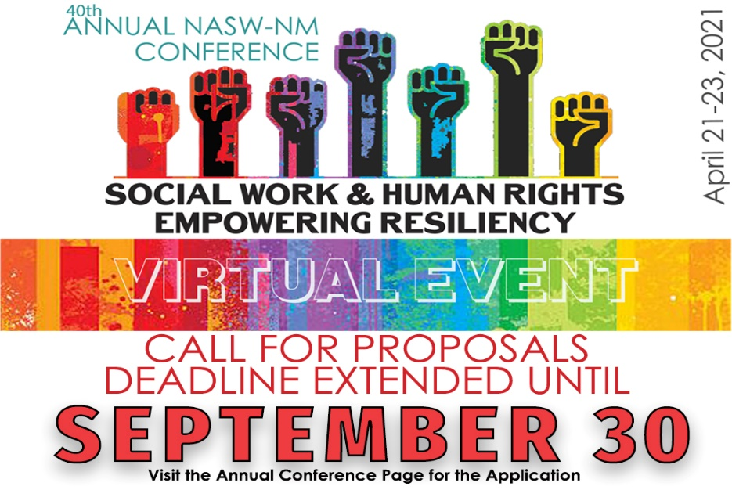
Present a session at our first Social Work VIRTUAL CONFERENCE
PREFERENCE WILL BE GIVEN TO ADVANCED PRACTICE AND/OR CULTURAL TOPICS
Part 1: 2021 Conference Theme
NASW-NM is seeking submissions for our 2021 Social Work Conference. Social Work & Human Rights: Empowering Resiliency.
Given the current events and with member input it has been decided that the theme will remain the same as it would have been for our 2020 conference. The theme is so timely with the state of our nation in regarding social justice and the emotional and physical toll that COVID-19 has taken. We will also proclaim it to be our 40th Annual Conference! The fact that People Matter and Human Rights are the defining issues of our time is resounding. The historical and generational trauma created by the institutional injustices of indigenous people and people of color feels overwhelming. This is not a new conversation nor how we respond to it, but social work is so pivotal in creating a different world, a different foundation. This year we want to strive for presentations that have the passion and direction to improve our world and work. Applicants must give relevant and pragmatic solutions and tools that social workers can implement in their communities as professionals.
We are looking for advanced and applied presentations that relate to Social Work and Human Rights at every level: micro, mezzo, and macro. This can include local efforts, national interests, as well as international developments. It may include the areas of health/mental health, criminal justice, teaching/research, children/youth/families, clinical work, advocacy, and community development, as well as work with specific populations at risk such as immigrant, indigenous, minority, LBGTQ, veteran, aging, and homeless populations. Proposals that include elements of culture, strengths, and resiliency specific to those living in the Southwest are of special interest to our conference.

Criteria for Submission:
Each proposal will be rated on the basis of meeting the following criteria:
- Relevance to conference theme and nature of cultural content.
- Innovative, applied, and advanced content. Content cannot be basic or entry level.
- Quality of proposal.
- Use of real-world examples and new tools.
- Plan for audience interaction and critical thinking.
Required Format:
The Submission Review Committee seeks high quality presentations and all submissions must include the following elements:
- A completed Application Form.
- A 150 word biography describing all presenters and co-presenters credentials, titles, and experience.
- Three learning objectives.
- A 400-500 word abstract including the purpose for and content delivered in your proposed session.
- A 100-150 word summary describing your presentation for the conference registration
- A high resolution photo for the conference website
Notes and Reminders:
- This conference will be virtual and presenters must have access to web cam with microphone, reliable internet and feel comfortable to present in an online setting.
- All pages of the application must be typed; incomplete, unedited, unprofessional, and/or hand-written proposals will not be reviewed.
- All communications from NASW-NM will go to the lead presenter who will be responsible for conveying information to co-presenters.
- Selected proposals will be received one (1) free full conference registration and one (1) 50% off conference registration for a co-presenter.
- The committee will be specifically looking for proposals that address minorities and that have cultural and linguistic forward content.
- In the event that acceptable proposals exceed the conference CEU limit, preference will be given to applications submitted by NASW members. For information about becoming a member please visit https://www.socialworkers.org/nasw/join.

Part 2: Application for Conference Presentation
Applications must be emailed to conference.naswnm@socialworkers.org by September 30th, 2020.
If you DO NOT receive an email confirmation that we received your proposal within 2 business days, please contact the office at 505-247-2336 ext. 101.
- Name of person submitting application:
- Date application submitted:
- Title of Presentation (15 words max):
- Format (select any that will work for you): ___ 1.5 hours ___ 2 hours ___ 3 hours
- Level of session (select one): ___ Entry Level ___ Advanced Practice
- Have you presented online before? ___ Yes ___No
- Are you comfortable presenting virtually? ___ Yes ___No
- Current NASW Member? ___ Yes ___No
- Presentation Type: __ Lecture/PowerPoint
__ Panel Discussion (at least three presenters- including a designated moderator) __ Group Interaction (if selecting this category, explain planned activities below
- Specialty (select all that apply):
__ Child Welfare | __ Criminal Justice | __ Disability | __ Gerontology | __ Human rights/ social justice
__LGBTQ | __ Legislative Issues | __Macro | __Medical Social Work | ___ Self-Care
__ School Social Work | __Substance Abuse | __ Veterans | __ Addresses a specific race culture or group

__Other (describe): _________________________________________________________________
- Consider for cultural presentation: __ Yes __No

Lead presenter name & credentials:
Employer: Email:
Address: City/State/Zip:
Phone: Phone 2:

Additional All Presenters: (for students list, anticipated degree, graduation year, university/college)
Name and credentials: Employer:
Name and credentials: Employer:
Name and credentials: Employer:

- This is my only submission? __ Yes __ No
If no, please list titles of other(s):
- If your proposal is not accepted for this year’s conference, would you be interested in presenting this topic at other NASW-NM events? __ Yes __No

Part 3: Details on Presentation Content
A completed application must contain the following information filled in on this page. Attachments are not necessary and will not be accepted for review.
- Lead Presenter Name:
- Presentation Title:
- Short Biographical Paragraph (no more than 150 words- MUST INCLUDE WORD COUNT)
- Three Learning Objectives
- A 400 – 500 Word Abstract (MUST INCLUDE WORD COUNT)
- Description of Presentation (for the program if proposal is selected) No more than 100-150 words
(MUST INCLUDE WORD COUNT)
Part 4: Application Checklist and Signature
___Application is completed and proofread. Incomplete applications will not be accepted
___Content materials are advanced and applied
___High resolution photos of all presenters are attached
___Application is signed and dated by lead presenter (virtual signature is accepted)

Lead Presenter Signature _____________________________________ Date:__________________
If you DO NOT receive an email confirmation that we received your proposal within 2 business days, please contact the office at 505-247-2336 ext. 101 to confirm that your application was received.

