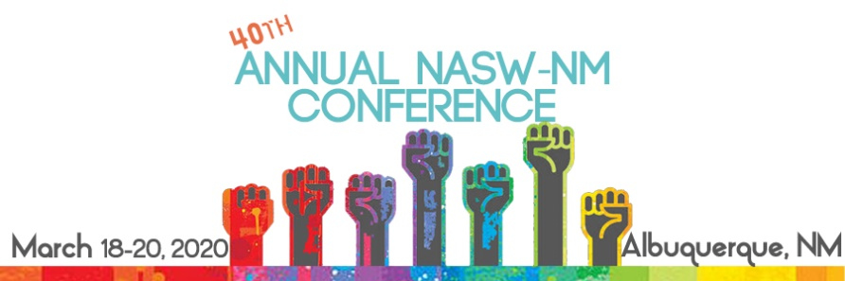

NASW-NM 2020 Conference
Student Volunteer Form

Thank you for your interest in volunteering at the NASW-NM 2020 Annual Conference in Albuquerque. We are offering 10 local social work students an opportunity to attend the conference at a 50% discount in exchange for volunteering during the event. Please fill out the application and return to us by February 18, 2020. Spots will be filled on a first-cone first-served basis.
Name: | NASW Member? (Y or N):
Email: | Phone:
School: | Degree:
Graduation Date: | GPA:

- Why did you choose social work as your profession?

- What area of practice are you most passionate about and why?

- Why are you interested in volunteering in our 2020 conference?

The following are volunteer spots that need filled:

- Pre-conference prep session- Mon. March 9th 10am – 2pm
- Early onsite registration- Tues. March, 17th 4-6pm
- Packet handout/onsite registration- Wed. 18th 7:45am – 9:15am
- Breakout session monitors on Wed. & Thurs. (various times)
- Fri. CEU distribution 12:00pm – 12:45pm

Would you prefer to do onsite registration on Wed. morning and miss the conference opening or conference preparation session which will be a weekday two weeks prior to the conference?
____ Pre-conference prep session
____ Wed. Registration

- Volunteers are required to volunteer for a minimum of 3 jobs PLUS CEU distribution on Fri. Are you able to fulfill this expectation? (Y or N)

- Are there any days or times during the conference you are not available to volunteer?

Return to conference@naswnm.org, by February 18, 2020 with VOLUNTEER APPLICATION
in the subject line.

Thank you! We will be in touch soon!

4223 Montgomery Blvd NE, Albuquerque, NM 87109
(505) 247-2336 • Fax: (505) 243-1472 • info@naswnm.org • www.naswnm.org

