This story reveals some mighty messed-up stuff. I apologize for jumping right in with the heavy-duty theological terminology. This is a mysterious story. I mean HOW do you LOSE the word of God at Church? But then, there is some miraculous stuff, too, because they found the Bible. All in all, this is a memorable story.

Let us remember that when we say “story” talking about a Bible story, we are talking about something real. We are talking about something important. We are talking about things that Almighty God Himself wants us to know. The Bible is God’s word to us. It is truth without any mixture of error. It is His love letter to us.

Maybe I should have called the message, “How Do You Lose the Bible at Church?” One time I called it “Bible Explosion.” That eminent theologian, Jeff Foxworthy tells a story that sets the stage for us this morning. I am going to let Jeff tell his story (see the link below…).

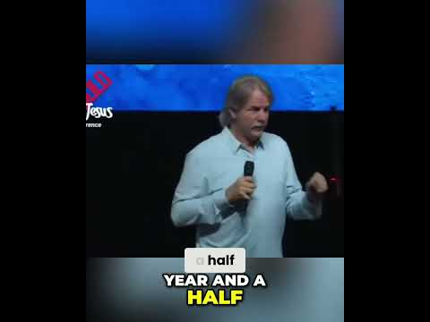

How DO you LOSE the BIBLE at CHURCH???

- THE POTENTATES FAIL - RULERS

- THE PRIESTS FAIL - RELIGIOUS LEADERS

- THE PEOPLE FAIL - REGULAR FOLKS

Do you think we may have LOST the Bible right here in the good ol USA?
Could we have lost the Bible right here in the Bible Belt?
Could we have lost the Bible right here in Dallas?
Could WE have lost the Bible?

Josiah is the king we are focusing on today. Josiah’s grandpa was Manasseh, that we talked about last week. Manasseh was followed by his son Amon (2 K 21.18). The Bible says that Amon “did what was evil in the LORD’s sight” (21.20). He was not a good king. Amon was succeeded by his son, Josiah. Josiah is known as one of the good kings. The
Bible says that “he did what was right in the LORD’s sight” (22.2).

Josiah starts a project to do some fixing up in the temple. In the process of cleaning and working and refurbing, they found a book in the temple. The Bible says, “The high priest Hilkiah told the court secretary Shaphan, “I have found the book of the law in the LORD’s temple,” and he gave the book to Shaphan, who read it. ⁹ Then the court secretary Shaphan went to the king and reported, “Your servants have emptied out the silver that was found in the temple and have given it to those doing the work ​— ​those who oversee the LORD’s temple.” ¹⁰ Then the court secretary Shaphan told the king, “The priest Hilkiah has given me a book,” and Shaphan read it in the presence of the king” (2 Kings 22:8-10).

IF we have lost the Bible in America. We need to FIND it. Things will NOT improve until we FIND the word of God. Let’s see what happened in Josiah’s story. I will summarize and make some applications.

Þ THINGS WILL IMPROVE WHEN WE FIND THE BIBLE (22.8a)
Discovery —> Possess

Þ THINGS WILL IMPROVE WHEN WE READ THE BIBLE (22.8b; 10)
Devouring —> Peruse

Þ THINGS WILL IMPROVE WHEN WE ACT ON THE BIBLE (22.11ff)
Devotion —> Pursue

The Bible tells that the LORD heard Josiah. It says, “I Myself have heard” (22.21). He got God’s attention. What can WE do to get God’s attention? We can do what Josiah did.

- Josiah tore his clothes (11) Sensitive

- Josiah inquired of the LORD (13) Seeking

- Josiah’s heart was tender (19) Soft

- Josiah humbled himself (19) Submissive

- Josiah wept before the LORD (19) Sincere

This is the same thing we found in the case of Manasseh last week. This is God’s formula that He gave in 2 Chron 7.14 . . . “and [if] My people, who bear My name, humble themselves, pray and seek My face, and turn from their evil ways, then I will hear from heaven, forgive their sin, and heal their land” (2 Chron 7:14).

We live in a land where we have largely let the word of God get away from us. It is LOST across a great portion of our population. We need to FIND it
- We need to POSSESS the word of God. FIND it
- We need to peruse the word of God. READ it
- We need to PURSUE the word of God ACT on it

What is YOUR situation today?
- Are you sensitive to the LORD?
- Are you seeking the Lord?
- Are you Soft toward the things of God?
- Are you submissive to the Lord?
- Are you sincere?

What is YOUR commitment today?

