ANTOINE BECHAMP & PLEOMORPHISM
AN INTRODUCTION

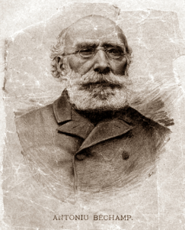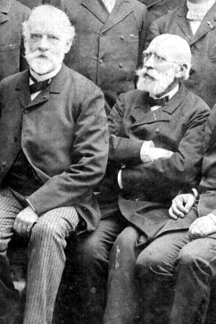
Pierre Jacques Antoine Béchamp (October 16, 1816 – April 15, 1908) Unknown colleague and Bechamp (R), in 1886.
During his lifetime, Antoine Bechamp (1816-1908) was a well-known and widely respected professor, teacher, and researcher. He was an active member of the French Academy of Sciences, and gave many presentations there during his long career. He also published many papers, all of which still exist and are available.
And yet, he has disappeared from history.
On the other hand, Louis Pasteur (1822-1895) is one of the great rock stars of medicine and biology. Of the two – Bechamp or Pasteur – he’s the one you’ve most likely heard of. His is one of the most recognizable names in modern science. Many discoveries and advances in medicine and microbiology are attributed to him, including vaccination and the centrepiece of his science – the germ theory of disease.
During their lifetimes, the rivalry between Bechamp and Pasteur was constant, and often bitter. They clashed frequently both in speeches before the Academy, and in papers presented to it. Bechamp repeatedly showed that Pasteur’s ‘findings’ included frequent plagiarizations (and distortions) of Bechamp’s own work.
When Bechamp and others objected to the plagiarization, Pasteur set out to use his political clout to destroy Bechamp’s career and reputation. Unfortunately, Pasteur largely succeeded. He was more skilful than Bechamp at playing politics and attending the right functions. He was good at making friends in high circles, and was popular with the royal family. Pasteur, in other words, was an A-lister. Bechamp was a worker.
The ideas, as well as the characters, of the two men were fundamentally opposed.
Pasteur argued for what we now call the ‘germ theory’ of disease, while Bechamp’s work sought to confirm pleomorphism; the idea that all life is based on the forms that a certain class of organisms take during the various stages of their life-cycles.
This difference is fundamental. Bechamp believed that his work showed the connection between science and religion – the one a search after truth, and the other the effort to live up to individual belief. It is fitting that his book Les Mycrozymas culminates in the acclamation of God as the Supreme Source. Bechamp’s teachings are in direct opposition to the materialistic views of the modern science of the twentieth century.
“These microorganisms (germs) feed upon the poisonous material which they find in the sick organism and prepare it for excretion. These tiny organisms are derived from still tinier organisms called microzyma. These microzyma are present in the tissues and blood of all living organisms where they remain normally quiescent and harmless. When the welfare of the human body is threatened by the presence of potentially harmful material, a transmutation takes place. The microzyma changes into a bacterium or virus which immediately goes to work to rid the body of this harmful material. When the bacteria or viruses have completed their task of consuming the harmful material they automatically revert to the microzyma stage”
– Antoine Bechamp

