EVENTS DATING BACK TO 1760 THAT GAVE ANTOINE BECHAMP HIS “EYES”
Introduction – What follows is a compilation of information relating to the greatest scientist of the latter half of the 1800’s. Professor Antoine Bechamp clearly laid out for humanity the very foundation of life, which at the time was thought to be the cell. Professor Bechamp’s discovery of the ‘microzyma’ was systematically obscured for the benefit of fame and political favour.
Following is the ‘roots’ of microscopy & lens making, dating back to 1760, which eventually led to giving Bechamp the ability to see clearly the microorganism responsible for life, from start to finish.
"... microzymas... as being the smallest of ferments, often so small that they could only be seen under the strongest enlargements of the immersion objectives of Nachet.
Also included are some pertinent details from Ethel D. Hume’s research/book, Bechamp or Pasteur? A Lost Chapter in the History of Biology.
CHARLES CHEVALIER (1804-1859)
Charles Louis Chevalier (April 19, 1804 - November 21, 1859) was a French optical lensmaker that built the camera for the first daguerreotypes. Note: Daguerreotype was the first publicly available photographic process
Born in Paris, his grandfather Louis Vincent Chevalier (1743-1800) and his father Vincent Jacques Louis Chevalier (1770 - 1841) were optical profession, so that after his studies in 1823 were associated in a tent on the Quai de l 'horloge number 69, which marketed their goals for achromatic microscopes to prevent chromatic aberration.
Charles Louis Chevalier (1804-1859)
engineer manufacturer optician
Charles Louis Chevalier was a French physicist and optician. Made lots improvements in various mathematical and physical devices, especially in microscopes. He was the first to produce microscopes with achromatic lenses (1823), introduced double lenses in telescopes (1834), and used such lenses with daguerreotype. He opened a photo studio in 1841in Paris.
Background
Charles Louis Chevalier was born on April 19,1804 in Paris, France. He was born in the family of the famous optician Vincent Jacques-Louis-Chevalier (1770–1841) - the owner and head of an optical company founded in 1760.
Career
The company of Vincent (the father of Charles) and Charles Chevalier was famous for the achromatic lenses which were invented by father Vincent, and the lens/prism optics they both had invented for camera obscuras.
In 1825, the cousin of Nicéphore Niépce came to the Chevaliers to buy achromatic lenses for his experimental cameras. He told the Chevaliers about his cousin's first efforts to achieve persisting photographs. That was when Louis Jacques Mandé Daguerre just got interested in similar experiments. Later Charles Chevalier gave him the address of Niépce, the first step for Daguerre to become a photography inventor himself. Chevalier also supplied Daguerre with photographic apparatuses and counseled him in his experiments. In 1828 Charles Chevalier provided Niepce with two new lenses and in 1834 made a lens for astronomical use which he adapted to his camera, "the Photographe," in 1840.
In 1832 Charles founded his own company. The manufacturer's early cameras consisted of two boxes, but in 1840 he introduced a wooden folding camera. Later productions included a problematic Megascope (1838), a lens with changeable front element (1844) and a complete daguerreotype-making outfit (1840). In 1840 he also made photomicrographs on daguerreotypes, and one of his last cameras was used for topographic photography. Also, at that time (in 1840) Chevalier made the first kind of folding camera, the Le Photographe, a whole-plate box camera that was collapsible to parcel size. Charles Chevalier developed a new doublet lens for cameras, with focal lens 29cm and aperture f/5.6, six times faster than the lenses he had made for the first daguerreotype cameras. In 1841 he reunited with father Vincent Chevalier's company. Together they and later Charles' son Louis Marie Arthur Chevalier successfully produced microscopes, glasses and other optical instruments.

Camille Sebastien Nachet (1799 – 1881)
by Ron Neumeyer, Vancouver, Canada
Camille Sebastien Nachet was a Parisian optician at the beginning of the 19th Century. He began producing lenses for the famous microscope manufacturer Chevalier but later set up his own small business at the address Rue Serpente 16, Paris. He produced his first instruments based on the drum- type base models made previously by other manufacturers. He was succeeded by his son Jean Alfred 1831-1908. Nachet was included with Chevalier and Oberhauser as the three leading makers in Paris at this time.
At the great London exhibition in 1851 both Chevalier and Nachet presented examples of their instruments. On final evaluation and judgment, it was announced that although Nachet's objectives were inferior to those of the leading English makers, his instruments were very well designed and made and his lenses better than those presented by other European makers. He was thus awarded a gold medal. Chevalier (his former employer) had to be satisfied with an honourable mention.
When one buys or obtains one of these instruments made by Nachet, one is faced with the almost impossible task of dating it. This is impossible to do with exactness as none of their instruments was given a serial number. There are some tips we can use to date these instruments however, so all is not entirely lost. The earlier instruments had the name "Nachet et fils" inscribed on the bar supporting the main tube or on the base. This simply means "Nachet and sons." The address was also inscribed below the name, the earliest being "Rue Serpente 16, Paris. Since Nachet moved his workshop to another address, namely, "17, Rue St. Séverin, Paris in 1862 then one can assume any instrument with the older address was manufactured between 1856 and 1862. I say 1856 because no evidence or information exists to present about his commoner instruments before this date, although there is evidence of earlier drum-type models.
When his son Albert succeeded him, he changed the company name to simply "A. Nachet." This period ran from around 1880 - 1890. Thus, if you have an instrument signed simply, "Nachet" with address "17,Rue St. Séverin Paris," then you can safely say the instrument dates between 1880 and 1890. The earlier forms up till about 1885 also used the older form of fine focus or micrometer screw system. This consisted of a very long iron rod with very fine thread running its length inserted into the centre of the prismatic brass slide. Over this was placed a strong spring. As the micrometer screw was screwed clock-wise, this depressed the spring and also forced the support tube down the inner prismatic slide. Turning the micrometer screw anti- clock-wise allowed the spring to force the support tube in an upward direction. Nachet decided to introduce the new system on all his models produced from 1885 onwards. If your model uses the former described micrometer system then you can judge the model was probably produced before 1885. After about 1890 the company's name returned to the original of "Nachet et fils."

Nachet Inverted Compound Monocular Microscope
Camille Sebastien Nachet was a French instrument designer and lens grinder who studied with Vincent Chevalier before opening his own shop in 1840. The inverted microscope designed and build by Nachet is described and illustrated in a short treatise entitled Microscopes to the End of the Nineteenth Century by F. W. Palmer and A. B. Sahiar.
The inscription on this instrument reads "Nachet et Fils, 17, Rue St. Séverin, Paris, indicating the authenticity of the microscope. A sturdy circular brass base supports four pillars that, in turn, support a platform containing the microscope limb and a prism box with a front silvered mirror. The single eye tube is threaded directly into the prism box, as is the inverted objective. The stage rides on the circular limb and is adjustable via a knurled knob. Coarse focus is achieved by sliding the objective tube, while fine focus is performed by adjusting a screw between the pillars that moves the stage up and down. Above the stage is a housing that contains a condenser lens and a planar mirror that assist in specimen illumination. Also mounted on the limb is an additional bi-convex lens that helps add light to the specimen.
According to Palmer and Sahiar, this inverted chemical microscope was made:
"… for the purpose of viewing objects from their underside when heat or reagents are being applied to them. It meets the requirements of observers engaged in the 'cultivation' of the minute organisms which act as ferments".

Quotes about Bechamp
Antoine Bechamp, from whose research Pasteur plagiarized whatever he thought was useful, came up with an interesting point of view that has never been refuted. Bechamp discovered tiny organisms he called "microzymas" which are present in all things - animal, vegetable, and mineral, whether living or dead. Depending upon the condition of the host, these microzymas could assume various forms. Bad bacteria and viruses were simply the forms assumed by the microzymas when there was a condition of disease. In a diseased body, the microzymas became pathological bacteria and viruses. In a healthy body, microzymas formed healthy cells. When a plant or animal died, the microzymas lived on. To this day, the whole theory of microzymas has never been disproved.
Later researchers like Naessens and Enderlein followed the same line of reasoning and developed their own systems of how these microzymas operate. Although their ideas were never proven false by opposing research, they were generally persecuted by mainstream medicine, which makes sense. Because without an enemy that can be identified and killed, what good is it to develop weapons? And developing weapons, that is, drugs, has been the agenda of the industry set up by Carnegie and Rockefeller even down to the present day, as we shall see. New drugs mean new research funding and government money and the need for prescriptions and for an entire profession to write those prescriptions. The Post-Antibiotic Age: Germ Theory by Tim O'Shea

"These microorganisms (germs) feed upon the poisonous material which they find in the sick organism and prepare it for excretion. These tiny organisms are derived from still tinier organisms called microzyma. These microzyma are present in the tissues and blood of all living organisms where they remain normally quiescent and harmless. When the welfare of the human body is threatened by the presence of potentially harmful material, a transmutation takes place. The microzyma changes into a bacterium or virus which immediately goes to work to rid the body of this harmful material. When the bacteria or viruses have completed their task of consuming the harmful material they automatically revert to the microzyma stage".--Bechamp. Sourced: Vaccination The "Hidden" Facts by Ian Sinclair p62
ACADEMIC RECORD – Professor Pierre Jacques Antoine Bechamp
Master of Pharmacy
Doctor of Science
Doctor of Medicine
Professor of Medical Chemistry and Pharmacy at Montpellier
Fellow and Professor of Physics and Toxicology — Strasbourg Higher School of Pharmacy
Professor of Chemistry at Strasbourg
Professor of Biological Chemistry and Dean of Faculty of Medicine of Lille
Chevalier of the Legion of Honour — Commander of the Rose of Brazil etc., etc.
Professor Bechamp's name has been covertly erased from medical history text books.
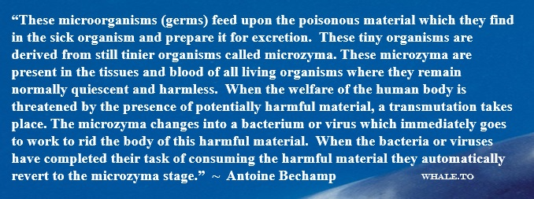

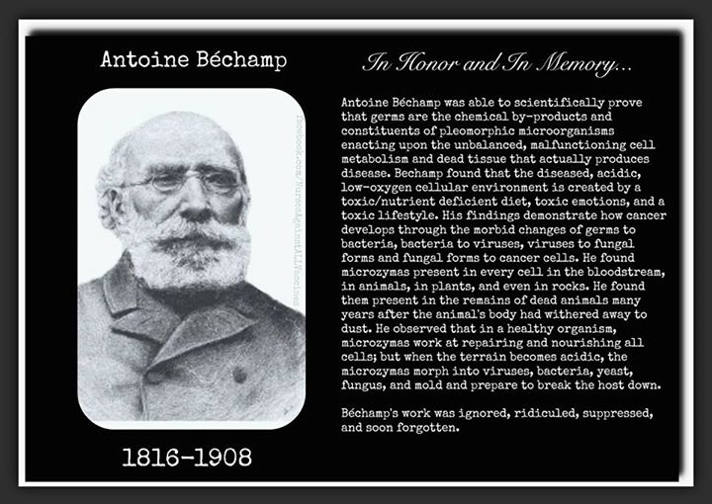

Particulars – Prof. Bechamp –
1835 Comptes rendus de l’Academie des Sciences, or simply Comptes rendus. The proceedings of the French Academy of Sciences
1866 First lists “microzymas” in Comptes Rendus
Experimental Fact - The very highest form of all evidence which can be supplied by science, cuts away the entire fabric of the microbian theory of disease from its very foundation. Never having been other than a baseless guess on the part of Pasteur and of his followers, it was fittingly designated by Bechamp as "the greatest scientific silliness of the age".
"Nothing is the prey of death; everything is the prey of life." (imperishable microzymas)
1863 Pasteur invents the word "microbe"
M. Leverson - re: academia "... and, what is worse, training students of biology, physiology, pathology and medicine to mistake follies for wisdom!"
Microzyma diameter < .0005 mm (<.0000005 m)(<0.5 micro m)(<500 nm) "hardly attains"
*Exosomes - "... a subtype of extracellular vesicles... typically 30 - 150 nm
Bechamp - microzymas, "no more than" & "hardly attains" 500 nm
"... molecular granulations..., where each granulation is a spherical mass of albuminoid matter having a microzyma for its centre." "... the very dilute HCl acid dissolves the enveloping albuminoid matter, leaving the central microzyma undissolved."
"We did not fail to add that the reason they had escaped the attention of histologists was because of their minuteness and transparency."
"The facts of this chapter establish definitely that the blood contains a third anatomical element... previously unrecognized because of its anatomical constitution, its location and its properties, I have named haematic microzymian molecular granulations."
Pasteur = protoplasmist = sees an organism as proximate principles (nothing in it figured or anatomically living).
"Servel, Estor's assistant, had presented to the academy (C.R. Vol. LXXIX p. 1270) a work verifying the fact that with absolute protection from atmospheric germs, the most diverse tissues could produce bacteria even in their interior, and cited other verifications made in Germany."
"The microzyma is at the beginning and at the end of every living organization.
"... and that even at the Academy of Medicine I said - and no one ventured to contradict me - that no one had ever been able to reproduce a disease on the nosological roll by taking the pretended pathogenic microbe in normal air, but only in the diseased animal."
"... the microzymian theory explains what the microbian system is powerless to make clear..."
"Now if the organism was what they think, and the sole cause of disease was what they say... everyone would, of equal necessity, become diseased..."
The air normally contains no pathogenic microzymas.
Leverson - "The term microbe, introduced for the purpose of drowning the grand discoveries of Bechamp, is, as presently shown, an etymological solecism." (error in word usage)
"The world has yet to learn how much it owes to this remarkable genius. The acknowledgement will be resisted by all those interests which fatten upon the ignorance and trusting confidence of the people. But thanks to his researches and discoveries it cannot be long* before the medical profession will recognize the dangerous errors into which it has been led by those who succeeded in establishing a conspiracy of silence around Bechamp and his discoveries." Leverson, 1912!

References:
- What Really Makes You Ill? - Why Everything You Thought You Knew About Disease is Wrong
Lester, Dawn/Parker David
- Goodbye Germ Theory
Trebing, Will Dr.
- Bechamp or Pasteur? – A Lost Chapter in the History of Biology
Hume, Ethel D.
- The Invisible Rainbow – A History of Electricity & Life
Firstenberg, Arthur
- CROOKED – A History of Man-Made Disease
Maready, Forrest
- Pasteur: Plagiarist, Imposter – The Germ Theory Exploded
Pearson, R.B.
- The Contagion Myth
Morell, Sally Fallon MA/Cowan, Thomas MD
- Power vs. Force
Hawkins, David PhD, MD
- Love Your Disease – It’s Keeping You Healthy
Harrison, John, MD
- The Urantia Book
Various Authors
- A Course in Miracles
Christ Michael

Note: If you read these 4 books, then you will never use the word “disease” again. Actually, book 1) will do the job alone!

"To teach the Rockefeller drug ideology, it is necessary to teach that Nature didn't know what she was doing when she made the human body. Hans Ruesch
Hans Ruesch
Hans Ruesch was a Swiss racing driver, a novelist, and an internationally prominent activist against animal experiments and vivisection. Ruesch has been described as a pioneer of the anti-vivisection movement.
"Most secrets of knowledge have been discovered by plain and neglected men than by men of popular fame. And this is so with good reason. For the men of popular fame are busy on popular matters."
Roger Bacon (c. 1220 – 1292) English philosopher and scientist

This document can be printed here: www.oneeyedbudgie.com/the-truth-centre (5 tabs)
Videos related to this Paper & the Truth Centre, Keremeos, B.C. – BitChute, search name “davesheers”
For those who know that something is not right, and do not know where to turn, they can find community & Truth on our Saturday evening Zoom sessions @ 6pm PST – email ds7715990@gmail.com for invite/link.

