**Paper**: The Biggest Hoax Ever Perpetuated on Humanity

**Date**: 27 Sep. 2020 (rev. 23 Sep. 2021)

**By**: D. R. Shearer

**Topic**: Back in April 2020 the “alarm bell” rung loud & clear – something was not quite right about life on planet Earth. The following CDC information on the IFR (Infection Fatality Rate) of this “pandemic” confirms the title of this paper.

Almost immediately, in the earlier part of 2020, information started creeping forward to illustrate that something was not quite right with the emerging “pandemic”. This information that was coming forward, was not covered by the main stream media. As is indicated from current circumstances, the vast majority of the population did not and have not received that information (as of Sep. 2021). From this, it has been clear that mainstream media dictates majority collective human consciousness.

The main reasons that this information is not readily available has been proven to be by nature of the process of *“censorship”* along with total mainstream domination. This censorship was and is primarily dictated by an alternative agenda, and promulgated by YouTube, Facebook & Google. This allegation has been authenticated by the actions of the President of the United States, Donald Trump’s move to outlaw the practice of censorship with these mega online social networking companies. Whether or not this governmental mandate actually comes into enforcement is another story!

It is important to note that the information coming forth, that is being censored, is largely from healthcare professionals and other various researchers. When a person actually extends themselves beyond the confines of mainstream media and social network media, a common thread runs throughout what becomes available – that common thread is clearly defined as **nefarious falsehood**.

This claim of nefarious falsehood is most always confirmed by the practice of *“follow the money”*. Additionally, this falsehood is exhaustively supported by the research, and is also supported by the several books that have taken on the task of illustrating the true nature of what can be defined as, ‘*life on planet Earth*’. With, not hundreds, but **many thousands** of referenced independent *case studies* and *medical journal articles*, a person would be no less than foolish, to consider these sources of research *unworthy*. And, of course, following the money can be also applied to the outcomes of this research, at every turn.

Regarding the topic of this paper, what follows is a CDC Report on the ‘Infection Fatality Ratio’ (IFR) noting the actual percentage of deaths occurring amongst the *“Covid infected”* population. Two notable & pertinent things should be **recognized** while assessing this data:

1. The term *“asymptomatic”* automatically fails one of Koch’s Postulates on proving infectious contagion. (**All 4** of the Postulates **must** prove true and failure of one is failure of the test.) But no one seems to be acknowledging this *obvious* detail.
2. Regarding the testing of Covid cases the test used is the Reverse Transcription – Polymerase Chain Reaction (RT-PCR). The inventor of this test, **Dr. Kary Mullis**, stated emphatically that the test itself **does not prove causation**. Period.

The CDC information is as follows, and clearly defines the title of this paper. “A lockdown of the world, producing more deaths than the “virus” itself, mandates the entire program as illegitimate.” Robert F. Kennedy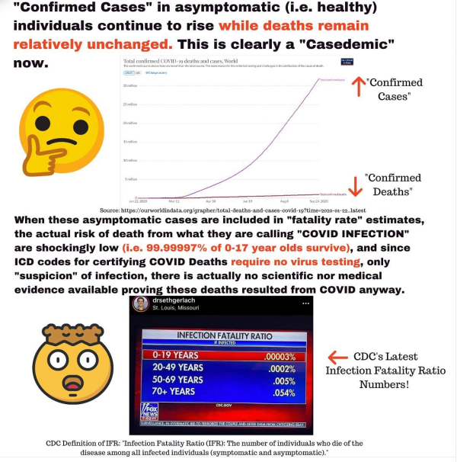

Conclusion

Based upon the presented information, with sources as noted, clarity & conclusiveness to the current world program regarding a “pandemic” is fully illuminated, at this point. In **no way** do the mainstream media reports coordinate with the reported numbers above.

The roots of this tyranny & falsehood practically go back 160 years to the guesswork of (“mediocre”) chemist Louis Pasteur. At this time, Professor Antoine Bechamp and his dedicated colleague, Professor Alfred Estor were uncovering the fundamentals of cytology/histology, in their lab. Unfortunately for humanity, what followed was carnage surpassing all the wars in history, as a result of following unsupported & misguided representations of biology.

It was Mohandas K. Ghandi who stated, “Error does not become truth by reason of multiplied propagation; nor does truth become error because only one person knows of it.”

It will be only by the general public waking up to the **reality** of what is going on, that will allow Truth to take its *rightful* place, in spite of the *propagandized falsehood*, that is widely presented currently. It will be then, that the average person will be empowered, which will lead directly to planet Earth moving to **its** *rightful* place – that place being a planet that is **“Settled in Light & Life”**!

Important Rider

Understanding that the world population has been insidiously guided by falsehood for many decades may be necessary, when one considers the alternative – continued allegiance to these false practices will come with ever-degrading repercussions. However, a counter force principle is available (& needed) to balance the negativity that comes from such a realization.

It is therefore, strongly recommended, that a person tackling this realization acknowledges and/or attempts to understand a principle from higher levels of consciousness. That principle is, “the past does not exist”. With this principle, allowance for full dissolution of the falsehood can occur, and counter balance is supplied which circumvents possible future destructive tendencies (retaliation/ vengeance).

Briefly, “the past does not exist” is cemented in the idea that any nefarious thought/word/deed from the past, will unconditionally NOT be allowed beyond our physical lifetimes. In other words, why would Spirit want to be infected with the low vibration & false activities of our 3D world? Then accordingly, why should we bother with them while we are here (now)? See paper on “True Forgiveness”.

This is the CDC official record of deaths covering the period 01 Jan. 20 to 13 Feb. 21:



Quote from **Dr. Roger Hodgkinson**, Medical Specialist in Pathology, Edmonton, Alberta –

“There is unfounded public hysteria driven by the media & politicians … it’s outrageous! ... this is the **greatest hoax** ever perpetrated on an unsuspecting public … it’s politics playing medicine, and that’s a very dangerous game!”

References:

1. What Really Makes You Ill? - Why Everything You Thought You Knew About Disease is Wrong

Lester, Dawn/Parker David

1. Bechamp or Pasteur? – A Lost Chapter in the History of Biology

Hume, Ethel D.

1. The Invisible Rainbow – A History of Electricity & Life

Firstenberg, Arthur

1. CROOKED – A History of Man-Made Disease

Maready, Forrest

1. Pasteur: Plagiarist, Imposter – The Germ Theory Exploded

Pearson, R.B.

1. Love Your Disease – It’s Keeping You Healthy

Harrison, John, MD

This document can be printed here: [www.oneeyedbudgie.com/the-truth-centre](http://www.oneeyedbudgie.com/the-truth-centre) (5 tabs)

Videos related to this Paper & the Truth Centre, Keremeos, B.C. – BitChute, search name “davesheers”

For those who know that something is not right, and do not know where to turn, they can find community on our Saturday evening Zoom sessions @ 6pm PST – email [ds7715990@gmail.com](mailto:ds7715990@gmail.com) for invite/link.