**Paper**: Systematic Historical Misrepresentation –

Rudolph Ludwig Carl Virchow & Pierre Jacques Antoine Bechamp

**Date**: 23 March 2021

**By**: D. R. Shearer

**Topic**: What is being revealed, in an ever-increasing fashion, over the past 12 months, is that the planetary races have been led by a manipulated falsehood, that has spanned just about every aspect of our existence. This is neither *conspiracy theory*, nor *conjecture*, **because**, it is, and has been revealing itself, every day, for the past 12 months!

As always, the human race has the choice to *observe* what is occurring right under its nose, or, by way of **cognitive dissonance**, *reject* the Reality that is before them.

By way of such documentaries as “JFK to 911 – Everything is a Rich Man’s Trick” (YouTube), a person is able to begin to address the incredible manipulation of, not only everyday activity, but what is turning out to be the bulk of history itself.

While history has tried to bury & slander such notable & prestigious beings, as the ones within this Paper, the Truth is something that will always prevail in the end. This is indicated in the notation, “The seeds of destruction are contained within every evil act/thought or word.”

**Two of the** most accomplished and esteemed scientists of the late 19th century, came from Germany & France. Their respective bodies of study, mirrored each other, even though they were from different nations. This is the universal nature of **Truth**, and they are:

**Rudolf Ludwig Carl Virchow (**[**/ˈvɪərkoʊ, ˈfɪərxoʊ/**](https://en.wikipedia.org/wiki/Help:IPA/English)**;**[**[1]**](https://en.wikipedia.org/wiki/Rudolf_Virchow#cite_note-1)

German: [[ˈfɪʁço]](https://en.wikipedia.org/wiki/Help:IPA/Standard_German) or [[ˈvɪʁço]](https://en.wikipedia.org/wiki/Help:IPA/Standard_German); 13 October 1821 – 5 September 1902) was a German physician, anthropologist, pathologist, prehistorian, biologist, writer, editor, and politician. He is known as "the father of modern [pathology](https://en.wikipedia.org/wiki/Pathology)" and as the founder of [social medicine](https://en.wikipedia.org/wiki/Social_medicine), and to his colleagues, the "Pope of medicine". He received the [Copley Medal](https://en.wikipedia.org/wiki/Copley_Medal) of the [Royal Society](https://en.wikipedia.org/wiki/Royal_Society) in 1892. He was a foreign member of the [Royal Swedish Academy of Sciences](https://en.wikipedia.org/wiki/Royal_Swedish_Academy_of_Sciences) and was elected to the [Prussian Academy of Sciences](https://en.wikipedia.org/wiki/Prussian_Academy_of_Sciences), but he declined to be ennobled as "von Virchow".

https://en.wikipedia.org/wiki/Rudolf_Virchow

**Anti-germ theory of disease**

Virchow did not believe in the [germ theory of diseases](https://en.wikipedia.org/wiki/Germ_theory_of_diseases), as advocated by [Louis Pasteur](https://en.wikipedia.org/wiki/Louis_Pasteur) and [Robert Koch](https://en.wikipedia.org/wiki/Robert_Koch). He proposed that diseases came from abnormal activities inside the cells, not from outside pathogens. He believed that epidemics were social in origin, and the way to combat epidemics was political, not medical. He regarded germ theory as a hindrance to prevention and cure. He considered social factors such as poverty major causes of disease. He even attacked Koch's and [Ignaz Semmelweis](https://en.wikipedia.org/wiki/Ignaz_Semmelweis)' policy of handwashing as an antiseptic practice. He postulated that germs were only using infected organs as habitats, but were not the cause, and stated, "If I could live my life over again, I would devote it to proving that germs seek their natural habitat: diseased tissue, rather than being the cause of diseased tissue".

<https://www.britannica.com/biography/Rudolf-Virchow>

**Pierre Jacques Antoine Béchamp**

(October 16, 1816 – April 15, 1908) was a French scientist now best known for breakthroughs in [applied](https://en.wikipedia.org/wiki/Applied_chemistry) [organic chemistry](https://en.wikipedia.org/wiki/Organic_chemistry) and for a bitter rivalry with [Louis Pasteur](https://en.wikipedia.org/wiki/Louis_Pasteur).

Béchamp developed the [Béchamp reduction](https://en.wikipedia.org/wiki/Bechamp_reduction" \o "Bechamp reduction), an inexpensive method to produce [aniline dye](https://en.wikipedia.org/wiki/Aniline), permitting [William Henry Perkin](https://en.wikipedia.org/wiki/William_Henry_Perkin) to launch the [synthetic-dye](https://en.wikipedia.org/wiki/Synthetic_dye) industry. Béchamp also synthesized the first [organic arsenical](https://en.wikipedia.org/wiki/Organic_arsenic) drug, [arsanilic acid](https://en.wikipedia.org/wiki/Arsanilic_acid" \o "Arsanilic acid), from which [Paul Ehrlich](https://en.wikipedia.org/wiki/Paul_Ehrlich) later synthesized [salvarsan](https://en.wikipedia.org/wiki/Salvarsan), the first chemotherapeutic drug.

Béchamp's rivalry with Pasteur was initially for priority in attributing [fermentation](https://en.wikipedia.org/wiki/Fermentation_(biochemistry)) to microorganisms, later for attributing the silkworm disease [pebrine](https://en.wikipedia.org/wiki/Pebrine" \o "Pebrine) to microorganisms, and eventually over the validity of [germ theory](https://en.wikipedia.org/wiki/Germ_theory).[[1]](https://en.wikipedia.org/wiki/Antoine_B%C3%A9champ#cite_note-manchester-2001-1)[[2]](https://en.wikipedia.org/wiki/Antoine_B%C3%A9champ#cite_note-manchester-2007-2) Béchamp also disputed [cell theory](https://en.wikipedia.org/wiki/Cell_theory).

Claiming discovery that the "molecular granulations" in biological fluids were actually the elementary units of life, Béchamp named them *microzymas*—that is, "tiny enzymes"—and credited them with producing both enzymes and cells while "evolving" amid favorable conditions into multicellular organisms. Denying that bacteria could invade a healthy animal and cause disease, Béchamp claimed instead that unfavorable host and environmental conditions destabilize the host's native microzymas, whereupon they decompose host tissue by producing pathogenic bacteria.

While cell theory and germ theory gained widespread acceptance, granular theories became obscure. Béchamp's version, *microzymian theory*, has been retained by small groups, especially in [alternative medicine](https://en.wikipedia.org/wiki/Alternative_medicine).

<https://en.wikipedia.org/wiki/Antoine_B%C3%A9champ>

Questions? [davesheers@gmail.com](mailto:davesheers@gmail.com)

For access to documents in the Truth Centre, they can be found on 3 tabs here: https://oneeyedbudgie.com/the-truth-centre

For my videos which relate to the papers in the Truth Centre, and the current condition of the planet –

BitChute.com search the name “davesheers”

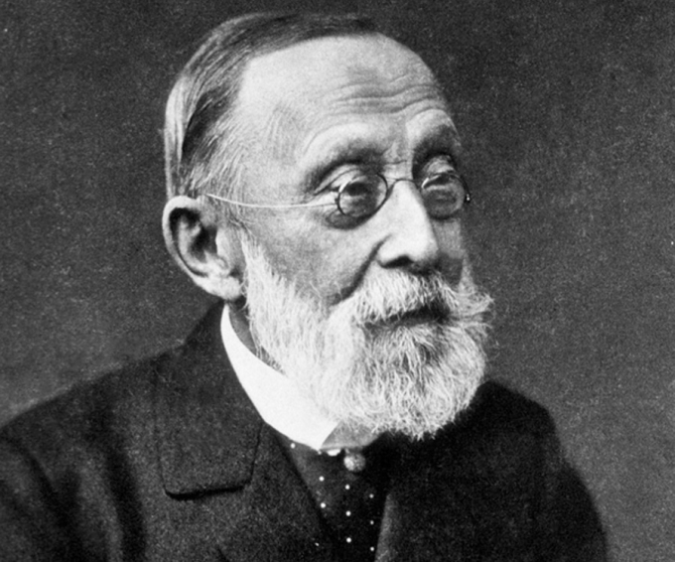

Rudolf Ludwig Carl Virchow

German physician, anthropologist, pathologist, prehistorian,

biologist, writer, editor and politician.



Pierre Jacques Antoine Bechamp

French scientist, chemist, physician, professor.

“Error does not become Truth by way of multiplied propagation.

Nor does Truth become error because only one person knows of it.”

Mohandas K. Ghandi