**Paper**: Systematic Historical Misrepresentation –

Rudolph Ludwig Carl Virchow & Pierre Jacques Antoine Bechamp

**Date**: 23 March 2021 (13 Nov. 21)

**By**: D. R. Shearer

**Topic**: What is being revealed, in an ever-increasing fashion, over the past 21 months, is that the planetary races have been led by a manipulated (series of) falsehood(s), that has spanned just about every aspect of our existence. This is neither *conspiracy theory*, nor *conjecture*, **because**, the proof is, and has been revealing itself, every day, for the past 21 months!

As always, the human race has the choice to *observe* what is occurring right under its nose, or, by way of **cognitive dissonance**, *reject* the Reality that is before them.

By way of such documentaries as “JFK to 911 – Everything is a Rich Man’s Trick” (YouTube), a person is able to begin to address the incredible manipulation of, not only everyday activity, but what is turning out to be the bulk of history itself.

While certain entities throughout history have tried to bury & slander such notable & prestigious beings, such as the ones within this Paper, the Truth is something that will always prevail, in the end. This is indicated in the quotation, “The seeds of destruction are contained within every evil act, thought or word.”

**Two of the** most accomplished and esteemed scientists of the late 19th century, came from Germany & France. Their respective bodies of study, mirrored each other, even though they were from different nations. This is the universal nature of **Truth**, and they are:

**Rudolf Ludwig Carl Virchow (**[**/ˈvɪərkoʊ, ˈfɪərxoʊ/**](https://en.wikipedia.org/wiki/Help:IPA/English)**;**[**[1]**](https://en.wikipedia.org/wiki/Rudolf_Virchow#cite_note-1)

German: [[ˈfɪʁço]](https://en.wikipedia.org/wiki/Help:IPA/Standard_German) or [[ˈvɪʁço]](https://en.wikipedia.org/wiki/Help:IPA/Standard_German); 13 October 1821 – 5 September 1902) was a German physician, anthropologist, pathologist, prehistorian, biologist, writer, editor, and politician. He is known as "the father of modern [pathology](https://en.wikipedia.org/wiki/Pathology)" and as the founder of [social medicine](https://en.wikipedia.org/wiki/Social_medicine), and to his colleagues, the "Pope of medicine". He received the [Copley Medal](https://en.wikipedia.org/wiki/Copley_Medal) of the [Royal Society](https://en.wikipedia.org/wiki/Royal_Society) in 1892. He was a foreign member of the [Royal Swedish Academy of Sciences](https://en.wikipedia.org/wiki/Royal_Swedish_Academy_of_Sciences) and was elected to the [Prussian Academy of Sciences](https://en.wikipedia.org/wiki/Prussian_Academy_of_Sciences), but he declined to be ennobled as "von Virchow".

https://en.wikipedia.org/wiki/Rudolf_Virchow

**Anti-germ theory of disease**

Virchow did not believe in the [germ theory of diseases](https://en.wikipedia.org/wiki/Germ_theory_of_diseases), as advocated by [Louis Pasteur](https://en.wikipedia.org/wiki/Louis_Pasteur) and [Robert Koch](https://en.wikipedia.org/wiki/Robert_Koch). He proposed that diseases came from abnormal activities inside the cells, not from outside pathogens. He believed that epidemics were social in origin, and the way to combat epidemics was political, not medical. He regarded germ theory as a hindrance to prevention and cure. He considered social factors such as poverty major causes of disease. He even attacked Koch's and [Ignaz Semmelweis](https://en.wikipedia.org/wiki/Ignaz_Semmelweis)' policy of handwashing as an antiseptic practice. He postulated that germs were only using infected organs as habitats, but were not the cause, and stated, "If I could live my life over again, I would devote it to proving that germs seek their natural habitat: diseased tissue, rather than being the cause of diseased tissue".

<https://www.britannica.com/biography/Rudolf-Virchow>

**Pierre Jacques Antoine Béchamp**

(October 16, 1816 – April 15, 1908) was a French scientist now best known for breakthroughs in [applied](https://en.wikipedia.org/wiki/Applied_chemistry) [organic chemistry](https://en.wikipedia.org/wiki/Organic_chemistry) and for a bitter rivalry with [Louis Pasteur](https://en.wikipedia.org/wiki/Louis_Pasteur).

Béchamp developed the [Béchamp reduction](https://en.wikipedia.org/wiki/Bechamp_reduction), an inexpensive method to produce [aniline dye](https://en.wikipedia.org/wiki/Aniline), permitting [William Henry Perkin](https://en.wikipedia.org/wiki/William_Henry_Perkin) to launch the [synthetic-dye](https://en.wikipedia.org/wiki/Synthetic_dye) industry. Béchamp also synthesized the first [organic arsenical](https://en.wikipedia.org/wiki/Organic_arsenic) drug, [arsanilic acid](https://en.wikipedia.org/wiki/Arsanilic_acid" \o "Arsanilic acid), from which [Paul Ehrlich](https://en.wikipedia.org/wiki/Paul_Ehrlich) later synthesized [salvarsan](https://en.wikipedia.org/wiki/Salvarsan), the first chemotherapeutic drug.

Béchamp's rivalry with Pasteur was initially for priority in attributing [fermentation](https://en.wikipedia.org/wiki/Fermentation_(biochemistry)) to microorganisms, later for attributing the silkworm disease [pebrine](https://en.wikipedia.org/wiki/Pebrine" \o "Pebrine) to microorganisms, and eventually over the validity of [germ theory](https://en.wikipedia.org/wiki/Germ_theory).[[1]](https://en.wikipedia.org/wiki/Antoine_B%C3%A9champ#cite_note-manchester-2001-1)[[2]](https://en.wikipedia.org/wiki/Antoine_B%C3%A9champ#cite_note-manchester-2007-2) Béchamp also disputed [cell theory](https://en.wikipedia.org/wiki/Cell_theory).

Claiming discovery that the "molecular granulations" in biological fluids were actually the elementary units of life, Béchamp named them *microzymas*—that is, "tiny enzymes"—and credited them with producing both enzymes and cells while "evolving" amid favorable conditions into multicellular organisms. Denying that bacteria could invade a healthy animal and cause disease, Béchamp claimed instead that unfavorable host and environmental conditions destabilize the host's native microzymas, whereupon they decompose host tissue by producing pathogenic bacteria.

While cell theory and germ theory gained widespread acceptance, granular theories became obscure. Béchamp's version, *microzymian theory*, has been retained by small groups, especially in [alternative medicine](https://en.wikipedia.org/wiki/Alternative_medicine).

<https://en.wikipedia.org/wiki/Antoine_B%C3%A9champ>

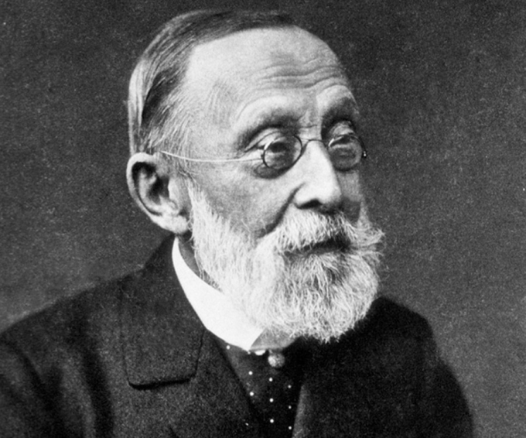

Rudolf Ludwig Carl Virchow

German physician, anthropologist, pathologist, prehistorian,

biologist, writer, editor and politician.



Pierre Jacques Antoine Bechamp

French scientist, chemist, physician, professor.

“Error does not become Truth by way of multiplied propagation.

Nor does Truth become error because only one person knows of it.”

Mohandas K. Ghandi

The Bottom Line

The professional credentials and dedication of these two scientists put them at the top of their fields, in the latter half of the 19th century. Although Professor Bechamp’s (and his able colleague Professor Alfred Estor’s) research is thorough and conclusion, and is logged in the French Academy of Sciences, the alternative “commercialization of medicine” stemming from the false principles of “germ theory” was the prevailing notion of that time. This is partially because of the simplicity of monomorphism and the “one microbe/one ‘disease’/one pill remedy” that captured the public attention and eagerness to grasp a simple concept.

The devastation & hardship that followed the invention of the word “microbe” (Pasteur) has surpassed that of all the world wars put together.

It is the revealing of Truth, during our current times, that will set the historical record correct for the first time in centuries. The result? Our dear planet Earth moving imminently & securely to a condition known as being **“Settled in Light & Life”**.

References:

1. What Really Makes You Ill? - Why Everything You Thought You Knew About Disease is Wrong

Lester, Dawn/Parker David

1. Goodbye Germ Theory

Trebing, Will Dr.

1. Bechamp or Pasteur? – A Lost Chapter in the History of Biology

Hume, Ethel D.

1. The Invisible Rainbow – A History of Electricity & Life

Firstenberg, Arthur

1. CROOKED – A History of Man-Made Disease

Maready, Forrest

1. Pasteur: Plagiarist, Imposter – The Germ Theory Exploded

Pearson, R.B.

1. The Contagion Myth

Morell, Sally Fallon MA/Cowan, Thomas MD

1. Power vs. Force

Hawkins, David PhD, MD

1. Love Your Disease – It’s Keeping You Healthy

Harrison, John, MD

1. The Urantia Book

Various Authors

1. A Course in Miracles

Christ Michael

Note: If you read these 4 books, then you will never use the word “disease” again. Actually, book 1) will do the job alone!

This document can be printed here: [www.oneeyedbudgie.com/the-truth-centre](http://www.oneeyedbudgie.com/the-truth-centre) (5 tabs)

Videos related to this Paper & the Truth Centre, Keremeos, B.C. – BitChute, search name “davesheers”

For those who know that something is not right, and do not know where to turn, they can find community & Truth on our Saturday evening Zoom sessions @ 6pm PST – email [ds7715990@gmail.com](mailto:ds7715990@gmail.com) for invite/link.