Town of Port Royal

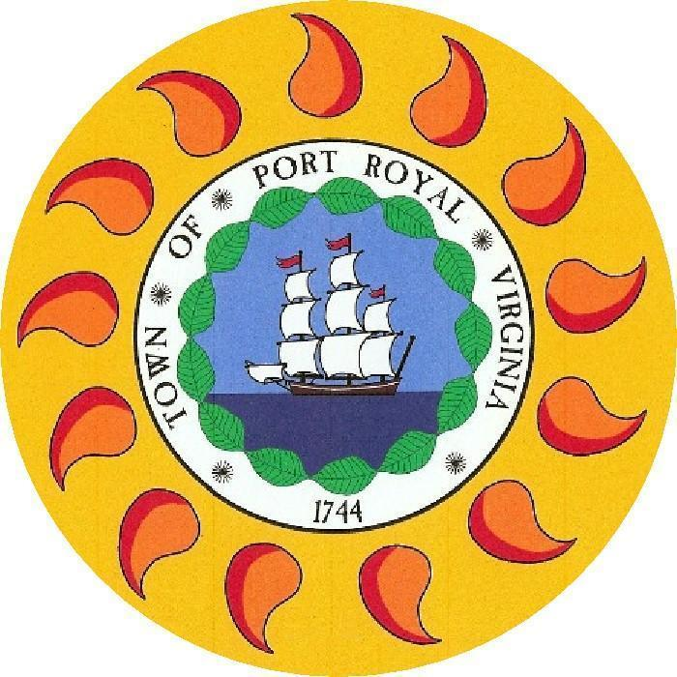

***“Behold Us Rising”* Established 1744**

**Port Royal Town Council**

**Meeting Agenda**

**March 28, 2024**

**6:00 p.m.**

**INVOCATION AND PLEDGE OF ALLEGIANCE**

**CALL MEETING TO ORDER – Mayor**

**AMENDMENTS TO THE AGENDA**

**PUBLIC COMMENT**

* Comments will be limited to three minutes, per person, in order to afford everyone an opportunity to speak. If comments relate to a specific public hearing item, we ask that you offer those comments at the time of the public hearing.
* If any issues arise from public comment to be addressed in detail, such issues will be put on the Agenda for the next meeting, or later, for this meeting, subject to a vote of the majority of Town Council.

**REPORTS OF MEMBERS OF THE TOWN COUNCIL** (including but not limited to committee/commission updates, reports on Council assignments, and items of interest).

* Donna Wilkerson, Vice-Mayor
* Angela Golden
* J.P. Wilkerson
* Justin McArdle
* Alex Long, Mayor

**ITEM NO**. **DESCRIPTION**

**3-10 3-10 Public Hearings**

3-10.1 TXT-01-2024 - An ordinance to amend the Code of Port Royal, Virginia, by repealing Article VI, Chesapeake Bay Preservation Area Overlay District, and establishing Chapter 25-Zoning, Article XIV, Chesapeake Bay Preservation Area Overlay District. The purpose of the amendment is to address required changes to the Chesapeake Bay Area Overlay District and map within the original boundaries of the Town.

3-10.2 TXT-02-2024 - An ordinance to amend the Code of Port Royal, Virginia, by repealing Chapter 26- Boundary Adjusted Lands, Article VIII-Supplemental Regulations, Section 819 - Chesapeake Bay Preservation Area Overlay District, and establishing Chapter 26-Boundary Adjusted Lands, Article XV, Chesapeake Bay Preservation Area Overlay District, to specifically identify, establish and adopt the applicability and regulations of the Chesapeake Bay Area Overlay District and map to the Boundary Adjusted Lands.

3-10.3 TXT-03-2024 - An ordinance to amend the Code of Port Royal, Virginia, by repealing and replacing Chapter 25-Zoning, Section 701-Site Plans. The purpose of the amendments is to add Chesapeake Bay Preservation required notes, submission, and inspection requirements for preliminary and final site plans within the original boundaries of the Town.

3-10.4 TXT-04-2024 - An ordinance to amend the Code of Port Royal, Virginia, by repealing and replacing Chapter 26, Section 26.802 - Site Plan Requirements. The purpose of the amendments is to add Chesapeake Bay Preservation required notes, submission, and inspection requirements for preliminary and final site plans in the boundary adjusted areas.

3-10.5 TXT-05-2024 - An ordinance to amend the Code of Port Royal, Virginia, by repealing and replacing Chapter 17-Subdivision of Land, Article III-Plat Requirements. The purpose of the amendment is to add Chesapeake Bay Preservation required notes, submission, and inspection requirements for all preliminary and final subdivision plats.

3-10.6 CP-01-2024 – An amendment to the Port Royal Comprehensive Plan to add Chapter IX Environmental and to generally identify environmental features and issues within the Town and specifically discuss Chesapeake Bay Preservation environmental features and issues identified in the Virginia Department of Environment Quality review of the Town Chesapeake Bay Preservation Area program.

3-10.7 TXT-06-2024 - An ordinance to amend the Code of Port Royal, Virginia, by repealing Chapter 3 Division 4 Vehicle License Tax. The purpose of this amendment is to eliminate the requirement for a personal property decal and fee for vehicles domiciled in the Town.

3-10.8 TXT-07-2024 - An ordinance to amend the Code of Port Royal, Virginia, by amending Chapter 18 to add Article 200 (Cigarette Tax); to establish the definitions and regulations governing cigarette taxes and to impose a tax on the sale or use of cigarettes in the Town of Port Royal in the amount of $0.40 for each package containing twenty cigarettes and $0.02 for each cigarette contained in packages of fewer or more than twenty cigarettes sold or used within the Town.

3-10.9 An ordinance to join the Chesapeake Bay Region Cigarette Tax Board (“CBRCTB”) and to approve the Chesapeake Bay Region Cigarette Tax agreement for the CBRCTB to administer collection, accounting, disbursement, compliance, monitoring, and enforcement of cigarette taxes assessed by the Town.

**3-11 Consent Agenda**

3-11.1 Approval of Meeting Minutes of the February 20, 2024, Town Council Meeting

**3-12 Financials – February 2023**

Review and questions as to documents

**3-13 Report of the Town Manager/Clerk**/**Zoning Administrator**

**3-14 Board/Commissions/Agency Representatives**

**3-15 Action Items**

**3-16 Discussion Items**

**3-17 Information Items**