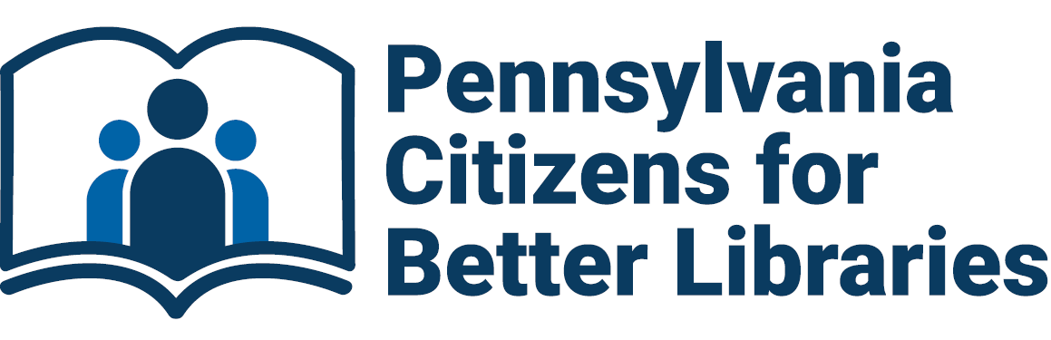

PCBL Membership Form

Individual/Organization Name: _____________________________________________

Address: ________________________________________________________________

City: _____________________________ State: ___________ Zip: _____________

Email: __________________________________________________________________

Membership Levels

 | Benefactor | $1,000
 | Patron | $500
 | Champion | $250
 | Sponsor | $125
 | Sustaining | $75
 | Library | $60
 | Friends Group | $50
 | Personal | $25
 | Other | _____

Donation
 | Educational and Legislative Efforts Amount | $________

Please make checks payable to Pennsylvania Citizens for Better Libraries
and mail along with this form to:
PCBL
P.O. Box 12822
Pittsburgh, PA 15241

or
Pay by PayPal by visiting pcblpa.org/membership-fees
and also mail or email this form to us.

