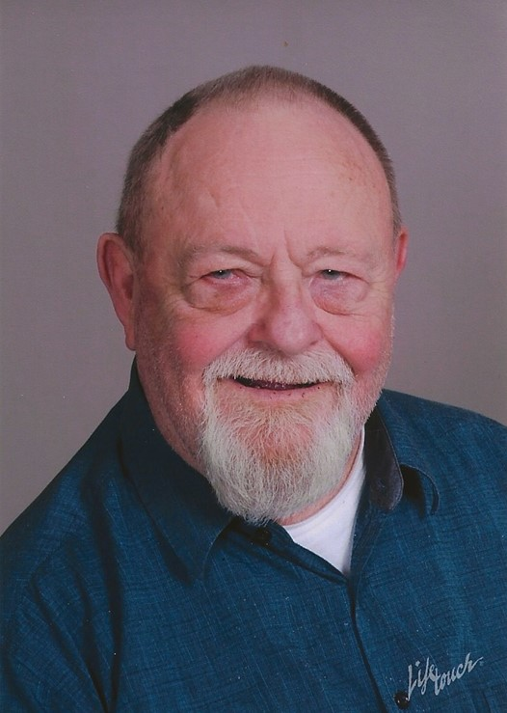

Biographical Sketch - Gary R. List (D.Sc.)

Dr. List was a Lead Scientist at the National Center for Agricultural Utilization Research in Peoria. He has been involved in research for over 50 years, beginning his career as a member of the United States Army at Edgewood Arsenal (1960-1963), Maryland where he conducted research on the reactions of chemical warfare agents with phenols and cholinesterase. In 1965 he was awarded a commendation by the Department of Defense for his work at Edgewood Arsenal. He began his career at the Northern Regional Research Laboratory in 1963 as a technician and has held positions as chemist, research chemist, lead scientist and research leader. His research interests have been analytical methods development, processing of oilseeds and edible oils, lecithin, hydrogenation, physical refining, deterioration of oilseed in international trade, supercritical fluid extraction, interesterification, genetically and structurally modified oils and functional properties of triglycerides. He retired from the USDA in 2007 and now is a consultant to the edible oil industry. Dr. List is the author of over 430 publications, proceedings, book chapters and abstracts. He has contributed to a number of books (22), 40 chapters including three revisions (4th, 5th, 6th) of the standard fats and oils textbook, A. E. Bailey’s Industrial Oil and Fat Products and The Handbook of Soybean Oil Processing and Utilization. He has edited eight books on fats and oils. He is a member of the American Oil Chemists’ Society and a Fellow of that organization. He serves as an Associate Editor for the Journal of the American Oil Chemists’ Society and is the Technical Index Editor as well. He also serves as Associate Editor for Inform, American Oil Chemists’ Society and the lipid library (AOCS) and Lipid Technology. He is a member of the American Chemical Society, the Institute of Food Technologists (Fellow), the Society of Chemical Industry (U.K.), the German Society for Fat Research (DGF), and the European Federation for Sciences and Technology of Lipids. He serves on the editorial boards of John Wiley and Sons and the Journal of the Science of Food and Agriculture. He has served as a corresponding member of the Fats and Oils Committee for the Society of Chemical Industry (UK). He is the presenter or coauthor of over 155 presentations at national and international meetings and conferences. He has been an invited speaker at the Oilseed Conference in New Orleans, LA (1998-2001). Dr. List has received numerous invitations to speak and chair symposia at international conferences and meetings including the World Conference on Oilseed Processing in Istanbul, Turkey, the China International Soybean Exhibition in Beijing, China and the International Conference on Nutraceuticals and Functional Foods in San Diego, CA, Las Vegas, NV and San Francisco, CA. He has been a lecturer at AOCS, Texas A&M and IFT Short Courses on Fats, Oils and Lecithin. In 1999, he was awarded the Alton E. Bailey Medal by the American Oil Chemists Society in recognition of his research accomplishments in fats and oils. In 2003 he was the recipient of the Stephen S. Chang Award for Lipid/Flavor Science given by the Institute of Food Technologists. In 2006, he was the recipient of the Harold Macy Award for Food Science and Technology by the Minnesota Section, Institute of Food Technologists. He is the 2007 recipient of the United Soybean Board Achievement Award and the 2008 Division Lecture Award, Food Chemistry Division IFT. He is the recipient of the Distinguished Service Award of the American Oil Chemists’ Society, Processing Division. In 2011, he was awarded an honorary Doctor of Science by the University of Illinois. In 2012 he was the recipient of the AOCS Stephen Chang award. Dr. List is the recipient of the American Oil Chemists’ Societies highest service award and has been recognized by AOCS for his contributions to analytical chemistry.

Dr.List is the recipient of the Supelco/Nicholas Pelick AOCS Award in lipid chemistry (2015) In 2011 he became only the second bench chemist to give to give the prestigious FW Tanner lecture during its 50 year history. Dr. List is a member of the American Legion, Gideon’s International, The Little Big Horn Associates, the National Rifle Association, the National Skeet Shooting Association, Sons of the American Revolution, and the Patrol Craft Sailors Association. Dr. List and his wife, Marlene, are the parents of four children and grandparents to seven. Both are active in their local church and in the children’s ministry. His hobbies include military history, fats and oils history, and fishing.

