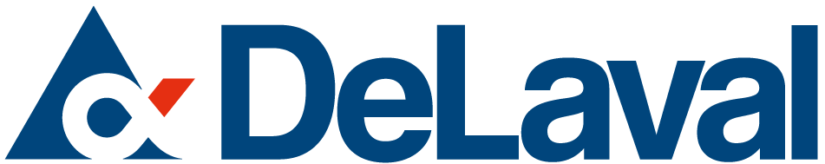

CHEMIST
Kansas City, MO

DeLaval has over 125 years of innovation and experience in the dairy business, supporting dairy farmers in managing their farms their way. The Milk Quality and Animal Health Business Area supplies sanitizers, topical disinfectants, and detergents, and is seeking a Chemist to support products for dairy farms and food processing industries. DeLaval is a global company and offers opportunities to interact with people worldwide.

https://corporate.delaval.com/careers/ Click on "Current Vacancies", then choose Kansas City as the location.

BASIC FUNCTION
The Chemist assists with product testing, technical service, and support of our manufacturing plants worldwide.

RESPONSIBILITIES
- Technical support to chemical manufacturing sites. Follow up with plant and field personnel to ensure that problems get resolved. This requires on-site visits when necessary.
- Help create and maintain master formula and raw material documents. Evaluate suitability of new raw material sources.
- Independently run support projects, which may include minor reformulations, compatibility testing, and manufacturing process improvements. This involves laboratory testing and on-site assistance.
- Up to 20% travel, including international, may be required.

REQUIRED SKILLS / COMPETENCIES
- Motivated self-starter with a confident attitude
- Practical knowledge of industrial chemistry and standard lab analytical techniques, along with good mechanical aptitude
- Clear and concise communicator
- Systematic approach to solving problems, with an ability to synthesize ideas into a workable project plan
- Ability to be versatile and handle multiple types of tasks and responsibilities

EXPERIENCE / BACKGROUND
- B.S./B.A. in Chemistry, Chemical Engineering, or related field required
- 2-5+ years of experience in a laboratory or processing environment
- Experience in technical service and/or manufacturing support is preferred
- Experience in the following areas is a plus:
  - Material/chemical compatibility
  - Corrosion
  - Formulation
- Understanding of lab safety and the ability to work safely with chemicals required

