December 2025
Volume 77 Issue 5
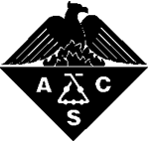

Inside this issue:

Holiday Networking p1
New Officers p2
Comm. Chairs p3
Exec. Board Members p4

ACS
Chemistry for Life
Please RSVP to Sarah Leibowitz: sleibowitzacs@gmail.com by Friday, December 5, 2025.
Thank you!

ACS-KC Section Monthly membership meeting:
Our Annual Holiday Networking Celebration!
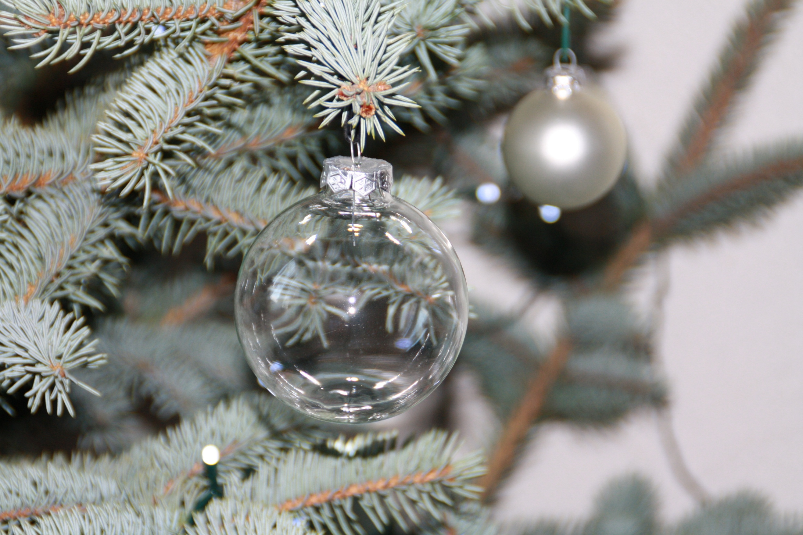

When: Thursday, December 11, 2025; 5:00-8:00pm
Where: Boulevard Brewery’s Smokestack Room, located upstairs in their Beer Hall, 2534 Madison Ave., KCMO
What: Holiday celebration including giveaways!
WHO: Everyone is welcome to join in the holiday fun!
Menu: Bountiful Platters of Appetizers included. Purchase drinks on your own.
RSVP: Please RSVP to Sarah Leibowitz: sleibowitzacs@gmail.com by December 5, 2025. Thanks; hope to see you there!

Thanks for voting!! 
Welcome to our new Chair! Executive Officers are listed on the following page

Chair: Dr. Gary Clapp
Dr. Clapp retired from his duties with Missouri Western State University in 2022 and received his B.S. (ACS) from Minnesota State-Mankato and his PhD in Physical Organic Chemistry from Oregon State University. He has been an active member of the American Chemical Society for the past 30+ years serving the KC section as Treasurer, Secretary, Vice-Chairman and Chairman for more than 20 years. Before joining the efforts at MWSU, Dr. Clapp spent 20+ years on contract pharmaceutical development and in aiding and guiding business start-ups. Dr. Clapp has a master’s in business development, over one hundred publications and presentations, and eight U.S and International patents. He continues to assist local laboratories including CIA Labs and Green Orchard Labs as a contractor, keeping him current on today’s laboratory technologies.

- AMERICAN CHEMICAL SOCIETY 1876-2025
- 149 YEARS
- *Make sure to check out our website!!
- www.acs-kc.com

the kc chemist

Chair Elect
Dr. Thomas Metz was born in Emporia Kansas in 1942. He received a Bachelor of Arts degree from Emporia Kansas State University in 1964. He then earned his PhD from the University of Nevada, Reno in 1971. He worked at Bayer Crop Science from 1970-2006 and is now a part time teacher at MCCKC, Longview, and has been since 2006. His ACS experience includes being Secretary from 1979-1980; Chair-Elect in 1981; Chair in 1982; and Councilor from 1983-1998. Dr. Metz is interested in expanding the representation in the KC section and bringing some fresh life to the section. He will attempt to get guest speakers from our local Universities, MRI, and Industry. He prefers to keep favorite spots for meetings like our local brewery and winery, but also will look to add some dinner meetings. He looks forward to working with the Executive Committee to achieve these and other goals to energize the section.

Secretary
Dr. Gregory D. Claycomb is an Assistant Professor of Chemistry at Park University. He teaches general, analytical, and physical chemistry courses as well as introductory physics. He is dedicated to providing a quality education in the classroom, and often works with students outside of the classroom by mentoring them in research related to the chemical analysis of food products. In addition to working with Park students, he serves the high school chemistry community by acting as the coordinator of the KC-ACS USNCO, the High School Chemistry Olympiad. He was educated first at the University of New Mexico, and then at Kansas State University where he studied the chemistry solid surfaces and received the degree of PhD in 2006.

Treasurer
Dr. Gary Clapp is the President & CEO of the Institute for Industrial and Applied Life Sciences and of DT Search and Design which are both located in the Kit Bond Science and Technology Incubator on Missouri Western State University’s campus. He received his undergraduate degree in Chemistry from Minnesota State University, Mankato in 1984, and his PhD from Oregon State University in 1990. For the past 20 years, Dr. Clapp has been involved with many operational activities of independent businesses performing laboratory testing and research development in support of human and animal pharmaceutical drug development operations for Aptuit, AAI Development Services, Oread Laboratories and Hauser Chemical Research. Dr. Clapp’s duties included oversight and supervision of work performed in Biotechnology, BioAnalytical, Pharmaceutical Chemistry, Pilot Plants and Preformulation/Formulation for pharmaceutical solid dosage forms. He has been an active member of the ACS for 26 years and has served as an officer in the KC section for the past 12 as Treasurer, Vice-Chairman and Chairman. Dr. Clapp has also served as an invited technical reviewer on numerous National Institute of Health (NIH) technical evaluation committees. In addition, he has served as the Chairman for the western region of the American Council of Independent Laboratories (ACIL).

Councilor
Dr. Eckhard Hellmuth is asking for your vote at the end of his second term as Councilor (’06-’11). He would be sincerely honored to represent the Section in serving on the ACS Council for a second three year term; the continuation of his work on the Bylaws & Constitution (B&C) Committee of the ACS depends on winning your support. He hopes to interact with everyone for a few more years. For many years he had the great pleasure to work closely with Chemists at the local and national level. Together he hopes to explore ways and means in identifying goals, and areas of interest of our members. “How can we find better, more relevant activities to suit your needs? How can we facilitate better interactions, more networking opportunities, scientific & technical task exchanges, and last but not least, social contacts between us, you, and your colleagues in Engineering and the Sciences in the large geographical area of the Section?” Dr. Hellmuth has served as Chair (’02, ’05), Secretary (’68), Alternate Councilor (’03-’05), and as Chair of many Section Committees including Education (70’s, 80’s), Science Start-Up (90’s), SEED (70’s, ‘00’s), and Program Committee (‘98-present). He also committed many hours to planning and administration of our 2001-2011 Spencer Awards including establishing good personal interactions with the Executive Committees of the ACS Divisions of Agricultural & Food Chemistry and Agrochemicals in support of the Spencer Award Events. Eckhard Hellmuth graduated with an MS (’55) and a PhD (’60) from the University of Marburg, Germany, did post-doctoral research in Marburg and at Rensselaer Polytechnic Institute in Troy, NY, and started his career at UMKC in Polymer and Physical Chemistry in 1965.

Alternate Councilor
Dr. Gary Clapp … Please see above under “Treasurer” …



PLEASE WELCOME OUR NEW 2026 ACS-KC SECTION EXECUTIVE OFFICERS
Thank you to our new Executive Officers for their willingness to serve our Section this year!
Terms begin Jan. 1, 2026, and are 1-year terms except for the Councilor whose term is 3 years.

*Our thanks to Dr. Gary Clapp who will serve as our new Chair in the coming year!

Chair-Elect: Dr. Bill Gutheil

Dr. William Gutheil has been an ACS Member since 1982. Current Position: Professor, UMKC School of Pharmacy. EDUCATION: Bachelor of Science (1983), Biochemistry, California Polytechnic State University, San Louis Obispo, CA. Doctor of Philosophy (1989), Chemistry, University of Southern California; Postdoctoral Research Fellow (1989-1991), Harvard Medical School, Boston MA; Postdoctoral Research Associate (1991-1994), Department of Biochemistry, Tufts University School of Medicine, Boston MA; 27 Career Publications. PROFESSIONAL SOCIETY MEMBERSHIP: American Chemical Society, 1982-present; American Association for the Advancement of Science, 1989-present; American Society for Biochemistry and Molecular Biology, 1987-present; Federation of American Societies for Experimental Biology, 1987-present; American Society of Microbiology, 2011-present; American Society of Mass Spectrometry, 2013-present and Patents Committee of the Council. PROFESSIONAL SERVICE: Treasurer, KC ACS, 2002-2005; Treasurer, Steering Committee for the American Chemical Society Midwest Regional Meeting, 2002-2005; Chairman Elect/Chairman, 2005/2006; Alternate Councilor for the Kansas City ACS section, 2008-2012; National ACS Committee on Patents and Trademarks, 2009-2016; Councilor, KC ACS, 2013-2016. STATEMENT OF PURPOSE: I have served the local KC-ACS section in several capacities over the last 14 years and am interested in representing the local section as
Councilor at National ACS Meetings. As our local section transitions to internet-based communications with our membership, it is my intention to use email to notify our members of issues and to solicit feedback on important issues confronting the American Chemical Society. A key concern to all members in the present economic climate is high dues, and I will endeavor to ensure that dues accurately reflect the value of ACS membership.

Treasurer: Dr. Jeff Woodford

Dr. Jeff Woodford, Associate Professor of Chemistry, earned his B.S. in Chemistry from Carnegie Mellon University, and his PhD in Physical Chemistry from the University of Nebraska-Lincoln. He served as a professor at Eastern Oregon University before coming to Missouri Western State University in 2010. His research interests include computational studies of cyclic peroxides, conformational studies of natural products, and the pseudo-Jahn-Teller effect. Dr Woodford also served as the Chair of our section in 2021.

Secretary: Ms. Michele Sanders

Michele Sanders BSMT, ASCP (NCA) currently serves as Alternate Councilor (2024 – 2026) for the Kansas City local ACS section to help bring our local section value to the overall American Chemical Society. She also serves as the Safety Committee and Women Chemists Chair. In the past, Michele served as Kansas City ACS Secretary (2016), Chair Elect (2017), Chair (2018), and Alternate Councilor (2021 – 2023). As Chair Elect, she organized the Spencer Award activities and committee. She still serves as editor for the yearly Spencer Award pamphlet and medallion and name plaque engraving.
Michele is a member of the ACS Analytical Chemistry, Industrial & Engineering, and Professional Relations Divisions. She serves on the national ACS Committee on Analytical Reagents (CAR) and its Organics and Validation subcommittees and University Taskforce. The committee members determine analytical testing and chemical specifications for chemicals to be labeled as ACS grade. They also develop monographs and validated methods for analytical testing.
Michele received her Bachelor of Science degree in Medical Technology from Avila University in Kansas City, Missouri. She is an Analytical - Product Development Chemist and Chemical Hygiene Officer at Harcros Chemicals Inc. in Kansas City, Kansas. Throughout her career, she has been involved in the laboratory profession in medical, pharmaceutical, specialty chemicals, research and development, and regulatory compliance.

ACS-KC Standing Committees & Chairs
Please consider volunteering on one (or more) of our committees!
We welcome your thoughts, ideas, and contribution!

*Please contact Gary Clapp (geclapp424@yahoo.com) if you are interested in joining one of the committees. Thank you! We would appreciate it and we welcome your input and assistance!


Check us out on Facebook: ACS-KC and LinkedIn: ACS-KC

COMMITTEES and CHAIRS
AWARDS……………………………………………………………………Alcinda Ruuskanen, MWSU
EDUCATION………………………………………………………………Dr. Jeffrey Woodford, MWSU
ENVIRONMENTAL IMPROVEMENT………………………......Dr. Shuo Han, UMKC
FINANCE……………………………………………………………………Dr. Jeffrey Woodford, MWSU
LONG RANGE PLANNING…………………………………………..OPEN
MEMBERSHIP…………………………………………………………...Dr. Jeffrey Woodford, MWSU
MINORITY AFFAIRS…………………………………………………...OPEN
NCW & GREEN CHEMISTRY COORDINATOR……………….OPEN
NEWSLETTER EDITOR………………………………………………..Mary Jean Clapp, EDUStaff/emPowerU
NOMINATIONS Local Section Executive Committee….OPEN
PROFESSIONAL RELATIONS……………………………………….Dr. David Van Horn, UMKC
PROGRAM………………………………………………………………..Dr. William Gutheil, UMKC
PUBLIC (Government) AFFAIRS…………………………………OPEN
PUBLIC RELATIONS……………………………………………………Dr. Gary Clapp, Retired, MWSU
SAFETY………………………………………………………………………Michele Sanders, Harcros Chemicals
SENIOR CHEMIST………………………………………………………Mr. Mark Northrup, Retired
SPENCER AWARD NOMINATIONS……………………………..Dr. Tom Hemling, TCH Animal Health, LLP
WEBMASTER…………………………………………………………….Dr. Gary Clapp, Retired, MWSU
WOMEN CHEMISTS…………………………………………………..Michele Sanders, Harcros Chemicals

ACS-KC Section 2025 EXECUTIVE BOARD MEMBERS

Chair: Dr. Bill Gutheil (UMKC) (816) 235-2424
Visit our website!! American Chemical Society
Kansas City Section
View online:
www.acs-kc.com
Chair-Elect: Dr. Gary Clapp (Retired, MWSU) (816) 341-3230
Treasurer: Dr. Jeff Woodford (MWSU) (816) 271-4100
Secretary: Mr. Alex Marin (Honeywell) (919) 215-6425
Councilor: Dr. Sarah Leibowitz (TriRX Pharm. Serv.) sleibowitzacs@gmail.com
Alt. Councilor: Michele Sanders (Harcros Chemicals) (913) 621-7883
Newsletter Editor: Mary Jean Clapp (SJSD) Clappmj@aol.com
Website Director: Gary Clapp (Retired, MWSU) geclapp424@gmail.com
Immediate Past Chair: Mr. James Partridge (Honeywell) (913) 669-2441

DECEMBER 2025
American Chemical Society
Kansas City Chemist
2903 Wilshire Court
St. Joseph MO 64506

