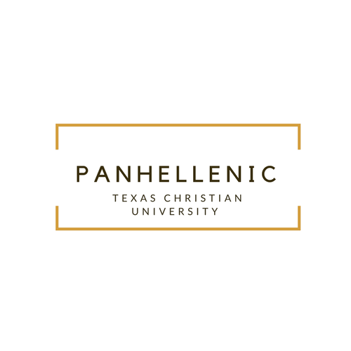

On behalf of the Panhellenic community, I want to wish you my warmest welcome and sincerest thanks for your interest in the Texas Christian University Panhellenic Council!

My name is Ellen Andrews, and I have the honor and privilege of serving as the 2018 Panhellenic President. It is nothing short of a dream come true to be the head of the governing body over our 13 incredible chapters. The sorority experience has impacted my college career more than anything else. Being a Panhellenic woman has taught me the power of respect, tenacity, authenticity, and above all, selflessness. There is nothing more consistent or impactful on our campus than the Panhellenic community. Panhellenic women demonstrate all that it means to be a successful collegian- they are intelligent, kind, generous and fun. Our women excel academically, demonstrate hearts for service and philanthropy, and find lifelong sisterhood.

Each year, we strive to push our members to be the best they can be. The Panhellenic women of TCU make up over half of undergraduate women on campus, and nearly one-third of the total population, with an average GPA that sits above the all-campus average GPA. We are one of only a select few campuses to receive the College Panhellenic Excellence Award for four consecutive years. TCU Panhellenic has also won awards for their scholarship and attention to the Month of the Scholar. The National Panhellenic Council’s own philanthropy, the Circle of Sisterhood Foundation, supports education for women worldwide. Our community was able to fully fund a Trek to Nicaragua in 2016, in which 14 Panhellenic women aided in the building of a school for impoverished girls. We are currently working to fund our second school build in 2019, this time in Nepal. We have won awards for our efforts toward the Circle of Sisterhood. These are just a few of the accomplishments of our high achieving community.

The TCU Panhellenic Council is one-fifth of the Fraternity and Sorority Life community. The Greek community at TCU offers unique opportunities to every Horned Frog. Students on this campus have the opportunity to join the Interfraternity Council (IFC), the National Pan-Hellenic Council, the Multicultural Greek Council (MGC) and the Independent Greek Council (IGC). Information about each of these councils can be found in the “Other Councils” page of this website.

It is my hope that by exploring our website, you are able to gain a deeper understanding of the impact and endless opportunities that are created by our 13 amazing chapters and the Panhellenic community at TCU. Please don’t hesitate to reach out to me or any of our executive officers with any questions you may have. Our organizations are made up of some of the world’s best and brightest up-and-coming thinkers, leaders, dreamers, and doers. Our goal above all else is for our members to gain an enriching community and memories that will last a lifetime.

Go Greek and Go Frogs!

Ellen Andrews

Panhellenic President