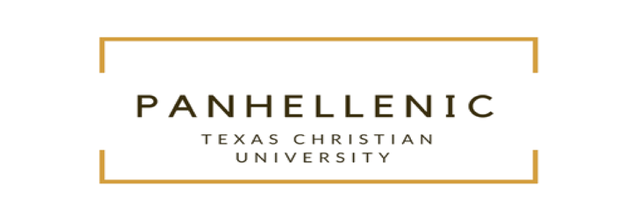
Panhellenic Summer Newsletter
The TCU Panhellenic Community has been hard at work preparing for recruitment this year! We are rolling out some exciting new updates to our recruitment process in order to make it a more values-centered experience for both potential new members and active chapter members. Some of these updates will foster deeper conversations during recruitment itself, improve interfraternal relations in the TCU fraternity and sorority community, and prepare new members for risk management during their first semester as members of their organizations.
Firstly, we are furthering our partnership with the fraternity and sorority specialists at Phired Up productions to provide our PNMs and active chapter members with a more values-centered recruitment experience. We are doing this through iValu and weValu surveys--in these, PNMs and chapter members can learn their own values and evaluate how those align with one another during natural, values-based conversations in the rounds of the recruitment process.
Additionally, we have an incredible speaker from Phired Up coming to town in early August to speak to our PNMs at recruitment orientation and our active members at Recruitment 201. Her name is KJ McNamara, and she believes in harnessing the potential of every person in the Greek community. KJ is fun, smart, kindhearted, and genuinely passionate about empowering others. We hosted KJ for a day in March to speak to recruitment chairs, advisors, and Rho Gammas, and she was a huge hit with our community. We can’t wait to welcome her here again!
When it comes to Panhellenic as a part of the greater Greek community at TCU, we are constantly working on fostering relationships with the other sororities on campus beyond just the Panhellenic chapters. The National Pan-Hellenic Council, Multicultural Greek Council, and Independent Greek Council all have incredible sororities with slightly smaller memberships, and are as high-achieving as Panhellenic sororities. During our formal Panhellenic recruitment process we have designated time for the chapters in other councils to come speak about their chapters so that more students on campus can be further educated as well as to promote how Panhellenic women can become further involved in fostering relationships across Greek council lines. We are excited to welcome these women to speak to our PNMs, and we hope that this will help to create a more welcoming and inclusive fraternity and sorority community for all.
Lastly, we have noticed a pattern of the newest members of our organizations being the most vulnerable to risky behaviors in the first few weeks or months of their memberships. To combat this issue, we have spearheaded a New Member Symposium to occur in the early fall of 2018. We are bringing in a speaker, Kim Novak, to educate our new members about risk management and issues such as hazing, sexual assault, and alcohol use to hopefully decrease harm and risk among our new members and create a safer campus and Greek community as a whole.
TCU Panhellenic is extremely excited for some of the new things happening in our community, and we are looking forward to seeing the progress that our community makes as a result.

