Name________________________

Address________________________

City_________________________

State __________ Zip___________

Phone__________________________

Date of Birth__________________

Age _______ Height____________

The parents or guardians signing this form acknowledge the risks of injury inherent in volleyball, including, but not limited to injuries to the head, brain, spinal cord, cardiovascular system, bones, joints, and soft tissues, arising out of rigorous contact or no contact athletic activity. In consideration of the reasonable fees charged for putting on the Golden Touch Volleyball Camp, the undersigned parents or guardians, on behalf of themselves and their minor camper who enrolls in the camp, hereby exculpate from liability, release and waive any and all claims for personal injury against The Golden Touch Basketball Academy, David T. Pettit, Union Grove High School, and all Assistant Coaches, arising out of negligent supervision, control, coaching, training, instruction, unsafe premises, and all other responsibilities necessary to run the camp.

My child is covered by an insurance company, policy number:

___________________________

Are there restrictions on your daughter’s participation?

Yes_____ No ______

(If yes, please attach a note explaining)

Parent’s/Guardian’s signature:

_________________________________

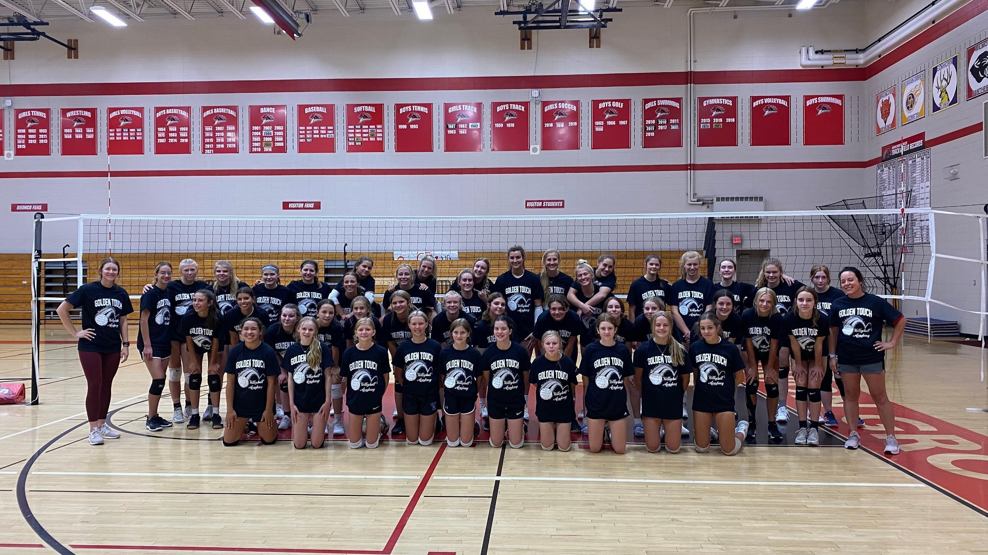

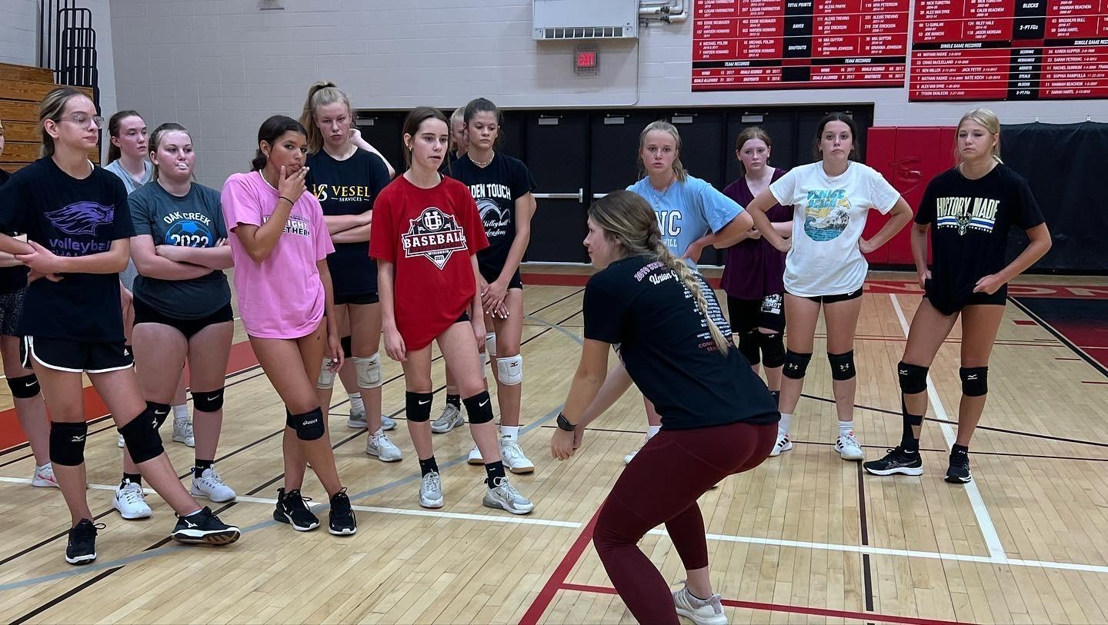

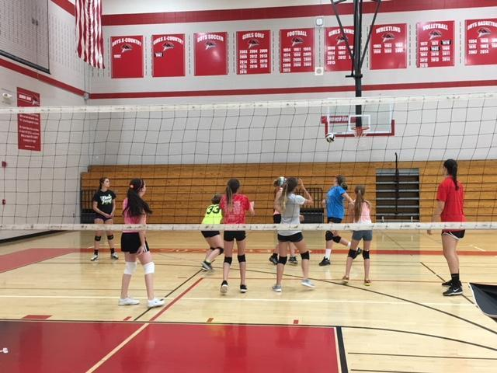

## Golden Touch Volleyball Camp



**At Union Grove**

**High School**

**Grade Age: 1st-8th Grade**

**When: July 7, 8, 9**

**Time: 1:00- 3:30pm**

**Cost: $80**

**Grade: 9th Grade**

**When: July 7, 8, 9, 10**

**Time: 1:00- 3:30pm**

**Cost: $100**

**Grade: 10th-12th Grade**

**When: July 8, 9, 10**

**Time: 1:00- 3:30pm**

**Cost: $80**

The Golden Touch Volleyball camp will be conducted for girls in grades 1st-12th. Union Grove Head Coach Abbie Hogan will run the camp with her assistants.

Abbie Hogan has been a part of the UGVB program since 2016 and has served as head coach since 2022.

Abbie earned a bachelor’s degree in Exercise and Sports Science with a focus on K-12 Physical Education, a minor in Health, and coaching certifications from Carthage College. In addition to coaching, she teaches high school Physical Education in Racine.

In 2025, she was named an AVCA High School 30 Under 30 Coach, a recognition of her impact on the sport. She also coaches for Wisconsin Juniors Volleyball Club, where she serves as the girls' volleyball strength and conditioning coach.

As a certified club volleyball official, she continues to deepen her expertise.

Passionate about athlete development, Coach Hogan mentors middle school girls, encouraging healthy habits that will last into adulthood. Outside of coaching, she enjoys fitness, cooking, and spending time with her family.

TO REGISTER

The camp will be held at Union Grove High School. The cost of attending the three-day session ranges between $80-$100 depending on the camper’s session. To register for camp, complete the Application Form and the Physical Waiver Form that is attached. Print clearly and fill in all the blanks. **Enclose a check or money order for the $40.00 deposit or the full amount, payable to the Golden Touch Basketball Academy** with your application, and mail it to the address below. If you have any questions, call David T. Pettit at 262-633-0838. You may also register online at goldentouchacademy.org and use a credit card for payment.

**If you sign up online, check the correct shirt size! There are youth and adult options!**

**RETURN TO:**

David T. Pettit

8400 Queensbury Ln

Sturtevant WI 53177

**APPLICATION FORM**

Golden Touch Volleyball Camp

Name ____________________

School____________________

Email_____________________

Grade level for Fall 2025_______

Home Phone_______________

Cell Phone_________________

**Youth** Shirt Size (please circle)

S M L XL

**Adult** Shirt Size (please circle)

S M L XL

____$35 Deposit

____paid in full

**Please note:** Shirt is only guaranteed if registered by June 20th