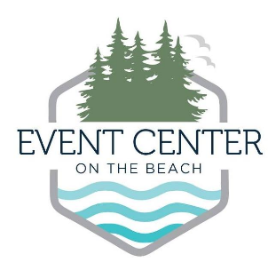
Curry County Fair Board
29392 Ellensburg Avenue, Gold Beach, OR 97444
541-247-4541
Eventcenteronthebeach.com

Agenda
November 20, 2024
5:30 p.m. – Docia Hall

- Call to Order
- Amendment and Approval of the Agenda
- Approve Minutes
  - 10.8.24 Minutes

- Public Comment (3 Minutes)

- Discussion Items/Action Items
  - Fair Budget for 2025 Fair
  - Rental contracts/fees/discounts

- Reports
  - Commissioner Liaison Report
  - Superintendent Report
  - Fair Manager Report
  - Next Meeting – ____________ at 5:30 p.m.

- Adjourn

