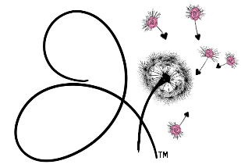
THE BARS™ INFORMATION FORM

Client Name: ________________________________Date: ______________________
Phone# ________________________________ Email:__________________________________
Address:_______________________________________________________________________________
Are you sensitive to a light touch from me to perform The Bars™ session? Yes or No
Reason for Visit: (please mention all the apply)
Physical: ______________________________________________________________________________
Emotional: _____________________________________________________________________________
Mental/Spiritual: ________________________________________________________________________
How did you hear about Jenny Darlin? ____________________________________________________
Have you been able to look at the web site for Jenny Darlin? www.JennyDarlin.com Yes or No
Have you ever had a Bars session before? Yes or No If yes, how many total _______

Client fully understands that performing The Bars™ is a simple, gentle, hands-on energy technique that is used for stress reduction and relaxation. I understand that The Bars™ practitioners do not diagnose conditions nor do they prescribe or perform medical treatment, prescribe substances, nor interfere with the treatment of a licensed medical professional. I understand that The Bars™ does not take the place of medical care. It is recommended that I see a licensed physician or licensed health care professional for any physical or psychological ailment I may have. I understand that the body has the ability to heal itself and to do so. I acknowledge that long term imbalances in the body sometimes require multiple sessions in order to facilitate the level of relaxation and clearings needed by the body to heal itself.
Client Signature:___________________________________________ Date:_________________________

Privacy Notice: No information about any client will be discussed or shared with any third party without written consent of the client or parent/guardian if the client if under 18.

Information during session:__________________________________________________________________________________________________________________________________________________________________________________________________________________________________________________________________________________________________________________________________________________________________________________________________________________________________________________________________________________________________________________________________________________________________________________________________________________________________________________________________________________________________________

