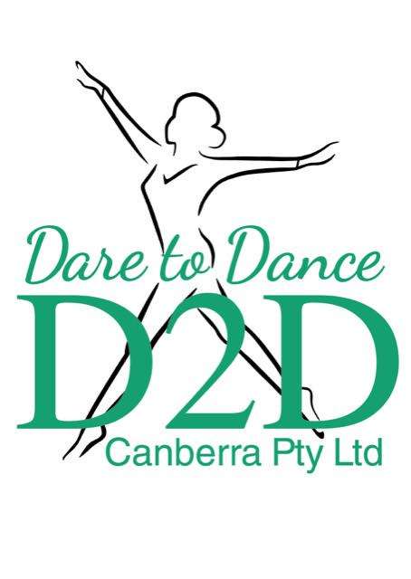
Dare to Dance Canberra
Fees Schedule 2026-2027

CLASS/ES BREAKDOWN | PER TERM | OTHER
Tiny Tots | $195
Pre Primary and Primary | $220
1 Class | $220
2 Classes | $405
3 Classes | $600
4 Classes | $720
5 Classes | $810
6 Classes | $860
7 Classes | $900
8 Classes | $1000
9 Classes | $1200
10+ Classes | $1480 | This includes PL Scheduled for Soloists
Private Lessons | $40 each | Any extra scheduled PL per 30 mins
Adult Single Class | $150
Adult Double Class | $210
Family Quarter Packages  (Ex. Up to x7 Classes per week) | $840
Family Half Packages  (Ex. Up to x15 Classes per week) | $1260 | This includes PL Scheduled for Soloists
Family Full Packages  (Ex.2-3 family members unlimited) | $2200 | This includes PL Scheduled for Soloists
Insurance, Aria Fee, Per Student  (Music Rights, Insurance Levy) | $15 | Added to all invoices

Additional Expenses:
- Class Uniforms/Shoe
- Troupe Uniforms (Troupe members only)
- Workshops – Extra Classes
- Competition Entry (Troupe and Solo Kids
- Ballet Exams (RAD)
- D2D Merchandise
- Production Package for the end of year concert (contains all photos and concert video)
- Costume Hire (end of year concert)

