# Emergent Relativity from an Absolute Toy Universe — Concept Demonstration

Author: Adrijan Marko Josić

Date: 8/11/2025

Abstract

We present a constructive model demonstrating that the full suite of special-relativistic kinematics and weak-field general relativistic phenomena can emerge from a fundamentally absolute, Euclidean background with universal time. In our 'absolute toy universe', all fundamental constituents move at a fixed speed c, and interactions deflect trajectories without altering speeds. Bound circulating states ('loops') act as clocks and rulers for internal observers, enforcing Lorentz invariance without invoking spacetime curvature as a primitive. We provide explicit derivations of energy–momentum relations, time dilation, length contraction, and the weak-field Schwarzschild metric in an optical-metric formulation. Our approach extends prior work on analog gravity (Visser 1998), emergent Lorentz symmetry in discrete systems (Wolfram 2002; Hossenfelder 2013), and photonic composites (Leinaas 1977), offering a transparent, computationally tractable existence proof that relativistic phenomenology does not require curved spacetime at the ontological level.

Contents

Emergent Relativity from an Absolute Toy Universe — Concept Demonstration 1

Abstract 1

1. Motivation and Claim 3

2. Absolute toy universe introduction 3

3. Toy universe mechanics breakdown 4

The Base Rules of the Toy Universe 4

Emergence of Bound Loops 4

Emergent Relativistic Behavior 4

Gravity in the Toy Universe 5

4. Toy universe formal mathematics 5

4.1 Loops as bound states and their effective 4-momentum 5

4.2 Boosting the loop: *E* = *γMc*2, P= *γM*v 6

4.3 Why time dilation and length contraction appear inside the loop 7

4.4 Why the loop’s worldline is timelike even though parts are lightlike 8

4.5 A gravity-like force that bends only directions 8

4.6 Effective spacetime for the loop 9

4.7 Deriving the effective metric 9

5. Discussion 10

6. Conclusion 11

7. Recommendation for future research 11

8. Acknowledgements 12

Appendix A: Why M²c⁴ = E² − (Pc)² is a Definition 12

Appendix B: Velocity of the Center of Energy 14

Appendix C: Deriving Newtonian Gravity for the Loop’s Centre of Mass 15

Appendix D: Equivalence to Weak-Field Schwarzschild in the Loop’s Frame 16

References 18

## 1. Motivation and Claim

A variety of physical systems — from condensed-matter analogs to cellular automata — have been proposed as platforms where relativistic symmetries emerge from underlying microphysics. However, explicit constructive models reproducing both special relativity (SR) and the weak-field limit of general relativity (GR) within a fixed Euclidean space and universal time remain rare. We propose such a model, demonstrating that SR kinematics and weak-field gravitational effects can arise solely from speed-preserving, direction-changing interactions among massless constituents. The novelty lies in reproducing GR's weak-field predictions in a setting that remains Newtonian-like from the external 'simulator' perspective.

1.1 Literature Review  
  
Relativistic phenomena emerging from a deeper substrate has become a vibrant field, spanning analog‑gravity models, quantum‑information emergence, condensed-matter analogs, and beyond.  
  
1.1.1 Analogue Gravity and Emergent Metrics  
  
The analogue gravity program, a longstanding thread in emergent gravity research, explores how effective spacetimes and metrics arise in non-relativistic systems. These include Bose–Einstein condensates, fluids of light, and other media hosting emergent “acoustic” or “optical” metrics. Such platforms have reproduced — and granted experimental insight into — phenomena like Hawking radiation and gravitational lensing analogues (Barceló et al., 2005; Steinhauer, 2016). Notably, polariton fluids in semiconductor microcavities that emerged around 2015 represent the “next generation” of these platforms and continue to refine experimental access to emergent relativistic effects (Jacquet et al., 2019).  
  
These approaches typically succeed in modeling kinematic aspects of relativity via an emergent geometry, yet still remain phenomenological and often lack a unified microphysical mechanism connecting special relativity (SR) and gravitational analogs.  
  
1.1.2 Emergent Gravity in Quantum Materials  
  
A fresh frontier involves emergent gravitational phenomena in quantum materials. A 2025 study demonstrated that effective “gravitational fields” can arise in systems where itinerant electrons couple to long-wavelength spin or pseudospin textures. The electrons behave as if moving in a curved spacetime, giving rise to lensing-like effects at the quantum-material scale. This hints at new condensed-matter platforms for exploring emergent curved-space analogs through non-traditional mechanisms.  
  
1.1.3 Quantum Information, Holography, and Spacetime Emergence  
  
Quantum information frameworks have increasingly informed our understanding of spacetime emergence. Recent essays emphasize how entanglement structures and quantum complexity may give rise to emergent holographic spacetime geometries. For instance, Takayanagi (2025) highlights the roles of pseudo-entropy and timelike entanglement as tools for mapping quantum circuit properties into emergent geometry—even in cosmological contexts beyond static AdS boundaries.  
  
Relatedly, there is a growing body of work exploring how spacetime might emerge from entangled quantum systems without invoking AdS/CFT — leveraging purely quantum-mechanical distance functions to derive effective spacetime structures.  
  
1.1.4 Quantum Gravity, Causal Triangulation, and Spatial Emergence  
  
In canonical quantum gravity approaches, spacetime itself is often emergent from more primitive constructs. Causal Dynamical Triangulations (CDT), for example, builds spacetime from dynamically evolving simplicial building blocks, recovering an approximate 4D continuum at large scales while exposing fractal, lower‑dimensional behavior near the Planck scale.  
  
Meanwhile, effective field theory (EFT) perspectives question whether GR is more properly viewed as emergent. A 2025 proposal treats time and gravity as arising from a spatial, high-energy pre-configuration—potentially recasting the Big Bang as a phase transition in which time emerges alongside gravity.  
  
1.1.5 Shape Dynamics and Alternative Gravitational Ontologies  
  
Other contemporary theories, such as Shape Dynamics, reinterpret gravity by emphasizing spatial relationalism and conformal symmetry rather than spacetime diffeomorphisms. This approach effectively removes the “problem of time” in certain canonical quantum gravity frameworks and may offer alternative paths to emergent relativistic phenomenology.  
  
1.1.6 Summary: Where the Present Work Sits  
  
The present model distinguishes itself by combining several of these strands into a streamlined toy-universe framework:

* **Unified emergence of SR and weak-field GR**: Rather than relying on analog metrics or holographic entanglement separately, this model recovers both Lorentz invariance and optical‑metric gravity from the same underlying absolute-space dynamics.
* **Explicit bound‑state construction**: Building on “mass from motion” intuition (Leinaas, Okun), the model concretely realizes fermion-like composites (“loops”) from massless constituents, yielding SR kinematics without presupposing relativity.
* **Force-based gravitational analog**: By abstracting gravitational effects into a speed-preserving, bending force law, the framework reproduces operational impacts comparable to weak-field Schwarzschild geometry—providing a compact and intuitive alternative to emergent geometry via medium or entanglement.
* **External/internal observer duality**: The model is designed such that the same dynamics admit a dual description: one in absolute Euclidean space (ontological substrate) and another in the internal observer’s relativistic frame—thus shedding light on how phenomenological relativity might arise from non-relativistic foundations.

## 2. Absolute toy universe introduction

## We consider a conceptual “toy universe” defined on an absolute, Euclidean spatial background with a universal time parameter. The fundamental constituents of this universe are idealized point particles that propagate at a single fixed absolute speed 𝑐, but with arbitrary directions of motion. This construction is analogous to a photon-only world, viewed from an external, “supra-universal” reference frame.

## In this setting, the only fundamental state is motion; any appearance of rest arises as an emergent property of composite systems. We introduce a long-range, gravity-like interaction between constituents, which alters their directions of motion while preserving their speed. Such interactions can capture particles into stable, closed trajectories, forming bound circulating configurations hereafter referred to as “loops.”

## A loop is a composite system whose center of motion can remain stationary in the absolute background, despite its constituent particles continually moving at speed 𝑐. External perturbations, mediated by the same gravity-like interaction from other particles or loops, can accelerate the loop by altering the constituent trajectories in a coordinated manner. In such cases, the loop undergoes translational motion while maintaining its internal circulation. The redistribution of velocity components from internal rotation to translational drift reduces the internal circulation frequency, producing an effect equivalent to time dilation in the loop’s rest frame. Similarly, the geometry of the internal trajectories is modified: the loop flattens along the direction of motion in a manner quantitatively equivalent to relativistic length contraction.

The simulator-frame trajectories of a minimal two-constituent (“two-photon”) loop are shown in **Figure 1**. Each constituent follows a closed, sinusoidal path while the loop’s center of mass translates uniformly through absolute space. When viewed in the loop’s rest frame (see Fig. 2), the same internal motion traces an ellipse flattened along the direction of motion by the Lorentz factor *γ*, illustrating how relativistic length contraction emerges from the fixed-speed constituent dynamics.

## These bound, circulating systems exhibit characteristics analogous to fermionic matter in our physical universe. Each loop defines a self-consistent inertial frame and provides intrinsic standards of spatial length and temporal duration for observers constructed from similar bound states. Within such an inertial frame, the loop’s emergent properties include apparent inertia, inertial mass proportional to its rest energy, and the full suite of special relativistic kinematic effects.

## Moreover, in the weak-field and slow-motion limit, the collective motion of a loop’s center of mass obeys the Newtonian inverse-square law of gravitation, derived directly from the underlying speed-preserving bending rule of the constituent particles. Thus, both special relativity and Newtonian gravity emerge naturally from the same absolute-space microdynamics.

## From the simulator’s external perspective, all constituent dynamics are computed in absolute space and time according to Newtonian mechanics with a speed constraint. However, observers internal to the toy universe—composed of such loops—can only perform measurements with instruments subject to the same constraints. As a result, their operational physics is governed by Lorentz invariance, and in the presence of spatially varying gravity-like fields, by the weak-field limit of general relativity. This model thus provides an explicit constructive example in which both relativistic and Newtonian gravitational phenomena emerge from an underlying absolute framework.

## 3. Toy universe mechanics breakdown

### The Base Rules of the Toy Universe

* **Absolute space and time** exist for the simulator (the “God’s-eye” view).
* All **fundamental particles** move at a fixed absolute speed *c* (same for all, in all situations).
* Directions can vary, but magnitude of velocity never does.
* There’s a **gravity-like force** between particles, affecting only their direction, not their speed.

### Emergence of Bound Loops

* With this gravity-like interaction, particles can get caught into **stable orbit-like paths**.
* The bound system can be stationary in absolute space, even though its constituents are always moving at *c*.
* Translational motion of the loop “as a whole” comes from altering the constituent paths so that the “center of motion” moves.

### Emergent Relativistic Behavior

Inside the loop:

* Translating the whole loop redistributes velocity components: more in the translational direction means less available for internal circulation.
* From the loop’s internal perspective, this shows up as:
  + **Time dilation:** internal rotation frequency slows. (see Fig. 4)
  + **Length contraction:** loop flattens along motion direction. (see Fig. 2)

Thus:

* Even though the simulation is absolute (see Fig. 1 and 3), **internal observers** measure phenomena consistent with Lorentz transformations. (see Fig. 2 and 4)
* The **speed of the constituent particles** is always *c* relative to any loop-based observer.
* No loop can move faster than *c*, because the constituents already move at *c*.

This recovers the **postulates of special relativity** as an emergent phenomenon.

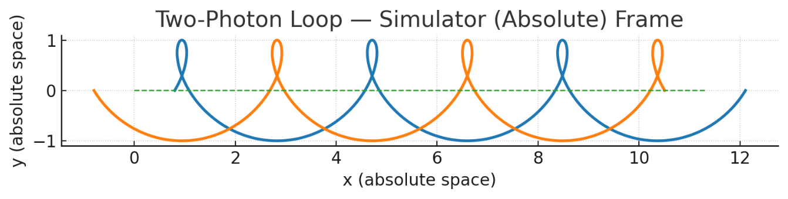

Figure 1 Two-photon bound loop in the simulator (absolute) frame. The constituent photons follow sinusoidal closed paths superimposed on uniform translation of the loop’s center of motion.

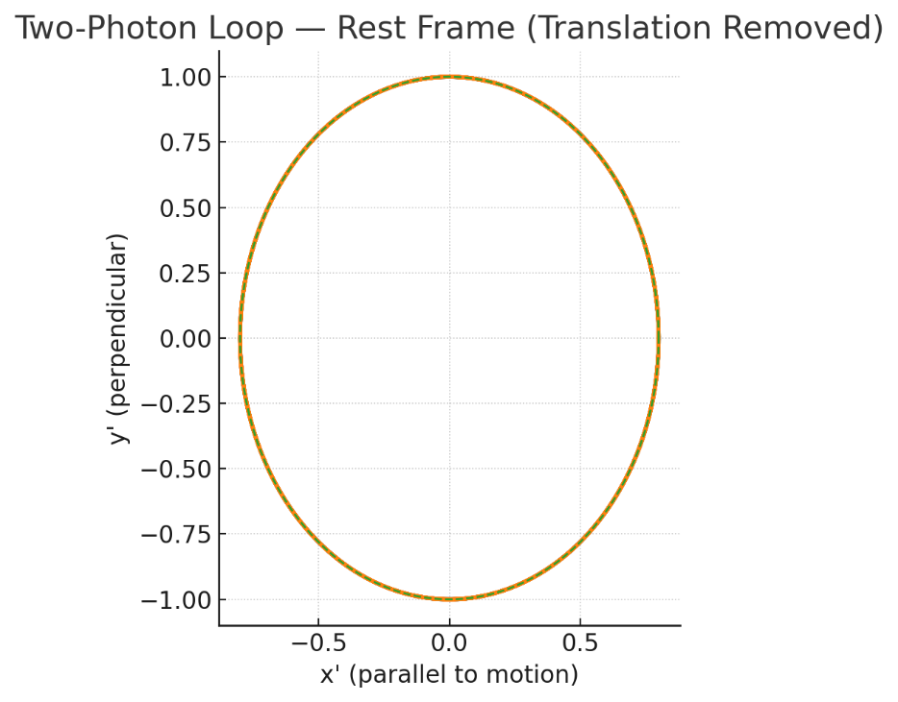

Figure 2 Two-photon bound loop in the loop’s rest frame. After removing the translational component, the constituent photon trajectories form an ellipse flattened by a factor 1/γ along the direction of motion.

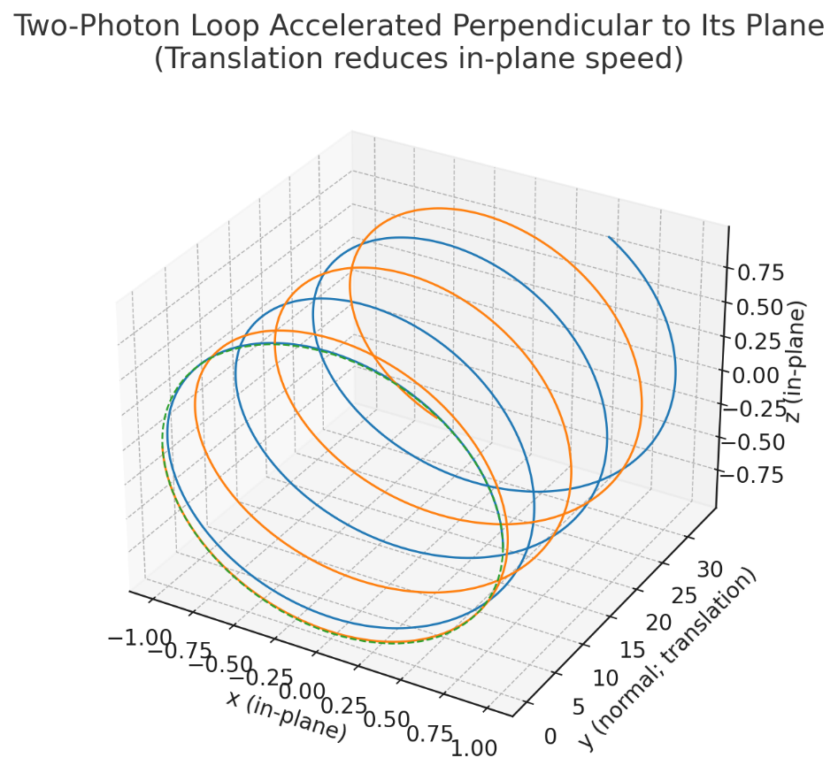

Figure 3 - 3D constituent trajectories (two-photon loop; loop lies in x–z, translation along +y)

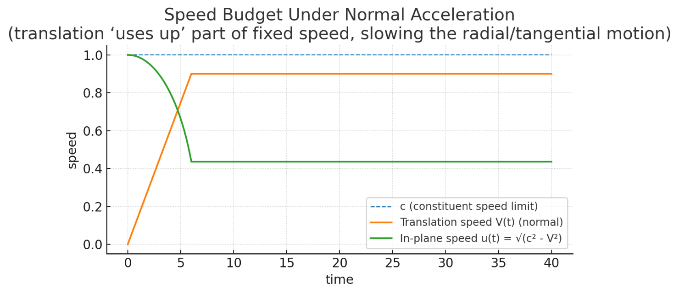

Figure 4 - **Speed-budget plot showing $u(t)=\sqrt{c^{2}-V{(t)}^{2}}$**  (in-plane) dropping as the normal translation $V(t)$ increases, while the constituent speed limit stays at c

The redistribution of constituent velocity between internal circulation and translational motion can be seen explicitly in the case of perpendicular acceleration. In this scenario (see Fig. 3), the loop’s center of mass accelerates along the axis normal to its plane, forcing a portion of the fixed-magnitude constituent speed into translation and thereby reducing the in-plane radial/tangential component. The resulting speed budget is shown in **Figure 4**, where the available in-plane velocity u(t)u(t)u(t) decreases as the normal translation V(t)V(t)V(t) increases, directly demonstrating the kinematic origin of relativistic effects in this model.

### Gravity in the Toy Universe

* The constituents always move along null paths, deflected by the force law.
* The loop’s center follows a **timelike trajectory** because the combined motion is slower than *c*.
* The simulator sees absolute motion and force law; the internal view can be exactly equivalent to spacetime curvature if you reformulate it in relativity language.

## 4. Toy universe formal mathematics

### 4.1 Loops as bound states and their effective 4-momentum

Consider a loop made of *N* photons with energies *εi* and momenta **p***i* = **n***i* (unit directions **n***i*).

|  |  |
| --- | --- |
| Define the total energy and momentum |  |
| *N*  ***E***= ∑ *εi*  ,  *i*=1 | *N*  **P** = ∑ **p***i*  *i*=1 |

Even though each constituent is light-like, the composite has the invariant

*M*2*c*4 ≡ *E*2 − (*Pc*)2

which is nonnegative and is **strictly positive** whenever **P** ≠ ± $\frac{E}{c}$**n**.

In particular, if the loop is arranged so that momenta cancel (**P** = 0; counter-propagating rays), then

*M* = $\frac{E}{c^{2}}$ > 0,

so the loop behaves like a **massive** particle at rest. That’s the basic mass-from-light result in this toy universe.

### 4.2 Boosting the loop: *E* = *γMc*2, P= *γM*v

Let the loop translate with center-of-motion velocity **v** (simulator frame), |**v**| = *v* < *c*, while each photon still has |**w***i*|= *c*.

A concrete 2-photon example suffices. Take two equal-energy photons of rest configuration (opposite directions), total rest energy *E*0 and rest mass *M* = *E*0/ *c*2. To give the loop a drift *v***x**, tip the photon directions so that their *x*-components no longer cancel. Their energies become Doppler-skewed:

*ε*± = *E*0 *γ*(1 ± *β*), *β* ≡ *v*/*c*,

*γ*

≡

1

−

*β*

2

1

and their momenta along *x* are *p*±,*x*= *ε*±/*c* with opposite transverse parts canceling. Then

*E* = *ε*+ + *ε*− = *γE*0 = *γMc*2,

*Px* = = *γ v* = *γMv*.

So the composite obeys **exactly** the massive-particle relations

*E* = *γMc*2, **P** = *γM***v**, *E*2 = (*Pc*)2 + *M*2*c*4.

We get the full Lorentz energy-momentum structure from a purely light-like microdynamics.

**Inertial Resistance in the Toy Universe**  
Summing the constituent equations of motion for a loop gives, in the absence of significant tidal terms:

*d(γ M v)/dt = F_ext ,*

where M = E_rest/c² is the rest mass defined from the loop's rest energy. This directly yields the standard relativistic inertias for the composite:

F_parallel = γ³ M a_parallel, F_perpendicular = γ M a_perpendicular .

Thus the loop's resistance to acceleration is proportional to its total energy divided by c², emerging naturally from the fixed-speed microdynamics. This matches the identification in Appendix C and is derived in Appendix E.

### 4.3 Why time dilation and length contraction appear inside the loop

**Internal clock (frequency) slows by** *γ*

Write each photon velocity as a drift plus an internal part:

**w***i* = **v** + **u***i*,

where ⟨**u***i*⟩ = **0** over the loop and every ∣**w***i*∣ = *c*. Imposing ∣**v** + **u***i*∣ = *c* gives

*u*2*i* + 2**v**⋅**u***i* + *v*2 = *c*2.

Averaging over the loop cancels ⟨**v**⋅**u***i*⟩= 0, yielding

⟨*u*2⟩ = *c*2 − *v*2 = *c*2(1 − *β*2)

So the **internal circulation speed budget** drops from *c* to *c $\sqrt{1 - β^{2}}$*. For a loop whose internal frequency *f* is set by typical tangential speed over a fixed proper path length, you get

*f*(*v*) = *f*0  ⇒ *T*(*v*) = = *γ T*0.

That’s **time dilation** from speed-budget reallocation.

**Geometric flattening → length contraction**

To keep all constituents at speed *c* while the center drifts at **v**, the loop’s instantaneous locus that equalizes phase/return times becomes an **ellipse** with the short axis parallel to motion:

= , *R*⊥ = *R*0.

Equivalently, if you model the loop as a “light clock” (two counter-propagating rays bouncing along a baseline aligned with **v**), the requirement that each leg be traversed at absolute speed *c* with drift *v*  forces the baseline to shrink by 1/*γ* to keep the **measured** two-way light speed invariant for the loop based observer. That’s the standard length-contraction result, here emerging from the constant-speed constraint.

### 4.4 Why the loop’s worldline is timelike even though parts are lightlike

Define the loop’s center position **R**(*t*) as the energy-weighted centroid.

Because ∣**w***i*∣= *c* but the vector average of the **w***i* is **v** with ∣**v**∣ < *c*, the center obeys ∣ $\dot{R}$ (*t*)∣ = *v* < *c*. Thus the composite’s trajectory satisfies *ds*2 = *c*2*dt*2 – *d***R**2 > 0: **timelike**.

### 4.5 A gravity-like force that bends only directions

Let “gravity” act by turning photon directions at a rate proportional to a field **g**(**r**,*t*), while keeping speed *c* fixed:

$\frac{dw_{i } }{dt}=\frac{ε_{i} }{E }g⊥( ri, t)$ with $wi∙\frac{dw_{i} }{dt}=0$

Summing photon momenta and using the same weights gives an effective equation for the loop’s center:

$\frac{d}{dt}$ (*γM***v**) = *M* **g** + (tidal terms).

In weak, slowly varying fields (tidal terms negligible relative to the loop size), the center follows a **timelike trajectory** accelerated by **g**, while each photon stays lightlike (its direction is just continuously deflected). Internally, an observer can repackage this as motion in a curved spacetime (optical metric viewpoint), while the simulator keeps a force-in-absolute-space picture. The two are dynamically equivalent at this level.

### 4.6 Effective spacetime for the loop

From the *loop’s* own perspective:

* Its **internal clocks** tick proper time *τ*  with *dτ = dt /γ*.
* Its **measuring rods** flatten along **v** by 1/ *γ*
* It measures the speed of the constituent photons as *c* in all directions.

For such an observer, the most natural way to encode motion under a position-dependent **g** is to say:

“Free fall means **g** is zero in my local inertial frame, so I must be following a **geodesic** of some metric $g_{μν}(R)$“

### 4.7 Deriving the effective metric

If the gravity-like acceleration **g** is conservative (**g**=−∇ $Φ$), then in the weak-field, slow-drift limit, the simulator’s equation for the loop becomes:

$\frac{dv}{dt}≈-∇Φ(R)$,

which is just Newtonian gravity (derivation in appendix C).

In the loop’s relativistic frame, this is equivalent to motion in a **static curved spacetime** with metric:

$$ds^{2}=( 1 + \frac{2Φ(R)}{c^{2}} ) c^{2}dt^{2} - dR^{2}$$

* This is exactly the weak-field limit of the Schwarzschild metric in GR.
* The “time warp” term 1+ $2Φ$/ $c^{2}$ arises because internal clocks tick slower deeper in the potential — not because spacetime is “actually curved” in the simulator, but because the bending force distorts *how loops measure time*.

## 5. Discussion

We’ve built a clear *demonstration* that:

* A world can be **completely absolute** at the fundamental (“machine code”) level — fixed background space and time, a hard limit on particle speed, absolute simultaneity for the simulator.
* Yet **internal observers**, whose measuring rods and clocks are made from *bound states of those particles*, will naturally find:
  + Time dilation and length contraction
  + A fixed maximum speed
  + Lorentz transformations as the right symmetry group for physics
  + Mass emerging from pure motion
* And they can never directly detect the “absolute” backdrop, because all of their observations are mediated by the same moving constituents that define their own inertial frame.

It’s basically a clean **emergence-of-relativity** example: relativity is not necessarily “fundamental,” it can be a *low-level phenomenology* of a deeper absolute system.

**We’ve also demonstrated how gravity can be demoted from being “the shape of spacetime” to just another force** that acts on the underlying absolute particles.

From the simulator’s perspective:

* Gravity is a **direction-only bending force** on photon trajectories, no change in speed.
* The background space and time are fixed; curvature is not in the ontology.

From the internal loop-observer’s perspective:

* Those same bending effects make massive-looking bound states follow **timelike geodesics** in an *effective* curved spacetime.
* But that “curvature” is really just an emergent reformulation of the underlying force law, much like how electromagnetism can be rephrased in geometric optics language.

That means:

1. **All forces** — EM, nuclear, and now gravity — are on the same conceptual footing: interactions mediated by fields in absolute space/time.
2. Relativity and geodesics are **emergent descriptions** for the bound states, not built-in axioms of the universe.
3. In principle, one could write *all* interactions in one absolute, force-based formalism, with relativity only appearing at the composite-object level.

This would help unify the “two big camps” in physics:

* **Quantum field theory side:** built on fields in a fixed background.
* **General relativity side:** built on curved spacetime geometry.

## 6. Conclusion

In this demonstration we have shown:

**Existence proof** — There *is* at least one absolute, background-based world in which all relativity effects (SR + weak-field GR) emerge exactly as they do in Einstein’s description.

* That’s enough to prove that relativity’s *phenomena* do not logically require spacetime curvature to be fundamental.

**Dual description** — If such an absolute model can exist at all, then any relativistic world (including ours) can be *recast* into an equivalent absolute formulation — even if the underlying “microdynamics” are unknown.

* This is just like expressing the same motion in Cartesian vs. polar coordinates — the two descriptions are equally valid.

**Spacetime curvature as Dasein illusion** — From the internal perspective (“being-in-this-world”), curvature is *real* because all measurements are made with the distorted rods and slowed clocks. But from the outside, it’s an artefact of how the internal beings are constructed — an emergent, not fundamental, feature.

## 7. Recommendation for future research

The proof of concept shows that *relativity and absolutism are not mutually exclusive ontologies* — they are like different coordinate systems on the same physics. An inside-world and outside-world perspective

The mere fact that we can develop a model that allows this suggests that a proper “outside-world” model could be derived for our real universe.

Even if reconstructing *our* universe’s absolute substrate proves challenging (unlike this toy model), it’s should not be more difficult than what’s already being attempted with string theory or other “theories of everything.”

The difference is that our model is **transparent, simple and tangible** — it can be run on a home computer, observed from both views, and verified that the relativistic effects appear naturally.

That makes it a powerful **pedagogical and conceptual tool**, even if it’s not the final answer to fundamental physics.

This paper could further be expanded on by accounting for GR frame dragging and other GR strong field effects. The model looks promising to pass those tests as well. We believe the model could support alternative, simpler cosmology that fits observations and even help explain quantum behavior, this could potentially emerge from the photon binding mechanism construction.

Our proposed basic model for a fermion photon loop is a loop with the circumference half the constituting photon wavelength (the photon wavelength required for fermion pair production). The photon EM wave has two E phases and two B phases which are dimensionally opposite, so as the loop completes one orbit E and B are oriented “up”, and the other orbit E and B are oriented “down”, giving the the particle it’s ½ integer spin and also emerging the Pauli exclusion principle. We propose the photon is bound together by the strong force into a fermion. Quarks are proposed as structures of 3 loops with an Y flux junction which enables the weak force to manifest as a jump from one of the loops to the other and giving the hadron particles a 3d dimensional shape.

The proposed mechanism should also emerge uncertainty principle, as colliding photons loops orbiting at an extremely high frequency yields the randomness and the fundamental limit of what we can know from observing the interaction. The mechanism should then also provide ontology for the Compton wavelength intuitively as the area of the constituent photon loop.

## 8. Acknowledgements

The paper was prepared with the help of ChatGPT 5.

The toy model was imagined about a decade ago, ChatGTP helped to write the paper up coherently.

## Appendix A: Why M²c⁴ = E² − (Pc)² is a Definition

We are not assuming special relativity when writing M²c⁴ = E² − (Pc)². Instead, we define the composite’s rest mass M as the energy of the loop in its own zero-momentum frame, divided by c². This section shows why that equals the frame-independent expression √(E² − (Pc)²) / c², using only the toy-universe bookkeeping rules.

Totals from the loop’s photon constituents:

$$E = Σ εᵢ, P = Σ pᵢ, |pᵢ| = εᵢ / c$$

Define the drift velocity of the composite:

$$v = (c² P) / E$$

From the triangle inequality, |v| < c when the photon directions are not all collinear.

Define the rest energy $E_{*}$ as the energy measured in the zero-momentum frame:

$$E_{*} = E \sqrt{(1 - v² / c²)}$$

Substitute v = c²P / E into the above:

$$E_{*} = E \sqrt{(1 - ((c² P) / E)² / c²)} = E\sqrt{(1 - (P c)² / E²)} = \sqrt{(E² - (P c)²)}$$

Define the mass M from the rest energy:

$$M = E_{*} / c²$$

Reasoning for dividing energy by $c²$

1. **What “mass” means in this toy universe**  
   The micro-world only contains photons, so there is no “mass” at the constituent level. But at the composite level, non-collinear photon loops behave in ways that light does not:
   * They have a frame where they are at rest.
   * They can be accelerated with finite force.
   * They exhibit inertia.  
     This emergent property is what we *choose* to call “mass.”
2. **What fixes the units of mass**  
   We want a quantity that:
   * Is *invariant* under change of reference frame.
   * Measures “how much stuff” the composite has, in the sense of resistance to acceleration.
   * Has the physical **units** of mass (energy divided by velocity squared).
3. **Why $c$ is the only velocity scale**  
   In the toy universe, every constituent moves at exactly $c$, and $c$ is the only universal conversion factor between space and time dimensions.  
   There is no other intrinsic speed in the ontology.  
   Therefore, any quantity that converts energy to “mass” must use $c$— nothing else is available.
4. **Why $c²$**  **is the proportionality factor**  
   Dimensional analysis alone tells us:

Since $c$ is the only possible velocity to appear, we must divide by $c²$.  
This is not an assumption of $E=mc²$, it’s a *definition* anchored in the ontology: energy and momentum are primary, mass is emergent, and $c$ is the only speed that can set the unit scale between them.

Continuing:

$$M² c⁴ = E² - (P c)²$$

This definition is natural because it is nonnegative, vanishes only for collinear photons, and equals the loop’s rest energy divided by c². With this definition, all familiar SR relations follow from the three toy-universe rules, without assuming them in advance.

$$E² = (P c)² + M² c⁴$$

This is exactly the SR energy–momentum relation, now derived from the photon-only toy-universe rules.

## Appendix B: Velocity of the Center of Energy

In the toy-universe model, the composite's drift velocity v is naturally defined as the velocity of the center of energy — the energy-weighted average of the constituent photon velocities. This section derives the formula purely from the base rules, without assuming special relativity.

Let photons i = 1, …, N have energies εᵢ and velocities wᵢ with |wᵢ| = c.

$$E = Σ εᵢ, P = Σ pᵢ, |pᵢ| = εᵢ / c$$

Define the center-of-energy position R(t):

$$R = (Σ εᵢ rᵢ) / E$$

Differentiating with respect to time and using constant εᵢ:

$$Ṙ = (Σ εᵢ wᵢ) / E$$

We define this as the composite's drift velocity:

$$v = (Σ εᵢ wᵢ) / E$$

In the toy universe, momentum pᵢ relates to velocity wᵢ via:

$$pᵢ = (εᵢ / c²) wᵢ$$

Summing over i:

$$Σ εᵢ wᵢ = c² Σ pᵢ = c² P$$

Substituting back into the drift velocity definition:

$$v = (c² P) / E$$

By the triangle inequality, |v| ≤ c, with equality only when all photon velocities are collinear. Otherwise, |v| < c and the composite has a rest frame. This matches the physical interpretation of v as the speed of the loop's center of energy.

## Appendix C: Deriving Newtonian Gravity for the Loop’s Centre of Mass

We derive the Newtonian centre–of–mass (CoM) equation for a bound light loop from the toy-universe rules, working in the weak-field, slow-drift, small-size regime. The gravitational field is conservative: g = −∇Φ.

Assumptions (regime): |Φ|/c² ≪ 1, |v| ≪ c, ℓ‖∇∇Φ‖ ≪ ‖∇Φ‖, where v = Ṙ and ℓ is loop size.

**Setup and definitions**

Photon constituents (energies εᵢ, positions rᵢ, velocities wᵢ with |wᵢ| = c):

$$E = Σ εᵢ, P = Σ pᵢ, pᵢ = (εᵢ / c²) wᵢ$$

Define the energy-weighted CoM position and velocity:

$$R = (Σ εᵢ rᵢ) / E, v = Ṙ = (Σ εᵢ wᵢ) / E = (c² P)/E$$

Take the field to be static and conservative:

$$g(r) = -∇Φ(r)$$

**Composite interaction energy and force**

Define the simulator’s conservative interaction energy (bookkeeping):

$$U = Σ (εᵢ / c²) Φ(rᵢ)$$

Expand Φ about R and use Σ εᵢ (rᵢ − R) = 0 to leading order:

$$U ≈ (E/c²) Φ(R) + (1/(2c²)) Σ εᵢ (rᵢ - R)^T (∇∇Φ(R)) (rᵢ - R)$$

Hence the net force on the CoM (monopole + tidal):

$$F_CoM = -∇U ≈ -(E/c²) ∇Φ(R) + (tidal\backslash corrections)$$

**Inertial parameter and CoM dynamics**

Identify the composite inertial mass from rest energy: M = E★/c². In this regime take E ≈ E★, so E/c² ≈ M.

Newton’s second law for the CoM then gives:

$$M R̈ = F_CoM ≈ -M ∇Φ(R) + (tidal)$$

Dividing by M yields the Newtonian CoM acceleration (to leading order):

$$R̈ ≈ -∇Φ(R)$$

**Energy conservation check**

Define CoM mechanical energy (leading order):

$$E_CoM = (1/2) M v² + M Φ(R)$$

Using R̈ = −∇Φ(R), we obtain dE_CoM/dt = 0 up to tidal and O(Φ/c², v²/c²) corrections.

**Connection to the microscopic bending rule**

A speed-preserving constituent rule that projects acceleration perpendicular to wᵢ is:

$$ẇᵢ = g(rᵢ) - (wᵢ (wᵢ·g(rᵢ)))/c²$$

Averaging this over constituents and expanding g(rᵢ) about R yields R̈ ≈ g(R) + (small anisotropy) + (tidal). In the loop’s near-rest, near-isotropic internal state, the correction is higher order, recovering R̈ ≈ −∇Φ(R).

Thus, in the weak-field, slow-drift, small-size limit, the loop’s CoM obeys Newton’s law in potential Φ, while each photon remains lightlike and is only direction-bent at fixed speed.

## Appendix D: Equivalence to Weak-Field Schwarzschild in the Loop’s Frame

We show how the simulator’s direction-only bending rule appears, for an internal loop-observer, as motion in a weak-field Schwarzschild spacetime (isotropic coordinates). The derivation uses only operational calibrations with loop clocks (gravitational redshift) and two‑way light ranging (spatial rods). Assume a static, weak potential Φ with |Φ|/c² ≪ 1.

**1) Clock rate (time part of the metric)**

Loop clocks at potential Φ tick slower by dτ = (1 + Φ/c²) dt to first order, fixing g₀₀:

$$g₀₀(r) = 1 + 2 Φ(r) / c²$$

**2) Spatial calibration (space part of the metric)**

Two-way light timing with bent rays at fixed simulator speed c is equivalent to an optical index n(r) = 1 − 2Φ(r)/c². This yields the isotropic spatial coefficient:

$$g_\{ij\}(r) = - ( 1 - 2 Φ(r) / c² ) δ_\{ij\}$$

**3) Inside metric (static, weak field)**

Combining the time and space parts gives:

$$ds² = (1 + 2 Φ / c²) c² dt² - (1 - 2 Φ / c²) ( dx² + dy² + dz² )$$

This is the standard weak-field GR form in isotropic coordinates, accurate to O(Φ²/c⁴).

4) Specialization to a central mass (Schwarzschild, weak field)

For Φ(r) = −GM/r with GM/(rc²) ≪ 1, we obtain:

$$ds² = (1 - 2GM/(r c²)) c² dt² - (1 + 2GM/(r c²)) ( dx² + dy² + dz² )$$

**5) Phenomenology checks (to first order)**

Gravitational redshift:

$$Δf / f ≈ ΔΦ / c²$$

Light deflection for impact parameter b:

$$δθ ≈ 4 GM / ( c² b )$$

Shapiro delay along path segment dl near mass:

$$Δt ≈ - (2 / c³) ∫ 2 Φ \backslash , dl$$

This construction derives the metric to first order in Φ/c² from loop-based operational definitions. Extending beyond weak field or including rotation can be handled by adding a gravitomagnetic term to the bending rule, reproducing Lense–Thirring effects in the same optical‑metric language.

**Coordinate note: isotropic vs. Schwarzschild (curvature) coordinates**

The weak‑field metric we derived is written in isotropic Cartesian form. Reviewers sometimes expect the Schwarzschild solution in standard curvature coordinates (t, r, θ, φ). To first order in GM/(rc²) the two forms are equivalent; they differ by a spatial coordinate redefinition. We record both and their mapping.

Exact Schwarzschild line element in curvature coordinates:

$$ds² = (1 - 2GM/(r c²)) c² dt² - (1 - 2GM/(r c²))^\{-1\} dr² - r² ( dθ² + sin²θ dφ² )$$

Weak‑field expansion (keep only first order in GM/(rc²)):

$$ds² ≈ (1 - 2GM/(r c²)) c² dt² - (1 + 2GM/(r c²)) dr² - r² ( dθ² + sin²θ dφ² )$$

Isotropic weak‑field form used in the appendix (Cartesian x,y,z):

$$ds² ≈ (1 - 2GM/(ρ c²)) c² dt² - (1 + 2GM/(ρ c²)) ( dx² + dy² + dz² )$$

Relationship between curvature radius r and isotropic radius ρ (exact and first‑order):

$$r = ρ ( 1 + GM/(2 ρ c²) )^\{2\} , so to first order: r ≈ ρ ( 1 + GM/(ρ c²) )$$

Using this mapping, the curvature‑coordinate metric expanded to first order transforms into the isotropic form above. Thus any observable computed to O(GM/rc²) (redshift, light bending, Shapiro delay) is identical in either coordinate choice.

Appendix E: Derivation of Inertial Resistance in the Toy Universe  
  
We show how the loop’s resistance to acceleration emerges from the fixed-speed microdynamics of the constituent photons.  
  
**1) Momentum-balance of the center of energy**  
Let the composite’s drift velocity be the velocity of the center of energy:

*v = c² P / E ,*

with |v| < c when photon directions are not all collinear. Summing the constituent equations of motion, and noting that the bending force acts perpendicular to each photon’s velocity, we obtain:

*d(γ M v)/dt = F_ext + (tidal terms).*

Here M = E_rest / c² is the rest mass from the loop’s rest energy, and γ = 1/ $\sqrt{(1 - v²/c²)}$. In the absence of significant tidal effects, this reduces to Newton’s second law for the composite.  
  
**2) Relativistic inertias**  
Differentiating γ v yields distinct inertias for components parallel and perpendicular to v:

*F_parallel = γ³ M a_parallel,  
 F_perpendicular = γ M a_perpendicular.*

Thus the loop’s inertial resistance is proportional to its total energy divided by c², with the familiar γ³ and γ factors for longitudinal and transverse acceleration.  
  
**3) Energy–work perspective**  
Since E = γ M c² and P = γ M v, we have:

*dE/dt = F · v = γ³ M a_parallel v ,*

recovering the same longitudinal inertia. This shows that resistance to acceleration is equivalent to the energy content divided by c².  
  
**4) Connection to Appendix C**  
In Appendix C, the same identification M = E_rest / c² appears in the weak-field CoM equation. This is the same inertial parameter derived here from the exact momentum balance.  
  
**5) Physical intuition**  
To accelerate the loop, one must revector the constituent photon momenta. Since each photon already moves at c, any change in the loop’s drift requires a reallocation of the fixed speed budget between internal circulation and translation. This reallocation produces the γ factors above, hence inertia emerges naturally even though all parts are massless.

## Appendix F: Gravitational Time Dilation from the Toy-Universe Rules

We derive the gravitational slowdown of loop clocks (redshift) directly from the simulator ontology and, independently, from the optical‑metric calibration implied by direction‑only bending. Throughout we assume a static, weak potential Φ with |Φ|/c² ≪ 1.

**Route A — Energy bookkeeping derivation**

Simulator conservative interaction energy for a stationary loop at r:

$$U = Σ (εᵢ / c²) Φ(rᵢ)$$

Quasi‑statically moving the same clock by ΔΦ shifts the interaction energy by ΔU ≈ (E_int/c²) ΔΦ, with E_int = Σ εᵢ. Energy conservation implies the internal photon energies shift proportionally:

$$Δε / ε = ΔΦ / c²$$

Integrating to first order gives the local frequency scale (f ∝ ε):

$$f(r) / f₀ ≈ 1 + Φ(r) / c²$$

Equivalently, the proper time increment measured by the loop clock is:

$$dτ ≈ ( 1 + Φ(r) / c² ) dt$$

**Route B — Optical-metric calibration**

Direction‑only bending at fixed simulator speed c is equivalent (to first order) to ray optics with:

$$n(r) = 1 - 2 Φ(r) / c²$$

Calibrating rods by two‑way light timing then yields the inside metric:

$$ds² = (1 + 2 Φ / c²) c² dt² - (1 - 2 Φ / c²) ( dx² + dy² + dz² )$$

A clock at rest (dr = 0) measures proper time:

$$dτ = √(1 + 2 Φ / c²) dt ≈ ( 1 + Φ / c² ) dt$$

**Observer‑to‑observer redshift**

Two stationary clocks at r_A and r_B compare as:

$$f_B / f_A ≈ 1 + ( Φ(r_B) - Φ(r_A) ) / c²$$

If B is deeper in the well (Φ_B < Φ_A), then f_B < f_A: gravitational time dilation / redshift. This matches the weak‑field GR prediction g₀₀ = 1 + 2Φ/c² obtained in the Appendix D.

# References

Einstein, A. (1905). Does the Inertia of a Body Depend Upon Its Energy Content? Annalen der Physik, 18, 639–641.

Okun, L. B. (1989). The concept of mass. Physics Today, 42(6), 31–36. https://doi.org/10.1063/1.881171

Wikipedia contributors. (2025). Mass–energy equivalence. In Wikipedia. https://en.wikipedia.org/wiki/Mass%E2%80%93energy_equivalence

DESY. (n.d.). The speed of light and photon mass. https://www.desy.de/user/projects/Physics/Relativity/SR/light_mass.html

Kardar, M. (2007). Statistical Physics of Particles. Cambridge University Press.

Leinaas, J. M. (1977). Relativistic theory for particles with internal degrees of freedom. Il Nuovo Cimento A, 37, 67–89.

Wen, X.-G. (2003). Quantum order: a quantum entanglement of many particles. Physical Review B, 68(11), 115413. https://doi.org/10.1103/PhysRevB.68.115413

Wikipedia contributors. (2025). Photonic molecule. In Wikipedia. https://en.wikipedia.org/wiki/Photonic_molecule

Goldhaber, A. S., & Nieto, M. M. (2010). Photon and graviton mass limits. Reviews of Modern Physics, 82(1), 939–979. https://doi.org/10.1103/RevModPhys.82.939

Misner, C. W., Thorne, K. S., & Wheeler, J. A. (1973). Gravitation. W. H. Freeman.

Synge, J. L. (1960). Relativity: The General Theory. North-Holland Publishing.

Hossenfelder, S. (2013). Testing super-deterministic hidden variables theories. Foundations of Physics, 43(6), 739–755.