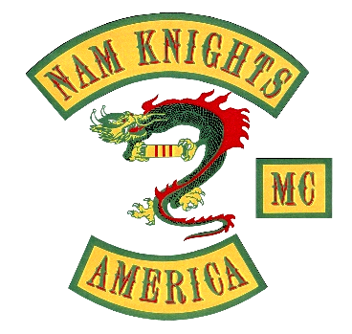

[Wawa to Wawa - Google Maps](https://www.google.com/maps/dir/Wawa,+510+Frost+Ave,+Warrenton,+VA+20186/Sperryville,+VA/Thornton+Gap+Entrance+Station/Lydia/8315+Seminole+Trail,+Ruckersville,+VA/Wawa,+Frost+Avenue,+Warrenton,+VA/@38.4752364,-78.4588064,10z/data=!3m2!4b1!5s0x89b67db6b09dd7a1:0x863952f574cc8c1f!4m43!4m42!1m5!1m1!1s0x89b67db6e64e7f2f:0x84b429c1d298592!2m2!1d-77.8087556!2d38.7166219!1m5!1m1!1s0x89b43191faca997f:0xa706a98af908ad75!2m2!1d-78.2261389!2d38.6570525!1m10!1m1!1s0x89b44a22e2aa0a75:0x8d26610f40fc6ccd!2m2!1d-78.3208103!2d38.6624106!3m4!1m2!1d-78.4073446!2d38.548983!3s0x89b445c7ed29b03d:0xf79a027bb72a8315!1m5!1m1!1s0x89b465e401e22957:0x55cf69548a60561!2m2!1d-78.492233!2d38.331318!1m5!1m1!1s0x89b472199ef67db3:0x84d28e75cdb7ff55!2m2!1d-78.3754677!2d38.2252068!1m5!1m1!1s0x89b67db6e64e7f2f:0x84b429c1d298592!2m2!1d-77.8087556!2d38.7166219!3e0?hl=en)

0930: Link up at Wawa, 510 Frost Ave, Warrenton, VA 20186

1030-1130: Photo ops on Skyline Drive, Shenandoah National Park

1230-1330: Lunch at Blue Ridge Cafe, 8315 Seminole Trail, Ruckersville VA 22968

1430: Arrive Wawa, 510 Frost Ave, Warrenton, VA 20186

Entrance to the Shenandoah National Park (and all US National Parks) is free for veterans, retired military, active duty military, and Gold Star Families. [Free Entrance to National Parks for Veterans and Gold Star Families (U.S. National Park Service) (nps.gov)](https://www.nps.gov/planyourvisit/veterans-and-gold-star-families-free-access.htm#:~:text=%20In%20national%20parks%20that%20charge%20an%20entrance,U.S.%20driver%E2%80%99s%20license%20or%20identification%20card%20More%20)