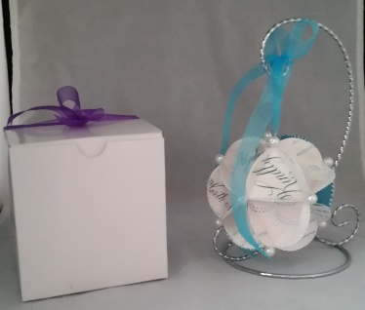
Any questions, call me at (609)617-3597 or e-mail me at Kathy@kathys-kustomkreations.com
www.kathys-kustomkreations.com
Your Name: ________________________ Date: ____________
Address: ___________________________________________
City: ___________________ State: _____ Zip: ____________
Phone: _________________ E-Mail: _____________________
Special instructions (do not use original, use pink ribbon, etc.)
___________________________________________________
Check enclosed: □ Venmo:@KaThy-Rogers-23931 □
PayPal info sent separately: □
Coupon code: _____________ Please include “Special” flyer
It will be returned to you as your own keepsake ornament attractively boxed and ready to give
Each
ornament $45.00
Rush orders
available
(3 day
minimum)
$12.00 extra
Kathleen Rogers Kustom Kreations
738 Green Mount Avenue
Deptford, NJ 08096 (new address)
To have your invitation or announcement transformed into a beautiful, unique, keepsake ornament simply use this form and send your invitation or announcement along with your check, to:

athleen Rogers
ustom
reations

