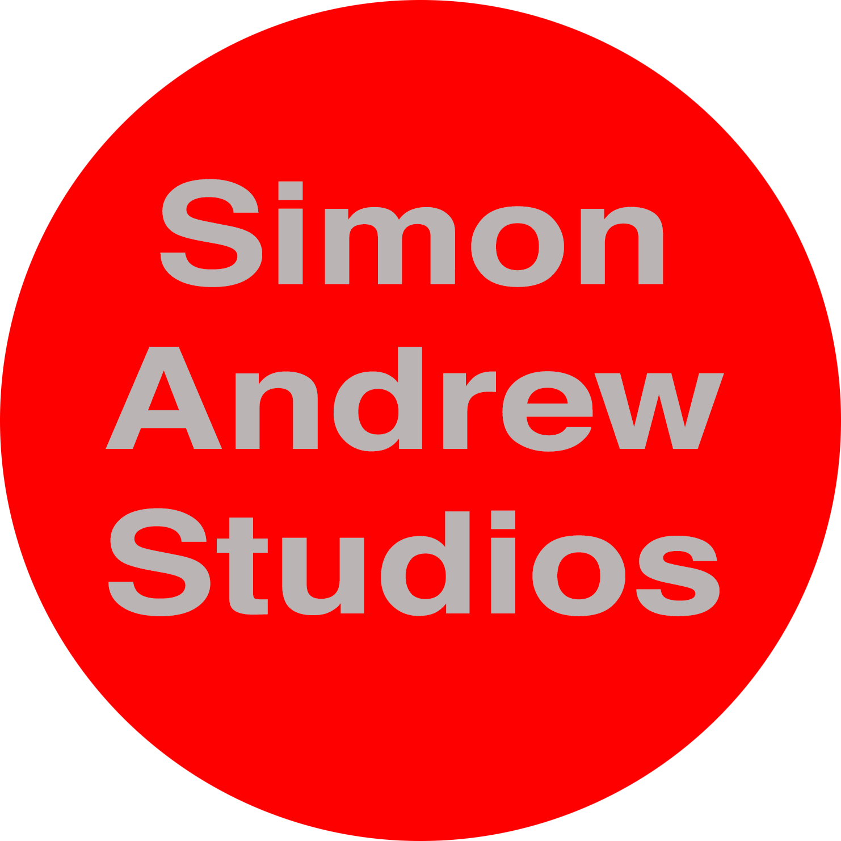

P.O. Box 2121 Kingston Ontario Canada K7L 5J8

Email: studio@simonandrew.com Web: http://www.simonandrew.com/

BIO

Simon Andrew was born in Portsmouth, spent his formative years in Penwith, Cornwall, studied science at Queen's University, Canada and fine art at Newcastle University where he received his MFA. While Simon was at Newcastle he was the beneficiary of The Lawrence Atwell Scholarship Award from Skinners’ Hall, London. U.K.

Simon was awarded first prize (Northern Region) for his work in The Laing National Landscape Competition. London. His work was also selected for The Hunting Group Contemporary Art Competition.

He has received arts council grants and is represented in major corporate collections, including Glaxo Wellcome, Hewlett Packard, Canadian Business Development Bank, Fidelity Investments and Her Majesty the Queen in Right. Simon has produced art for the artistic ventures of Mel Gibson and the Canadian multi - Juno Award winning group The Tragically Hip. He has attended residencies in both Canada and abroad and was the recipient of a full fellowship award from The Vermont Studio Center, USA. Recently Simon won first prize for his work in Exposures, an exhibition which was judged by curators from contemporary public art galleries in Canada. He has had numerous solo shows at galleries both public and commercial at home and abroad. Currently Simon works in Canada and England.

